AP US Government & Politics: Des Moines Public Schools
2017-18 CURRICULUM GUIDE SOC507/508

AP US Government & Politics
AP United States Government and Politics introduces students to key political ideas, institutions, policies, interactions, roles, and behaviors that characterize the political culture of the United States. The course examines politically significant concepts and themes, through which students learn to apply disciplinary reasoning assess causes and consequences of political events, and interpret data to develop evidence-based arguments. Social Studies Weebly: socialstudies.dmschools.org DMPS Grading Resources: grading.dmschools.org

AP US Government and Politics Course Goals:
- Describe and compare important facts, concepts, and theories pertaining to U.S. government and politics.
- Explain typical patterns of political processes and behavior and their consequences (including the components of political behavior, the principles used to explain or justify various government structures and procedures, and the political effects of these structures and procedures).
- Interpret basic data relevant to U.S. government and politics (including data presented in charts, tables, and other formats).
- Critically analyze relevant theories and concepts, apply them appropriately, and develop their connections across the curriculum.

Topic Outline for AP US Government and Politics:
• Constitutional Underpinnings
• Political Beliefs and Behaviors
• Political Parties, Interest Groups, and Mass Media
• Institutions of National Government
• Public Policy
• Civil Rights and Civil Liberties

AP US Government and Politics Exam
The AP United States Government and Politics Exam asks students to explain and apply key and supporting concepts. The exam measures students’ understanding of American political culture and the interactions of governing and linkage institutions. Questions are based on the six major topics in the course, and students must be able to define, compare, explain, and interpret political concepts, policies, processes, perspectives, and behaviors that characterize the U.S. political system.
Format of Assessment Section I: Multiple Choice | 60 Questions | 45 Minutes | 50% of Exam Score
• Demonstrate understanding of major course concepts, policies and institutions • Apply skills of comparison and interpretation
Section II: Constructed Response | 4 Questions | 1 Hour, 40 Minutes | 50% of Exam Score
• Define concepts and explain or interpret content across all course topics
• Analyze political relationships and evaluate policy changes using examples from the course to support the argument or response
Link to Course Information @ AP Central: http://apcentral.collegeboard.com/apc/public/courses/teachers_corner/2259.html
Grading Topics  Semester 1 | College Board Curriculum Framework Alignment | Grading Topics  Semester 2 | College Board Curriculum Framework Alignment
Constitutional Underpinnings | Big Idea 1: Constitutional Democracy  EUs: 1.A, 1.B | Legislative Branch | Big Idea 5: Interaction Among Branches  EUs: 5.A  Big Idea 1: Constitutional Democracy  EUs: 1.C
Structure & Function of the Constitution | Big Idea 1: Constitutional Democracy  EUs: 1.C, 1.D | Executive Branch & Bureaucracy | Big Idea 5: Interaction Among Branches  EUs: 5.B, 5.D  Big Idea 1: Constitutional Democracy  EUs: 1.C
Political Culture & Beliefs | Big Idea 3: American Political Culture & Beliefs  EUs: 3.A, 3.B  Big Idea 4: Political Participation  EUs: 4.A | Judicial Branch | Big Idea 5: Interaction Among Branches  EUs: 5.C  Big Idea 1: Constitutional Democracy  EUs: 1.C
Linkage Institutions | Big Idea 4: Political Participation  EUs: 4.A, 4.B, 4.C | Civil Liberties &  Civil Rights | Big Idea 2: Civil Liberties & Civil Rights  EUs: 2.A, 2.B, 2.C
Electoral Process | Big Idea 4: Political Participation  EUs: 4.D, 4.E
Writing Informative Text FRQs | CCSS.ELA-LITERACY.WHST.11-12.2 (A-E)  Write informative/explanatory texts. | Writing Informative Text FRQs | CCSS.ELA-LITERACY.WHST.11-12.2 (A-E)  Write informative/explanatory texts.
Civic Practices | CCSS.ELA-LITERACY.WHST.11-12.7  Conduct short as well as more sustained research projects to answer a question or solve a problem.  CCSS.ELA-LITERACY.SL.11-12.1  Initiate and participate effectively in a range of collaborative discussions.  CCSS.ELA-LITERACY.SL.11-12.4  Present information, findings, and supporting evidence, etc. | Civic Practices | CCSS.ELA-LITERACY.WHST.11-12.7  Conduct short as well as more sustained research projects to answer a question or solve a problem.  CCSS.ELA-LITERACY.SL.11-12.1  Initiate and participate effectively in a range of collaborative discussions.  CCSS.ELA-LITERACY.SL.11-12.4  Present information, findings, and supporting evidence, etc.
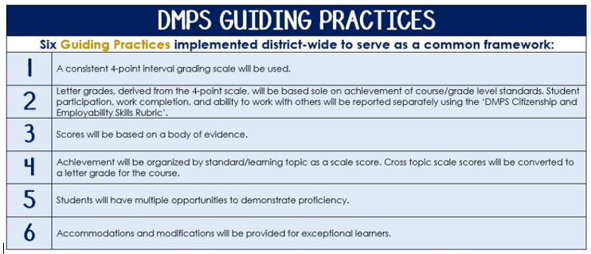
Standards-Referenced Grading Basics
The teacher designs instructional activities and assessments that grow and measure a student’s skills in the elements identified on our topic scales. Each scale features many such skills and knowledges, also called learning targets. These are noted on the scale below with letters (A, B, C) and occur at Levels 2 and 3 of the scale. In the grade book, a specific learning activity could be marked as being 3A, meaning that the task measured the A item at Level 3.

The Body of Evidence in a Process-Based Course
Process-Based SRG is defined as an SRG course design where the same scale recurs throughout the course, but the level of complexity of text and intricacy of task increase over time.

AP US Government & Politics cycles students through the some topics repeatedly as they progress through the course, with changing content and an increasing complexity of the text, analysis, and expectations throughout.

To account for this, process-based courses like this have their evidence considered in a “Sliding Window” approach. When determining the topic score for any given grading topic, the most recent evidence determines the topic score. Teacher discretion remains a vital part of this determination, but it is hard to overlook evidence from the most recent (and therefore rigorous) assessments.

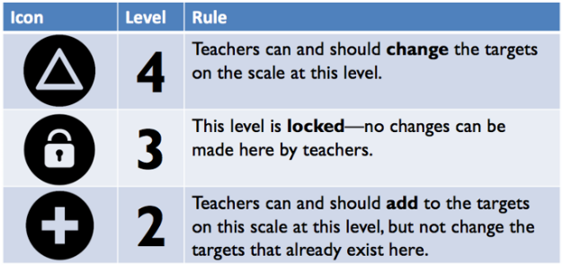
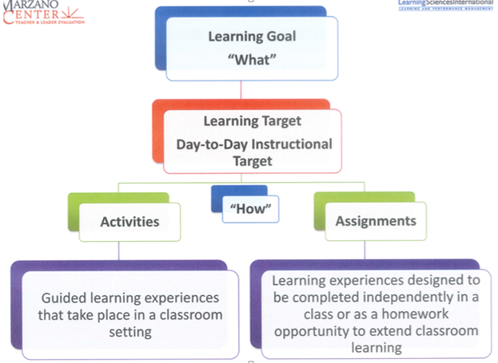

Constitutional Underpinnings
Text and Resources
KIA Project Cycle: Founders’ Intent
3A: LO1.A.1
3B: LO1.A.2
3C: LO1.A.3, LO.B.1, LO1.B.2, LO1.B.3

Topic | 4 | 3 | 2
Constitutional Underpinnings | In addition to meeting the learning goal, the student demonstrates in-depth inferences and applications that go beyond the goal. | 3A: Compare how models of representative democracy and republicanism are visible in major institutions, policies, events, or debates in the U.S.  3B: Explain how democratic ideals are reflected in U.S. foundational documents.  3C: Trace the development of debates and documents surrounding the creation of a new government. | 2A: Describe the different forms of representative democracies (participatory, pluralist, and elite democracy).  2B.1: Describe democratic ideals.  2B.2: Explain how the “Madisonian republic” protects against factions.  2C.1: Describe the events and issues that highlighted the weaknesses of the Articles of the Confederation.  2C.2: Describe the compromises necessary to secure the adoption and ratification of the Constitution.

Structure & Function of the Constitution
Text and Resources
KIA Project Cycle: Founders’ Intent
3A: LO1.C.3 (LO1.C.1 and LO1.C.2)
3B: LO1.D.2 (LO1.B.3, LO1.D.1)

Topic | 4 | 3 | 2
Structure & Function of the Constitution | In addition to meeting the learning goal, the student demonstrates in-depth inferences and applications that go beyond the goal. | 3A: Describe how the distribution of powers among the three federal branches impacts policymaking.  3B: Discuss the advantages and disadvantages of America’s federal system at different points of time. | 2A.1: Describe the powers allocated to each branch of government.  2A.2: Explain how each branch of government has the ability to restrain the others.  2B.1: Distinguish between expressed, concurrent, and reserved powers.  2B.2: Explain how the appropriate balance of power between national and state governments has been interpreted differently over time.

Political Culture & Beliefs
Text and Resources
KIA Project Cycle: Elections
3A: LO3.A.1, LO3.A.2, LO4.D.3
3B: LO3.B.1, LO3.B.2, LO3.B.3
3C: LO4.A.1

Topic | 4 | 3 | 2
Political Culture & Beliefs | In addition to meeting the learning goal, the student demonstrates in-depth inferences and applications that go beyond the goal. | 3A: Generalize how factors influence political attitudes and socialization.  3B: Compare how political ideologies vary on the role of government in economic and social issues.  3C: Explain how public opinion polling and polling results influence elections, political behavior, and policy processes. | 2A.1: Identify the factors of political socialization.  2A.2 Explain how core American values are shaped by different understandings of the relationship between the government and citizens.  2B: Describe the beliefs of different political ideologies (liberal, conservative, communitarian, and libertarian).  2C.1: Describe different types of polling  2C.2: Describe elements of a scientific poll.

Linkage Institutions
Text and Resources
KIA Project Cycle: Elections
3A: LO4.B.1, LO4.B.2
3B: LO4. C.1, LO4.C.2, LO4.C.3, LO4.C.4, LO4.C.5

Topic | 4 | 3 | 2
Linkage Institutions | In addition to meeting the learning goal, the student demonstrates in-depth inferences and applications that go beyond the goal. | 3A: Evaluate to what extent how increasingly diverse choices of media and communication outlets influence political institutions and behaviors.  3B: Compare and contrast the structure, function, and goals of political parties and interest groups. | 2A: Identify the types of media outlets, and the political institutions they affect.  2B: Identify the political parties and interest groups that play an influential role in the electoral process.

Electoral Process
Text and Resources
KIA Project Cycle: Elections
3A: LO.4.E.1
3B: LO4.E.2, LO4.E.3
3C: LO4.E.4

Topic | 4 | 3 | 2
Electoral Process | In addition to meeting the learning goal, the student demonstrates in-depth inferences and applications that go beyond the goal. | 3A: Compare and contrast how the different processes work in a U.S. federal election.  3B: Explain how the organization, finance, and strategies of national political campaigns affect the election process.  3C: Evaluate the extent to which the Electoral College facilitates or impedes democracy | 2A: Describe each of the various means of selecting candidates and the characteristics of each.  2B: Describe the key components necessary to run campaign.  2C: Describe the purpose and function of the electoral college.

Legislative Branch
Text and Resources
KIA Project Cycle: Congress
KIA Project Cycle: Government in Action
3A: LO5.A.1, LO5.A.2
3B: LO5.A.4
*Teach LO5.A.3 – gerrymandering, redistricting, ideological divisions, divided government

Topic | 4 | 3 | 2
Legislative Branch | In addition to meeting the learning goal, the student demonstrates in-depth inferences and applications that go beyond the goal. | 3A: Compare the Senate and the House of Representatives in terms of how constituencies, lawmaking authority, and rules and roles affect the policymaking process.  3B: Explain how Congress uses its oversight power in its relationship with the executive branch. | 2A.1: Describe the organization, powers, and functions of the legislative branch.  2A.2: Identify the different qualifications and powers of the House and the Senate.  2B.1: Define oversight power.  2B.2: Identify and describe congressional powers such as committee hearing committees and power of the purse.

Executive Branch & Bureaucracy
Text and Resources
Mini-Cycle – Presidency
KIA Project Cycle: Government in Action
3A: LO5.B.1, LO5.B.2, LO5.B.3, LO5.B.4
3B:LO5.B.5, LO5.D.1,
*Teach LO5.D.2, LO5.D.3 bureaucracy’s discretionary and rule-making authority to implement policy; how other institutions control or influence the bureaucracy

Topic | 4 | 3 | 2
Executive Branch & Bureaucracy | In addition to meeting the learning goal, the student demonstrates in-depth inferences and applications that go beyond the goal. | 3A: Trace the development of the American “imperial presidency.”  3B: Explain how the president ensures that executive branch agencies and departments carry out their responsibilities in concert with the goals of the administration. | 2A: Identify the qualifications and powers of the President.  2A1: Describe how the role of the President has changed over time.  2B: Describe the role of executive agencies in the policymaking process.

Judicial Branch
Text and Resources
KIA Project Cycle: SCOTUS
KIA Project Cycle: Government in Action
3A: LO5.C.1, LO5.C.3
3B: LO5.C.2

Topic | 4 | 3 | 2
Judicial Branch | In addition to meeting the learning goal, the student demonstrates in-depth inferences and applications that go beyond the goal. | 3A: Explain how the judicial branch checks the power of other branches and how other branches check the power of the judicial branch.  3B: Explain how the exercise of judicial review in conjunction with life tenure can lead to controversy about the legitimacy of the Supreme Court’s power. | 2A.1: Describe the powers of judicial branch as set forth in the Constitution and Marbury v. Madison.  2A.2: Describe restrictions placed on the Supreme Court by the legislative branch, Constitution, Executive branch, and judicial appointment process.  2B.1: Explain how controversial or unpopular court decisions can lead to challenges of the court’s legitimacy.  2B.2: Distinguish between judicial activism and judicial restraint.

Civil Liberties & Civil Rights
Text and Resources
KIA Project Cycle: SCOTUS
3A: LO2.A.1, LO2.A.2
3B: LO2.B.1, LO2.B.2
3C: LO2.C.1, LO2.C.2, LO4.D.1

Topic | 4 | 3 | 2
Civil Liberties & Civil Rights | In addition to meeting the learning goal, the student demonstrates in-depth inferences and applications that go beyond the goal. | 3A: Explain the extent to which the Supreme Court’s interpretation of the Constitution reflects a commitment to a balance between protecting individual liberty and public order and safety.  3B: Explain the ways in which the Supreme Court has used the due process clause in order to selectively incorporate key civil liberties.  3C: Evaluate to what extent the fourteenth amendment has supported and motivated social movements and responses. | 2A.1: Describe the commitment of the court to the protections of the 1st and 2nd amendment and provide case law to support your description  2A.2: Describe the protections of pre-trial, trial, and sentencing rights and provide case law to support your descriptions  2B.1: Describe the changes in interpretation of the due process clause over time.  2B.2: Describe the process of selective incorporation as it applies to civil liberties and provide case law to support your descriptions.  2C.1: Describe the social movements that have been inspired by the 14th amendment’s equal protection clause

Writing Informative Text - FRQs
Text and Resources
CCSS.ELA-LITERACY.WHST.11-12.2 (A-E)
Write informative/explanatory texts.

Topic | 4 | 3 | 2
Writing Informative Text (FRQs) | In addition to meeting the learning goal, the student demonstrates in-depth inferences and applications that go beyond the goal.  4A - Addresses all parts of the prompt, and scores all available points.  4B - Develops the topic with relevant facts, evidence and accurate examples that are appropriate to the topic; uses extended definitions and/or examples. | 3A - Addresses all parts of the prompt, and scores more than half of the available points.  3B - Organize ideas and concepts in the order presented.  3C - Develops the topic with relevant facts, evidence and accurate examples that are appropriate to the topic. | A level 2 writing sample fails to meet the learning goal in two or more areas.

Civic Practices
Text and Resources
3A: CCSS.ELA-LITERACY.WHST.11-12.7
3B: CCSS.ELA-LITERACY.SL.11-12.1
3C: CCSS.ELA-LITERACY.SL.11-12.4

Topic | 4 | 3 | 2
Civic Practices | In addition to meeting the learning goal, the student demonstrates in-depth inferences and applications that go beyond the goal. | 3A – Research specific concepts to answer a question or solve a problem.  3B - Engage effectively in a range of collaborative discussions (1:1, small group, structured debates, etc.).  3C - Present information, findings, and supporting evidence with organization, substance, and speech appropriate to purpose, audience, and task. | A level 2 writing sample fails to meet the learning goal in two or more areas.

SRG Scale Score | Topic:  AP-Style Assessments | AP Exam  Score Conversion
4 | In addition to meeting the learning goal, the student demonstrates in-depth inferences and applications that go beyond the goal. | 90-100%
3.5 | Student’s performance reflects exceptional facility with some, but not all Level 4 learning targets. | 80-89%
3 | Student’s performance reflects success on all Level 3 learning targets. | 70-79%
2.5 | Student’s performance reflects success on some, but not all, Level 3 learning targets | 60-69%
2 | Student’s performance reflects success on all Level 2 learning targets. | 50-59%
1.5 | Student’s performance reflects success on some but not all Level 2 learning targets | 40-49%
1 | Student’s performance reflects insufficient progress towards foundational skills and knowledge. | 20-39%

