AP Music Theory: Des Moines Public Schools
2017-2018 CURRICULUM GUIDE MUS501/502

AP Music Theory
The AP Music Theory course corresponds to one or two semesters of a typical introductory college music theory course that covers topics such as musicianship, theory, musical materials, and procedures. Musicianship skills, including dictation and other listening skills, sight singing, and harmony, are considered an important part of the course. Through the course, students develop the ability to recognize, understand, and describe basic materials and processes of tonal music that are heard or presented in a score. Development of aural skills is a primary objective. Performance is also part of the curriculum through the practice of sight singing. Students understand basic concepts and terminology by listening to and performing a wide variety of music. Notational skills, speed, and fluency with basic materials are also emphasized.

AP Music Theory – Course Content:
The AP Music Theory course supports mastery of the rudiments and vocabulary of music, including hearing and notating:
• Pitches
• Intervals
• Scales and keys
• Chords
• Meter
• Rhythm

Building on this foundation, the course progresses to include more complex and creative tasks, such as melodic and harmonic dictation; composition of a bass line for a given melody, implying appropriate harmony; realization of a figured bass; realization of a Roman numeral progression; analysis of melody, harmony, rhythm, texture, and form in repertoire drawn mostly from the Western European Common Practice style, but also including jazz, 20th century works, and world music; and sight singing of simple melodies.
Students learn to identify, both aurally and through score reading, tonal procedures based in common-practice tonality, such as: • Functional triadic harmony in traditional four-voice texture (with vocabulary including nonharmonic tones, seventh chords, and secondary dominants) • Cadences • Melodic and harmonic compositional processes (e.g., sequence, motivic development) • Standard rhythms and meters • Phrase structure (e.g., contrasting period, phrase group) • Small forms (e.g., rounded binary, simple ternary, theme and variation, strophic) • Modulation to closely related keys

AP Music Theory Exam: Format of Assessment – 2 Hours 40 Minutes
Section I: Multiple Choice | 75 Questions | 1 Hour 20 Minutes | 45% of Exam Score
• Questions based on aural stimuli and Questions based on the analysis of printed music scores
Section II: Free Response | 9 Exercises | 1 Hour 20 Minutes | 55% of Exam Score
• Melodic and Harmonic Dictation
• Part Writing from Roman Numerals and Figured Bass
• Composition of a Bass Line/Harmonization of a Melody
• Sight Singing

Link to DMPS Grading Resources: http://grading.dmschools.org
Link to Course Information @ AP Central: http://apcentral.collegeboard.com/apc/public/courses/teachers_corner/2261.html?excmpid=CBP5-ED-3-apcd
Semester 1 and 2 Topics | College Board Curriculum Framework Alignment
Aural Skills  FRQ 1, 2, 3 & 4 | V. Aural Skills  B. Melodic dictation  C. Harmonic dictation  D. Identification of isolated pitch and rhythmic patterns  E. Detection of errors in pitch and rhythm in one- and two-voice examples  F. Identification of processes and materials in the context of music literature representing a broad spectrum of genres, media, and styles.  I. Musical Terminology  A. Terms for intervals, triads, seventh chords, scales, and modes  B. Terms pertaining to rhythm and meter, melodic construction and variation, harmonic function, cadences and phrase structure, texture, small forms, and musical performance.
Sight-Singing Skills  FRQ 8 & 9 | V. Aural Skills  A. Sight-singing
Compositional Skills  FRQ 7 | III. Basic Compositional Skills  A. Four-voice realization of figured-bass symbols and Roman numerals  B. Composition of a bass line (with chord symbols) for a given melody  II. Notational Skills  A. Rhythms and meters  B. Clefs and pitches  C. Key signatures, scales, and modes  D. Intervals and chords  E. Melodic transposition
Analytical Skills  FRQ 3, 4, 5 & 6 | I. Musical Terminology  A. Terms for intervals, triads, seventh chords, scales, and modes  B. Terms pertaining to rhythm and meter, melodic construction and variation, harmonic function, cadences and phrase structure, texture, small forms, and musical performance.  IV. Score Analysis (with or without aural stimulus)  A. Small-scale and large-scale harmonic procedures  B. Melodic organization and developmental procedures  C. Rhythmic/metric organization  D. Texture  E. Formal devices and/or procedures

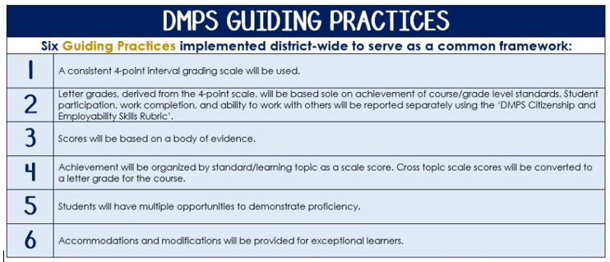
Standards-Referenced Grading Basics
The teacher designs instructional activities and assessments that grow and measure a student’s skills in the elements identified on our topic scales. Each scale features many such skills and knowledges, also called learning targets. These are noted on the scale below with letters (A, B, C) and occur at Levels 2 and 3 of the scale. In the grade book, a specific learning activity could be marked as being 3A, meaning that the task measured the A item at Level 3.

The Body of Evidence in a Process-Based Course
Process-Based SRG is defined as an SRG course design where the same scale recurs throughout the course, but the level of complexity of text and intricacy of task increase over time.

AP Music Theory does have a traditional unit-based design. In some topics, however, students cycle through the same topic repeatedly as they progress through the course, with changing content and an increasing complexity of the music, analysis, and expectations throughout.

To account for this, process-based courses like this have their evidence considered in a “Sliding Window” approach. When determining the topic score for any given grading topic, the most recent evidence determines the topic score. Teacher discretion remains a vital part of this determination, but it is hard to overlook evidence from the most recent (and therefore rigorous) assessments.

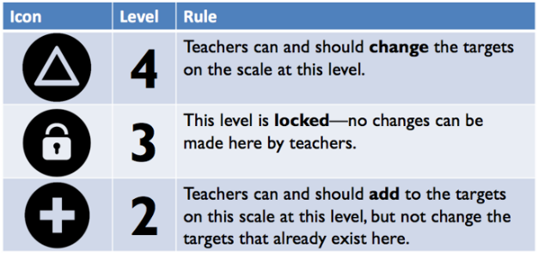
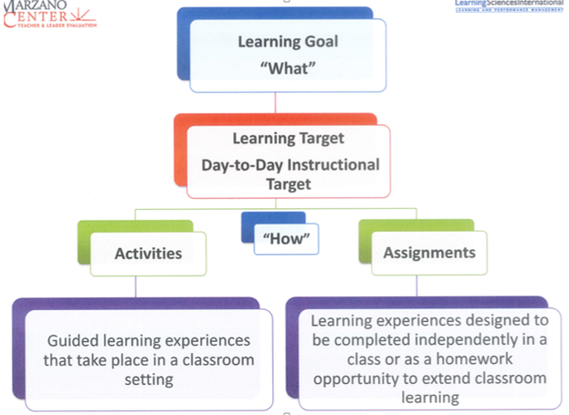

Aural Skills – Semester 1

Topic | 4 | 3 | 2
Aural  Skills  FRQ 1, 2, 3 & 4 | 4A: Investigate aural weaknesses and develop an individualized strategy to dictate melodic passages at a level beyond the learning goal.  4B: Investigate aural weaknesses and develop an individualized strategy to dictate rhythmic passages at a level beyond the learning goal. | 3A: Dictate melodic passages consisting of steps and triads leaps.  3B: Dictate rhythmic passages consisting of one division of the beat or larger. | 2A.1: Distinguish, aurally, all major, minor, and tritone intervals.  2A.2: Distinguish, aurally, major and natural, harmonic, and melodic minor scales.  2A.3: Distinguish, aurally, major, minor, diminished, and augmented triads.  2B.1: Distinguish, aurally, simple and compound, duple, triple, and quadruple meters.

Sight-Singing – Semester 1

Topic | 4 | 3 | 2
Sight-Singing Skills  FRQ 8 & 9 | 4A: Investigate sight-singing weaknesses and develop an individualized strategy to sight-sing melodic passages at a level beyond the learning goal.  4B: Investigate sight-singing weaknesses and develop an individualized strategy to sight-sing rhythmic passages at a level beyond the learning goal. | 3A: Sight-sing major and minor excerpts consisting of steps and triad leaps.  3B: Count rhythms consisting of one sub-division of the beat or larger. | 2A.1: Distinguish, through singing, all major and minor intervals.  2A.2: Distinguish, through singing, major and natural, harmonic, and melodic minor scales.  2B.1: Distinguish, visually, duration symbols.  2B.2: Distinguish, visually, simple and compound, duple, triple, and quadruple meters.

Compositional Skills – Semester 1

Topic | 4 | 3 | 2
Compositional  Skills  FRQ 7 | 4A: Investigate compositional weaknesses and develop an individualized strategy to compose melodic passages at a level beyond the learning goal.  4B: Investigate compositional weaknesses and develop an individualized strategy to compose rhythmic passages at a level beyond the learning goal. | 3A: Compose a melody and bass line using proper voice leading considerations of Common Practice Era.  3B: Compose rhythms in simple and compound meters using at least one division of the beat. | 2A.1: Notate pitches in G, F, and C clefs.  2A.2: Notate all major, minor, diminished, and augmented intervals.  2A.3: Notate all major and minor key signatures.  2A.4: Notate major and natural, harmonic, and melodic minor scales.  2A.5: Notate major, minor, diminished, and augmented triads.  2A.6: Notate major, minor, major-minor, half-diminished, and fully-diminished seventh chords.  2B.1: Notate correct beaming in simple meters.  2B.2: Notate beaming in compound meters.  2B.3: Notate duration symbols.

Analytical Skills – Semester 1

Topic | 4 | 3 | 2
Analytical  Skills  FRQ 3, 4, 5 & 6 | 4: Investigate analytical weaknesses and develop an individualized strategy to analyze music at a level beyond the learning goal. | 3A: Realize figured bass by notating chords based on provided diatonic Roman Numerals and bass position symbols.  3B: Analyze a musical excerpt using diatonic Roman Numerals and bass position symbols.  3C: Analyze perfect and imperfect authentic, plagal, half, phrygian half, and deceptive cadences. | 2ABC.1: Distinguish, visually, pitches in G, F, and C clefs.  2ABC.2: Distinguish, visually, all major, minor, diminished, and augmented intervals.  2ABC.3: Distinguish, visually, all major and minor key signatures.  2ABC.4: Distinguish, visually, major, minor, diminished, and augmented triads.  2ABC.5: Distinguish, visually, major, minor, major-minor, half-diminished, and fully-diminished seventh chords.

Aural Skills – Semester 2

Topic | 4 | 3 | 2
Aural  Skills  FRQ 1, 2, 3 & 4 | 4A: Investigate aural weaknesses and develop an individualized strategy to dictate passages at a level beyond the learning goal. | 3A: Dictate passages consisting of all diatonic intervals and rhythmic patterns in simple and compound meters.  3B: Dictate the outer voices (soprano and bass) and harmonic analysis in four-voice texture.  3C: Investigate processes and materials in the context of music literature. | 2AB.1: Distinguish, aurally, all major, minor, and tritone intervals.  2AB.2: Distinguish, aurally, major and natural, harmonic, and melodic minor scales.  2AB.3: Distinguish, aurally, major, minor, diminished, and augmented triads.  2A.4: Distinguish, aurally, simple and compound, duple, triple, and quadruple meters.  2C.1: Compare and contrast musical organization.  2C.2: Compare and contrast instrumentation and timbre.  2C.3: Compare and contrast texture.  2C.4: Compare and contrast formal procedures.

Sight-Singing Skills – Semester 2

Topic | 4 | 3 | 2
Sight-Singing Skills  FRQ 8 & 9 | 4A: Investigate sight-singing weaknesses and develop an individualized strategy to sight-sing passages at a level beyond the learning goal. | 3A: Sight-sing major and minor excerpts consisting of all diatonic intervals and rhythmic patterns in simple and compound meters. | 2A.1: Distinguish, through singing, all major and minor intervals.  2A.2: Distinguish, through singing, major and natural, harmonic, and melodic minor scales.  2A.3: Distinguish, visually, duration symbols.  2A.4: Distinguish, visually, simple and compound, duple, triple, and quadruple meters.

Compositional Skills – Semester 2

Topic | 4 | 3 | 2
Compositional  Skills  FRQ 7 | 4A: Investigate compositional weaknesses and develop an individualized strategy to compose four-part passages at a level beyond the learning goal. | 3A: Compose in four-part using proper voice leading considerations of Common Practice Era. | 2A.1: Categorize non-chord tones.  2A.2: Compare and contrast cadences.  2A.3: Notate a tonicization.  2A.4: Classify Common Practice Era harmonic progressions.

Analytical Skills – Semester 2

Topic | 4 | 3 | 2
Analytical  Skills  FRQ 3, 4, 5 & 6 | 4: Investigate analytical weaknesses and develop an individualized strategy to analyze music at a level beyond the learning goal. | 3A: Realize figured bass by notating chords based on provided diatonic Roman Numerals and bass position symbols.  3B: Analyze a musical excerpt using diatonic Roman Numerals and bass position symbols. | 2AB.1: Categorize forms.  2AB.2: Categorize modes.  2AB.3: Categorize texture.  2AB.4: Categorize transpositions.

