AP Macroeconomics: Des Moines Public Schools
2017-18 CURRICULUM GUIDE SOC511 SOC511A

AP Macroeconomics
The AP Macroeconomics is an introductory college-level course that focuses on the principles that apply to an economic system as a whole. The course places particular emphasis on the study of national income and price-level determination; it also develops students’ familiarity with economic performance measures, the financial sector, stabilization policies, economic growth, and international economics. Students learn to use graphs, charts, and data to analyze, describe, and explain economic concepts.

AP Macroeconomics – Course Content:
The AP Macroeconomics course provides students with a thorough understanding of the principles of economics and how economists use those principles to examine aggregate economic behavior. Students learn how the measures of economic performance, such as gross domestic product (GDP), inflation, and unemployment are constructed and how to apply them to evaluate the macroeconomic conditions of an economy. The course recognizes the global nature of economics and provides ample opportunities to examine the impact of international trade and finance on national economies. Various economic schools of thought are introduced as students consider solutions to economic problems.

I. Basic Economic Concepts
II. Measurement of Economic Performance a. National income accounts b. Inflation measurement and adjustment c. Unemployment
III. National Income and Price Determination a. Aggregate demand b. Aggregate supply c. Macroeconomics equilibrium
IV. Financial Sector a. Money, banking, and financial markets b. Loanable funds market c. Central bank and control of the money supply
V. Stabilization Policies a. Fiscal and monetary policies b. The Phillips curve
VI. Economic Growth a. Definition of economic growth b. Determinants of economic growth c. Growth policy
VII. Open Economy: International Trade and Finance a. Balance of payments accounts b. Foreign exchange market c. Imports, exports, and financial capital flows d. Relationships between international and domestic financial and goods markets

AP Macroeconomics Exam: Format of Assessment – 2 Hours 30 Minutes
Section 1: Multiple Choice | 60 Questions | 1 Hour, 10 Minutes – 66% of Exam Score
•Questions require the use of economics content knowledge and reasoning across the range of course topics.
• Some questions require analysis of different hypothetical situations.
Section 2: Free Response | 3 Questions | 1 Hour, 10 Minutes – 33% of Exam Score

Link to DMPS Grading Resources: http://grading.dmschools.org
Link to Course Information @ AP Central: http://apcentral.collegeboard.com/apc/public/courses/teachers_corner/2120.html
Grading Topics | College Board Curriculum Framework Alignment
Measures of Economic Performance | I. Basic Economic Concepts  A. Scarcity, choice, and opportunity cost  B. Production possibilities curve  II. Measurement of Economic Performance  A. National income accounts  B. Inflation measurement and adjustment  C. Unemployment  Financial Sector  A. Money, banking, and financial markets
Macroeconomic Equilibrium | I. Basic Economic Concepts  D. Demand, supply, and market equilibrium  E. Macroeconomic issues: business cycle, unemployment, inflation, growth  III. National Income and Price Determination  A. Aggregate demand  B. Aggregate supply  C. Macroeconomic equilibrium  VI. Economic Growth  A. Definition of economic growth  B. Determinants of economic growth  C. Growth Policy
Stabilization Policies | V. Stabilization Policies  A. Fiscal and monetary policies  B. The Phillips curve  IV. Financial Sector  Financial Sector  A. Money, banking, and financial markets  B. Loanable Funds Markets  C. Central bank and control of the money supply
Open Economy: International Trade and Finance | I. Basic Economic Concepts  C. Comparative advantage, specialization, and exchange  VII. Open Economy: International Trade and Finance  A. Balance of payments accounts  B. Foreign exchange market  C. Imports, exports, and financial capital flows  D. Relationships between international and domestic financial and goods markets  IV. Financial Sector  B. Loanable funds market
Graphing and Data Analysis | Statistical Analysis  Interpreting graphs  Using formulas to solve equations
Economic Investigations* | Investigating authentic, relevant economic concepts.

Standards-Referenced Grading Basics
The teacher designs instructional activities and assessments that grow and measure a student’s skills in the elements identified on our topic scales. Each scale features many such skills and knowledges, also called learning targets. These are noted on the scale below with letters (A, B, C) and occur at Levels 2 and 3 of the scale. In the grade book, a specific learning activity could be marked as being 3A, meaning that the task measured the A item at Level 3.

The Body of Evidence in a Process-Based Course
Process-Based SRG is defined as an SRG course design where the same scale recurs throughout the course, but the level of complexity of text and intricacy of task increase over time.

AP Macroeconomics cycles students through the some topics repeatedly as they progress through the course, with changing content and an increasing complexity of the text, analysis, and expectations throughout.

To account for this, process-based courses like this have their evidence considered in a “Sliding Window” approach. When determining the topic score for any given grading topic, the most recent evidence determines the topic score. Teacher discretion remains a vital part of this determination, but it is hard to overlook evidence from the most recent (and therefore rigorous) assessments.

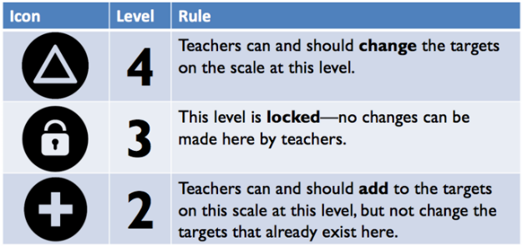
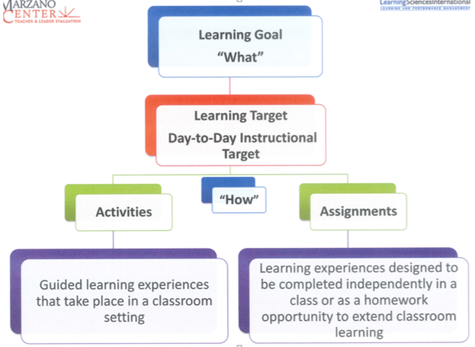

Measures of Economic Performance
Text and Resources

Topic | 4 | 3 | 2
Measures of Economic Performance | In addition to meeting the learning goal, the student demonstrates in-depth inferences and applications that go beyond the goal.  Describe the limitations of the classic economic indicators. | 3A – Compare and contrast the uses of real and nominal GDP.  3B – Predict who benefits and who loses from inflation.  3C - Determine the relationship between unemployment and economic growth. | 2A: Identify the components of GDP.  Calculate real and nominal GDP.  2B: Define inflation.  Calculate the inflation rate.  2C: Identify and describe types of unemployment.

Macroeconomic Equilibrium
Text and Resources

Topic | 4 | 3 | 2
Macroeconomic Equilibrium | In addition to meeting the learning goal, the student demonstrates in-depth inferences and applications that go beyond the goal.  Develop strategies to solve the problems of recessionary and inflationary gaps. | 3A: Given a scenario, determine changes in market equilibrium.  3B: Given a scenario, determine economic macro equilibrium.  3C: Given a scenario, determine appropriate economic growth policies. | 2A: Identify determinants of demand, supply, and market equilibrium.  2B.1: Identify and describe determinants of aggregate demand.  2B.2: Identify and describe determinants of short-run and long-run aggregate supply.  2B.3: Identify real output and price level at economic equilibrium.  Identify recessionary and inflationary gaps.  2C: Define economic growth.  Identify determinants of economic growth. Describe growth policies.

Stabilization Policies
Text and Resources

Topic | 4 | 3 | 2
Stabilization Policies | In addition to meeting the learning goal, the student demonstrates in-depth inferences and applications that go beyond the goal. | 3A: Evaluate the effectiveness of fiscal policy in solving economic problems.  3B: Evaluate the effectiveness of monetary policy in solving economic problems. | 2A: Define fiscal policy.  Identify and describe fiscal policies.  2B: Define monetary policy.  Identify and describe monetary policies.  Identify types of money.  Describe the uses of different types of money. Identify the determinants of supply and demand in the money supply.

Open Economy: International Trade & Finance
Text and Resources

Topic | 4 | 3 | 2
Open Economy: International Trade & Finance | In addition to meeting the learning goal, the student demonstrates in-depth inferences and applications that go beyond the goal.  Determine which exchange rate policy would be most appropriate to maintain a stable economy. | 3A: Determine the conditions under which countries will specialize and trade with each other.  3B: Determine the effects of changes in trade on a country’s balance of payments accounts.  3C: Form conclusions about the effects of changes in the loanable funds market on foreign investment. | 2A: Identify and define comparative and absolute advantage and specialization.  2B: Identify the components of balance of payments accounts.  2C: Identify the factors that change supply or demand of loanable funds.

Graphing and Data Analysis
Text and Resources

Topic | 4 | 3 | 2
Graphing and Data Analysis | In addition to meeting the learning goal, the student demonstrates in-depth inferences and applications that go beyond the goal.  Given data, determine the relationships. | 3A: Form conclusions about the PPC and how it shows efficiency, opportunity cost, and economic growth.  3B: Form conclusions about a country’s economic health based on AD/AS.  3C: Form conclusions about the relationship between inflation and unemployment in the short-run  3D: Form conclusions about the relationship between nominal interest rates and the money supply.  3E: Form conclusions about the effect on the real interest rate resulting from changes in the loanable funds market.  3F: Form conclusions about the relative value of currencies using the foreign exchange market. | 2A: Identify and draw the PPC.  2B: Identify and draw the AD/AS.  2C: Identify and draw the Phillips curve.  2D: Identify and draw the money market.  2E: Identify and draw the loanable funds market.  2F: Identify and draw the foreign exchange market.

Economic Investigations*
Text and Resources

Topic | 4 | 3 | 2
Economic Interpretation | In addition to meeting the learning goal, the student demonstrates in-depth inferences and applications that go beyond the goal.

SRG Scale Score | Topic:  AP-Style Assessments | AP Exam  Score Conversion
4 | In addition to meeting the learning goal, the student demonstrates in-depth inferences and applications that go beyond the goal. | 90-100%
3.5 | Student’s performance reflects exceptional facility with some, but not all Level 4 learning targets. | 80-89%
3  Learning Goal | Student’s performance reflects success on all Level 3 learning targets. | 70-79%
2.5 | Student’s performance reflects success on some, but not all, Level 3 learning targets | 60-69%
2 | Student’s performance reflects success on all Level 2 learning targets. | 50-59%
1.5 | Student’s performance reflects success on some but not all Level 2 learning targets | 40-49%
1 | Student’s performance reflects insufficient progress towards foundational skills and knowledge. | 20-39%

