The Des Moines Public Schools Curriculum guide contains the prioritized standards, required pacing, materials and resources, and assessment correlates for the school year. This document is intended to be used in conjunction with our balanced assessment plan to scaffold our students in mastery of the Iowa Core State Standards.
AP French Language & Culture: Des Moines Public Schools
2017-2018 CURRICULUM GUIDE WL503/WL504

AP French Language & Culture
The AP French Language and Culture course emphasizes communication (understanding and being understood by others) by applying interpersonal, interpretive, and presentational skills in real-life situations. This includes vocabulary usage, language control, communication strategies, and cultural awareness. The AP French Language and Culture course strives not to overemphasize grammatical accuracy at the expense of communication. To best facilitate the study of language and culture, the course is taught almost exclusively in French. The AP French Language and Culture course engages students in an exploration of culture in both contemporary and historical contexts. The course develops students’ awareness and appreciation of cultural products (e.g., tools, books, music, laws, conventions, institutions); practices (patterns of social interactions within a culture); and perspectives (values, attitudes, and assumptions).

AP French Language & Culture – Course Themes:
The AP French Language and Culture course is structured around six themes:
• Beauty and Aesthetics
• Contemporary Life
• Families and Communities
• Global Challenges
• Personal and Public Identities
• Science and Technology
Themes facilitate the integration of language, content, and culture and promote the use of the language in a variety of contexts. The themes may be combined, as they are interrelated.

World Languages and Cultures– Learning Objectives:
Students are expected to: • Engage in spoken interpersonal communication; • Engage in written interpersonal communication; • Synthesize information from a variety of authentic audio, visual, and audiovisual resources; • Synthesize information from a variety of authentic written and print resources; • Plan, produce, and present spoken presentational communications; and • Plan and produce written presentational communications.

AP French Language & Culture Exam: Format of Assessment – 3 Hours
Section I: Multiple Choice | 65 Questions | 1 Hour, 35 Minutes | 50% of Exam Score
• Part A: 30 Questions, 40 Minutes: Interpretive Communication – Print Tests • Part B: 35 Questions, 55 Minutes: Interpretive Communication –Print/Audio
Section II: Free Response | 4 Tasks | 1 Hour, 28 Minutes | 50% of Exam Score
• Task 1: Interpersonal Writing: Email Reply • Task 2: Presentational Writing: Persuasive Essay
• Task 3: Interpersonal Speaking: Simulated Conversation • Task 4: Presentational Speaking: Cultural Comparison

Link to DMPS Grading Resources: http://grading.dmschools.org
Link to Course Information @ AP Central: http://apcentral.collegeboard.com/apc/public/courses/teachers_corner/3499.html?excmpid=MTG243-PR-32-cd
Course Topics | College Board Curriculum Framework Alignment
Interpersonal Speaking | Spoken Interpersonal Communication  World Languages: Level 4 Semester 2 Topic Scales (ACTFL Proficiency Level: Advanced Low) ACTFL Standards:  · 1.1 Students engage in conversations, provide and obtain information, express feelings and emotions, and exchange opinions.  · 3.1 Students reinforce and further their knowledge of other disciplines through the foreign language.
Interpersonal Writing | Written Interpersonal Communication  World Languages: Level 4 Semester 2 Topic Scales (ACTFL Proficiency Level: Advanced Low) ACTFL Standards:  · 1.1 Students engage in conversations, provide and obtain information, express feelings and emotions, and exchange opinions.  · 3.1 Students reinforce and further their knowledge of other disciplines through the foreign language.
Presentational Speaking | Spoken Presentational Communication  World Languages: Level 4 Semester 2 Topic Scales (ACTFL Proficiency Level: Advanced Low) ACTFL Standards:  · 1.3 Students present information, concepts, and ideas to an audience of listeners or readers on a variety of topics.  · 2.1, 2.2 Students demonstrate an understanding of the relationship between the practices/products and then perspectives of the cultures studied.  · 4.2 Students demonstrate understanding of the concept of culture through comparisons of the cultures studied and their own.
Presentational Writing | Written Presentational Communication  World Languages: Level 4 Semester 2 Topic Scales (ACTFL Proficiency Level: Advanced Low) ACTFL Standards:  ·1.3 Students present information, concepts, and ideas to an audience of listeners or readers on a variety of topics.  ·3.1 Students reinforce and further their knowledge of other disciplines through the foreign language.  ·3.2 Students acquire information and recognize the distinctive viewpoints that are only available through the foreign language and its cultures.
Course Topics | College Board Curriculum Framework Alignment
Reading | Written and Print Interpretive Communication  World Languages: Level 4 Semester 2 Topic Scales (ACTFL Proficiency Level: Advanced Low)  ACTFL Standards:  · 1.2 Students understand and interpret written and spoken language on a variety of topics.  · 2.1, 2.2 Students demonstrate an understanding of the relationship between the practices/products and then perspectives of the cultures studied.  · 3.1 Students reinforce and further their knowledge of other disciplines through the target language.  · 3.2 Students acquire information and recognize the distinctive viewpoints that are only available through the foreign language and its cultures.
Listening | Audio, Visual, and Audiovisual Interpretive Communication  World Languages: Level 4 Semester 2 Topic Scales (ACTFL Proficiency Level: Advanced Low)  ACTFL Standards:  -1.2 Students understand and interpret written and spoken language on a variety of topics.  -2.1, 2.2 Students demonstrate an understanding of the relationship between the practices/products and then perspectives of the cultures studied.  -3.1 Students reinforce and further their knowledge of other disciplines through the target language.  -3.2 Students acquire information and recognize the distinctive viewpoints that are only available through the foreign language and its cultures.

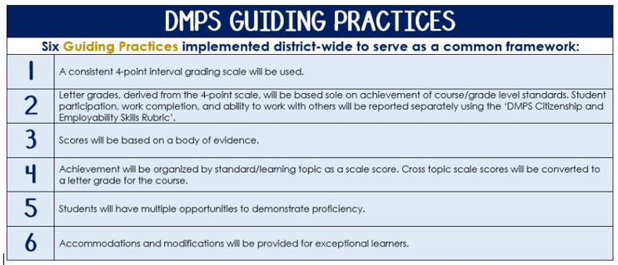
Standards-Referenced Grading Basics
The teacher designs instructional activities and assessments that grow and measure a student’s skills in the elements identified on our topic scales. Each scale features many such skills and knowledges, also called learning targets. These are noted on the scale below with letters (A, B, C) and occur at Levels 2 and 3 of the scale. In the grade book, a specific learning activity could be marked as being 3A, meaning that the task measured the A item at Level 3.

The Body of Evidence in a Process-Based Course
Process-Based SRG is defined as an SRG course design where the same scale recurs throughout the course, but the level of complexity of text and intricacy of task increase over time.

AP French Language & Culture immerses students in six themes as outlined by the College Board curriculum framework. Students cycle through the similar topics repeatedly as they progress through the course, with changing content and an increasing complexity of the text, analysis, listening, speaking, and writing expectations throughout.

To account for this, process-based courses like this have their evidence considered in a “Sliding Window” approach. When determining the topic score for any given grading topic, the most recent evidence determines the topic score. Teacher discretion remains a vital part of this determination, but it is hard to overlook evidence from the most recent (and therefore rigorous) assessments.
DMPS Grading Resources: grading.dmschools.org

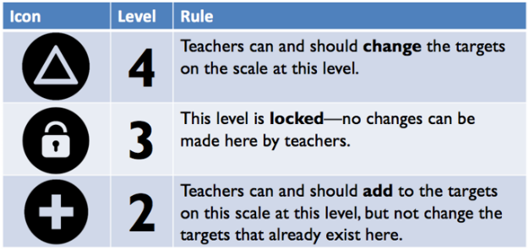
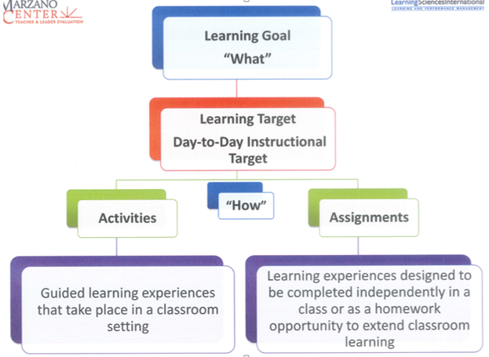

Interpersonal Speaking
4 | The student demonstrates in-depth inferences and applications that go beyond the goal.  4A: Maintains the exchange with a series of responses that is clearly appropriate within the context of the task.  4B: Provides statement and supported opinion with frequent elaboration.  4C: Fully understandable with ease and clarity of expression.
3 | The student demonstrates the ability to:  3A: Start, maintain, and exchange a response that provides required information incorporating cultural knowledge and idiomatic language in different tenses.  3B: Speak with fluidly connected sentences, elaboration, appropriate pacing and organization.  3C: Be fully understood with some errors that do not impede comprehensibility.
2 | The student demonstrates the ability to:  2A: Start, maintain, and end a spoken conversation using a variety of expressions and sentences in different tenses.  2B: Speak with partially connected sentences that may not be organized.  2C: Be understood with interpretation by a sympathetic listener. Errors occasionally impede comprehensibility.
1 | Student’s performance reflects insufficient progress towards foundational skills and knowledge.

Interpersonal Writing
4 | The student demonstrates in-depth inferences and applications that go beyond the goal.
3 | The student demonstrates the ability to:  3A: Start, maintain, and exchange a response that provides required information incorporating cultural knowledge and idiomatic language in different tenses.  3B: Write with fluidly connected sentences, elaboration, appropriate organization.  3C: Be fully understood with some errors that do not impede comprehensibility.
2 | The student demonstrates the ability to:  2A: Start, maintain, and end a written conversation using a variety of expressions and sentences in different tenses.  2B: Write with fluidly connected sentences and appropriate organization.  2C: Be understood with interpretation by a sympathetic reader. Occasional errors impede comprehensibility.
1 | Student’s performance reflects insufficient progress towards foundational skills and knowledge.

Presentational Speaking
4 | The student demonstrates in-depth inferences and applications that go beyond the goal.  4A: Clearly compares the student’s own community with the target culture, including supporting details and relevant examples.  4B: Organized and understandable presentation with transitional elements, clarity of expression, varied vocabulary and grammar and errors that do not impede comprehensibility.  4C: Pronunciation, pacing, and clarification that does not impede comprehensibility.
3 | The student demonstrates the ability to:  3A: Compare their culture with the target culture, including supporting details and relevant examples.  3B: Present information in an organized and mostly comprehensible manner with some transitional elements and clarity of expression.  3C: Be fully understood with some errors that do not impede comprehensibility.
2 | The student demonstrates the ability to:  2A: Compare their culture with the target culture, including few supporting details and relevant examples.  2B: Present information with some organization and limited transitional elements and clarity of expression.  2C: Be understood with interpretation by a sympathetic listener. Errors occasionally impede comprehensibility.
1 | Student’s performance reflects insufficient progress towards foundational skills and knowledge.

Presentational Writing
4 | The student demonstrates in-depth inferences and applications that go beyond the goal.
3 | The student demonstrates the ability to:  3A: Create a written text that expresses, defends and develops opinions or arguments on a variety of topics using evidence from authentic sources.  3B: Write fluidly connected sentences with ease of expression and appropriate organization.  3C: Be fully understood with some errors that do not impede comprehensibility.
2 | The student demonstrates the ability to:  2A: Create a written text that expresses an opinion or argument with minimal or ineffective defense and supporting details.  2B: Write with strings of sentences that may not be organized.  2C: Be understood with interpretation by a sympathetic reader. Errors occasionally impede comprehensibility.
1 | Student’s performance reflects insufficient progress towards foundational skills and knowledge.

Reading
4 | The student demonstrates in-depth inferences and applications that go beyond the goal.
3 | The student demonstrates the ability to:  Analyze an authentic resource in regards to:  - Author’s meaning, purpose and audience  - Main idea, theme, and tone  - Idiomatic and culturally relevant expressions  - Cultural products, practices, and perspectives
2 | Student performance reflects success on foundational skills and knowledge required to achieve the learning goal.
1 | Student’s performance reflects insufficient progress towards foundational skills and knowledge.

Listening
4 | The student demonstrates in-depth inferences and applications that go beyond the goal.
3 | The student demonstrates the ability to:  Analyze an authentic resource in regards to:  - Author’s meaning, purpose and audience  - Main idea, theme, and tone  - Idiomatic and culturally relevant expressions  - Cultural products, practices, and perspectives
2 | Student performance reflects success on foundational skills and knowledge required to achieve the learning goal.
1 | Student’s performance reflects insufficient progress towards foundational skills and knowledge.

 |  | Topic Conversion Tool  Reading and Listening | Multiple Choice Score Conversion
4 |  | Student demonstrates in-depth inferences and applications that go beyond the goal. | 80-100%
3.5 |  | Student’s performance reflects exceptional facility of learning goal targets. | 70-79%
3 |  | Students analyze an authentic resource in regards to:  A. Author’s meaning, purpose and audience  B. Main idea, theme, and tone  C. Idiomatic and culturally relevant expressions  D. Cultural products, practices, and perspectives | 60-69%
Learning Goal
2.5 |  | Student’s performance reflects success on some but not all Level 3 learning targets | 50-59%
2 |  | Student’s performance reflects success on foundational skills and knowledge required to achieve the learning goal. | 40-49%
1.5 |  | Student’s performance reflects success on some but not all Level 2 learning targets | 30-39%
1 |  | Student’s performance reflects insufficient progress towards foundational skills and knowledge. | 0-29%

