The Des Moines Public Schools Curriculum guide contains the prioritized standards, required pacing, materials and resources, and assessment correlates for the school year. This document is intended to be used in conjunction with our balanced assessment plan to scaffold our students in mastery of the Iowa Core State Standards.
AP European History: Des Moines Public Schools
2017-2018 CURRICULUM GUIDE SOC 523A/524A

AP European History
The AP European History course is equivalent to an introductory college-level course in European history. This course develops students’ abilities to think conceptually about U.S. history from approximately 1450 to the present and apply historical thinking skills as they learn about the past. Five themes of equal importance – interaction of Europe and the world; poverty and prosperity; objective knowledge and subjective visions; states and other institutions of power; and individual and society – provide areas of historical inquiry for investigation throughout the course. These require students to reason historically about continuity and change over time and make comparison among various historical developments in different times and places.

AP European History – Course Content:
• Period 1: 1450-1648 • Period 2: 1648-1815 • Period 3: 1815-1914 • Period 4: 1914-present

AP European History – Historical Thinking Skills:
• Chronological Reasoning
• Comparison and Contextualization
• Crafting Historical Arguments from Historical Evidence
• Historical Interpretation and Synthesis

AP European History Exam
The AP European History Exam measures students’ knowledge of European history and their ability to think historically.
Format of Assessment
Section I Part A: Multiple Choice | 50-55 Questions | 55 Minutes | 40% of Exam Score
• Questions appear in sets of 2-5 • Students analyze historical texts, interpretations, and evidence • Primary and secondary sources, images, graphs, and maps are included
Section I Part B: Short Answer | 4 Questions | 45 Minutes | 20% of Exam Score
• Questions provide opportunities for students to demonstrate what they know best • Some questions include texts, images, graphs, or maps
Section II Part A: Document-Based | 1 Question | 60 Minutes | 25% of Exam Score
• Analyze and synthesize historical data • Assess written, qualitative, or visual materials as historical evidence
Section II Part B: Long Essay | 1 Question | 35 Minutes | 15% of Exam Score
• Students select one of two questions • Explain and analyze significant issues in U.S. History • Develop an argument supported by an analysis of historical evidence

Link to Course Information @ AP Central: https://advancesinap.collegeboard.org/english-history-and-social-science/us-history

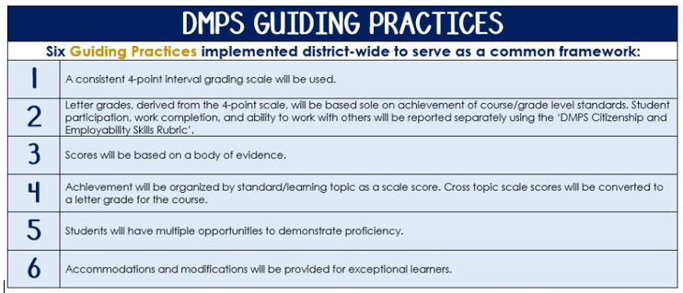
Standards-Referenced Grading Basics
The teacher designs instructional activities and assessments that grow and measure a student’s skills in the elements identified on our topic scales. Each scale features many such skills and knowledges, also called learning targets. These are noted on the scale below with letters (A, B, C) and occur at Levels 2 and 3 of the scale. In the grade book, a specific learning activity could be marked as being 3A, meaning that the task measured the A item at Level 3.

The Body of Evidence in a Process-Based Course
Process-Based SRG is defined as an SRG course design where the same scale recurs throughout the course, but the level of complexity of text and intricacy of task increase over time.

AP European History is a course in which students cycle through focused topics repeatedly as they progress through the course, with changing content and an increasing complexity of the text, analysis, and writing expectations throughout.

To account for this, process-based courses like this have their evidence considered in a “Sliding Window” approach. When determining the topic score for any given grading topic, the most recent evidence determines the topic score. Teacher discretion remains a vital part of this determination, but it is hard to overlook evidence from the most recent (and therefore rigorous) assessments.

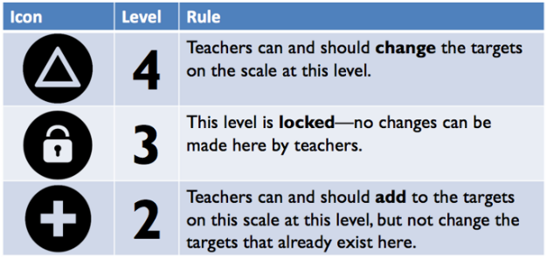
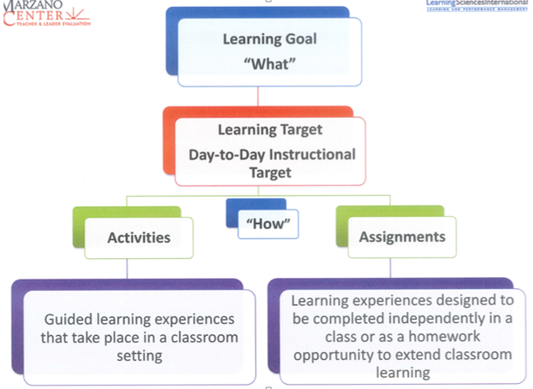

AP European History Course Topics
Text and Resources
Course Text:  A History of Western Society, Volume II. John P. McKay, et al | AP Teacher Community: https://apcommunity.collegeboard.org/web/apeuropeanhistory/

Scales
Topic | 4 | 3 | 2
Chronological Reasoning | 4A: Causation-Synthesize cause/effects by connecting to different period, situation or area or by utilizing a different historical lens  4B: CCOT-Synthesize CCOT by connecting to different period, situation or area or by utilizing a different historical lens  4C: Periodization-Synthesize different and/or competing models of periodization | 3A: Causation-Evaluate cause/effects & significance of factors  3B: Continuity/Change over Time (CCOT)-Evaluate the significance of historical continuities and changes over periods of time  3C: Periodization-Distinguish ways historical events and processes can be organized into discrete, different and definable historical periods, including analysis of particular events/dates as turning points | 2A: Causation-Describe cause/effect & describe significance of factors  2B: CCOT-Describe historical continuities and changes over time  2C: Periodization-Depict historical events and processes as well as historical turning points
Topic | 4 | 3 | 2
Comparison and Contextualization | 4A: Comparison-Investigate the reasons for the similarities and differences of multiple sources and types  4B: Comparison-Investigate similarities and differences across multiple events, development or processes and the reasons for those  4C: Contextualization- Draw conclusions about the relative significance of historical events, developments, or processes within the broader regional, national, or global context in which they occurred | 3A: Comparison-Compare and contrast multiple sources and types  3B: Comparison-Compare and contrast historical events, developments, or processes  3C: Contextualization-Situate historical events, developments, or processes within the broader regional, national, or global context in which they occurred | 2A: Comparison-Identify similarities or differences between sources and/or  2B: Comparison-Identify similarities or differences between historical events, developments, or processes  2C: Contextualization-Explain ways in which historical events, developments, or processes occur within a broader regional, national, or global context
Topic | 4 | 3 | 2
Historical Source Interpretation | 4A: Critique an historian’s argument, considering author’s point of view, purpose, audience and/or historical context  4B: Critique competing arguments or understanding of historical events, developments or processes | 3A: Analyze an historian’s argument while explaining how the argument has been supported in relation to the author’s point of view, purpose, audience, and/or historical context  3B: Analyze diverse historical interpretations | 2A: Summarize an historian’s argument  2B: Identify diverse historical interpretations
Topic | 4 | 3 | 2
Key Concepts | Synthesize understandings of content-specific key ideas, people, events and developments from each historical period. | Apply and analyze content-specific key ideas, people, events and developments from each historical period. | Identify and explain content-specific key ideas, people, events and developments from each historical period.
Topic | 4 | 3 | 2
Creating & Supporting an Argument from Evidence | 4A: Articulate a defensible claim that incorporates historical knowledge and sources while it critiques multiple factors with a diversity of supports  4B: Evaluates disparate, diverse or contradictory evidence to explain its relevance to a claim  4C: Evaluate historical evidence in a cohesive way to illustrate contradiction, corroboration, qualification and historical relationships in an argument | 3A: Articulate a defensible claim that evaluates the relative importance of multiple factors  3B: Differentiate disparate, diverse or contradictory evidence or perspectives  3C: Organize diverse historical evidence in a cohesive way | 2A: Introduce a defensible claim that acknowledges multiple factors  2B: Provide evidence to support the claim  2C: Provide multiple pieces of evidence
Topic | 4 | 3 | 2
Writing for AP | A level 4 writing sample achieves a-d, depending on type of writing (LEQ, DBQ)  4A: Thesis-historically defensible claim that answers all parts of the question and creates a cohesive argument that recognizes and accounts for historical complexity by demonstrating relationships among evidence such as contradiction, corroboration and/or qualification  4B: Option 1 DBQ - Utilizes content of at least 6 documents to support argument and explains significance of author’s point of view, purpose, historical context and/or audience for at least 4 documents  Option 2 LEQ - Utilizes targeted historical thinking skill  4C: Utilizes specific examples of evidence to fully and effectively substantiate the stated thesis or a relevant argument (DBQ requires outside knowledge)  4D: Option 1-Extends the argument in a different historical period, situation, or geographical area.  Option 2- Extends the argument to a course theme and/or a different historical lens from the essay topic (such as political, economic, social, cultural, or intellectual history) | A level 3 writing sample demonstrates a, and two other options (b, c, or d) depending on type of writing (LEQ, DBQ)  3A: Thesis-historically defensible claim that answers all parts of the question and creates a cohesive argument that recognizes and accounts for historical complexity by demonstrating relationships among evidence such as contradiction, corroboration and/or qualification  3B: Option 1 DBQ - Utilizes content of at least 6 documents to support argument and explains significance of author’s point of view, purpose, historical context and/or audience for at least 4 documents  Option 2 LEQ - Utilizes targeted historical thinking skill  3C: Utilizes specific examples of evidence to fully and effectively substantiate the stated thesis or a relevant argument (DBQ requires outside knowledge)  3D: Option 1 - Extends the argument in a different historical period, situation, or geographical area.  Option 2 - Extends the argument to a course theme and/or a different historical lens from the essay topic (such as political, economic, social, cultural, or intellectual history) | A level 2 writing sample demonstrates a and one other option (b, c, or d) depending on type of writing (LEQ, DBQ)  2A: Thesis-historically defensible claim that answers all parts of the question and creates a cohesive argument that recognizes and accounts for historical complexity by demonstrating relationships among evidence such as contradiction, corroboration and/or qualification  2B: Option 1 DBQ: Utilizes content of at least 6 documents to support argument and explains significance of author’s point of view, purpose, historical context and/or audience for at least 4 documents  Option 2 LEQ: Utilizes targeted historical thinking skill  2C: Utilizes specific examples of evidence to fully and effectively substantiate the stated thesis or a relevant argument (DBQ requires outside knowledge)  2D: Option 1- Extends the argument in a different historical period, situation, or geographical area.  Option 2- Extends the argument to a course theme and/or a different historical lens from the essay topic (such as political, economic, social, cultural, or intellectual history)

