The Des Moines Public Schools Curriculum guide contains the prioritized standards, required pacing, materials and resources, and assessment correlates for the school year. This document is intended to be used in conjunction with our balanced assessment plan to scaffold our students in mastery of the Iowa Core State Standards.
AP Calculus A/B: Des Moines Public Schools
2017-2018 CURRICULUM GUIDE MTH501/502 MTH557/558

AP Calculus A/B
AP Calculus AB is roughly equivalent to a first semester college calculus course devoted to topics in differential and integral calculus. The AP course covers topics in these areas, including concepts and skills of limits, derivatives, definite integrals, and the Fundamental Theorem of Calculus. The course teaches students to approach calculus concepts and problems when they are represented graphically, numerically, analytically, and verbally, and to make connections amongst these representations. Students learn how to use technology to help solve problems, experiment, interpret results, and support conclusions.

Topic Outline for AP Calculus A/B
I. Limits: Students must have a solid, intuitive understanding of limits and be able to compute one-sided limits, limits at infinity, the limit of a sequence, and infinite limits. They should be able to apply limits to understand the behavior of a function near a point and understand how limits are used to determine continuity.

II. Derivatives: Students should be able to use different definitions of the derivative, estimate derivatives from tables and graphs, and apply various derivative rules and properties. Students should also be able to solve separable differential equations, understand and be able to apply the Mean Value Theorem, and be familiar with a variety of real-world applications, including related rates, optimization, and growth and decay models.

III. Integrals and the Fundamental Theorem of Calculus: Students should be familiar with basic techniques of integration, including basic antiderivatives and substitution, and properties of integrals. Students should also understand area, volume, and motion applications of integrals, as well as the use of the definite integral as an accumulation function. It is critical that students understand the relationship between integration and differentiation as expressed in the Fundamental Theorem of Calculus.

The Mathematical Practices for AP Calculus (MPACs) capture important aspects of the work that mathematicians engage in, at the level of competence expected of AP Calculus students. These MPACs are highly interrelated tools that should be used frequently and in diverse contests to support conceptual understanding of calculus. 1. Reasoning with definitions and theorems 2. Connecting concepts 3. Implementing algebraic/computational processes 4. Connecting multiple representations 5. Building notational fluency 6. Communicating

AP Calculus A/B Exam
The AP Calculus AB Exam questions measure students’ understanding of the concepts of calculus, their ability to apply these concepts, and their ability to make connections among graphical, numerical, analytical, and verbal representations of mathematics.
Format of Assessment
Section I: Multiple Choice | 45 Questions | 1 hour, 45 Minutes |50% of Exam Score
Part A: 30 questions; 60 minutes (calculator not permitted) • Part B: 15 questions; 45 minutes (graphing calculator required)
Section II: Constructed Response | 6 Questions | 1 hour, 30 Minutes | 50% of Exam Score
Part A: 2 questions; 30 minutes (graphing calculator required) • Part B: 4 questions; 60 minutes (calculator not permitted)

Link to Course Information @ AP Central: http://apcentral.collegeboard.com/apc/public/courses/teachers_corner/2178.html
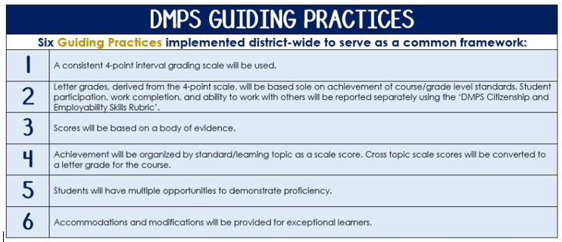
Standards-Referenced Grading Basics
The teacher designs instructional activities and assessments that grow and measure a student’s skills in the elements identified on our topic scales. Each scale features many such skills and knowledges, also called learning targets. These are noted on the scale below with letters (A, B, C) and occur at Levels 2 and 3 of the scale. In the grade book, a specific learning activity could be marked as being 3A, meaning that the task measured the A item at Level 3.

The Body of Evidence in a Process-Based Course
Process-Based SRG is defined as an SRG course design where the same scale recurs throughout the course, but the level of complexity of text and intricacy of task increase over time.

AP Calculus A/B cycles students through three basic topics repeatedly as they progress through the course, with changing content and an increasing complexity of the problems and mathematical expectations throughout.

To account for this, process-based courses like this have their evidence considered in a “Sliding Window” approach. When determining the topic score for any given grading topic, the most recent evidence determines the topic score. Teacher discretion remains a vital part of this determination, but it is hard to overlook evidence from the most recent (and therefore rigorous) assessments.

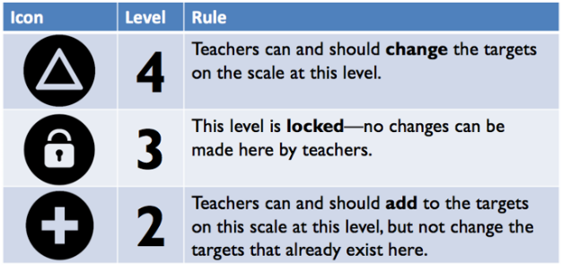
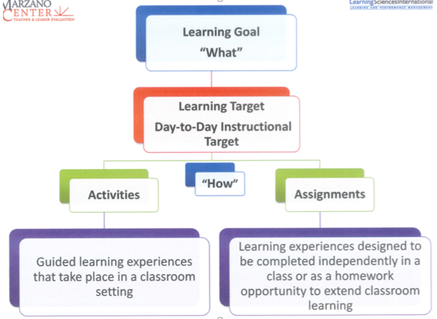
Semester 1 Topics | College Board Curriculum Framework Alignment | Semester 2 Topics | College Board Curriculum Framework Alignment
Limits | LO1.1A(a): Express limits symbolically using correct notation.  LO1.1A(b): Interpret limits expressed symbolically.  LO1.1B: Estimate limits of functions.  LO1.1C: Determine limits of functions.  LO1.1D: Deduce and interpret behavior of functions using limits.  LO1.2A: Analyze functions for intervals of continuity or points of discontinuity. | Integrals | LO3.1A: Recognize antiderivatives of basic functions.  LO3.2A(a): Interpret the definite integral as the limit of a Riemann sum.  LO3.2A(b): Express the limit of a Riemann sum in integral notation.  LO3.2B: Approximate a definite integral.  LO3.2C: Calculate a definite integral using areas and properties of definite integrals.  LO3.3A: Analyze functions defined by an integral.  LO3.3B(a): Calculate antiderivatives.  LO3.3B(b): Evaluate definite integrals.
Derivatives | LO2.1A: Identify the derivative of a function as the limit of a difference quotient.  LO2.1B: Estimate derivatives.  LO2.1C: Calculate derivatives.  LO2.1D: Determine higher order derivatives.  LO2.2B: Recognize the connection between differentiability and continuity.  LO2.3A: Interpret the meaning of a derivative within a problem.  LO2.3B: Solve problems involving the slope of a tangent line. | Applications of Integrals | LO3.4A: Interpret the meaning of a definite integral within a problem.  LO3.4B: Apply definite integrals to problems involving the average value of a function.  LO3.4C: Apply definite integrals to problems involving motion.  LO3.4D: Apply definite integrals to problems involving area and volume.  LO3.4E: Use the definite integral to solve problems in various contexts.
Application of Derivatives | LO1.2B: Determine the applicability of important calculus theorems using continuity.  LO2.1C: Calculate derivatives.  LO2.1D: Determine higher order derivatives.  LO2.2A: Use derivatives to analyze properties of a function.  LO2.3A: Interpret the meaning of a derivative.  LO2.3C: Solve problems involving related rates, optimization, and rectilinear motion.  LO2.3D: Solve problems involving rates of change.  LO2.4A: Apply the Mean Value Theorem to describe the behavior of a function over an interval. | Differentials | LO2.3E: Verify solutions to differential equations.  LO2.3F: Estimate solutions to differential equations.  LO3.5A: Analyze differential equations to obtain general and specific solutions.  LO3.5B: Interpret, create, and solve differential equations from problems in context.

Semester  1 and 2 Topics  *ungraded | College Board Curriculum Framework Alignment
Computational Proficiency  (not graded) | MPAC3.a: Select appropriate mathematical strategies  MPAC3.b: Sequence procedures logically  MPAC3.c: Compute processes correctly  MPAC3.d: Apply technology strategically  MPAC3.e: Attend to precision  MPAC3.f: Connect results of the process to the question
Reasoning  (not graded) | MPAC1.a: Use definitions and theorems to build arguments, justify conclusions, and prove results  MPAC1.b: Confirms hypotheses of theorem has been satisfied to apply a theorem  MPAC1.c: Apply definitions and theorems while solving a problem  MPAC1.d: Develop conjectures based on exploration  MPAC1.e: Interpret quantifiers in definitions and theorems  MPAC1.f: Produce examples and counterexamples
Communicating  (not graded) | MPAC6.a: Clearly present methods, reasoning, justification, conclusions  MPAC6.b: Use accurate and precise language and notation  MPAC6.c: Explain the meaning of expression, notation, etc.  MPAC6.d: Explain connections among concepts  MPAC6.e: Critically interpret and accurately report information  MPAC6.f: Analyze, evaluate, and compare the reasoning of others

AP Calculus A/B Scales – Semester 1

Resources and Examples

 | Topic: Limits
4 | In addition to meeting the level 3, the student makes in-depth inferences and applications that go beyond the learning goal.
3 | The student demonstrates the ability to:  3A Determine limits of functions. (LO 1.1C)  3B Analyze functions for intervals of continuity or points of discontinuity. (LO 1.2A)
2 | The student demonstrates the ability to:  2A1 Express limits symbolically using correct notation. (LO 1.1A(a))  2A2 Interpret limits expressed symbolically. (LO 1.1A(b))  2A3 Estimate limits of functions. (LO 1.1B)  2B1 Deduce and interpret behavior of functions using limits. (LO 1.1D)

 | Topic: Derivatives
4 | In addition to meeting the level 3, the student makes in-depth inferences and applications that go beyond the learning goal.
3 | The student demonstrates the ability to:  3A Calculate derivatives. (LO 2.1C)  3B Interpret the meaning of a derivative within a problem. (LO 2.3A)
2 | The student demonstrates the ability to:  2A1 Identify the derivative of a function as the limit of a difference quotient. (LO 2.1A)  2A2 Estimate derivatives. (LO 2.1B)  2A3 Recognize the connection between differentiability and continuity. (LO 2.2B)  2B1 Solve problems involving the slope of a tangent line. (LO 2.3B)
Resources and Examples

Resources and Examples

 | Topic: Application of Derivatives
4 | In addition to meeting the level 3, the student makes in-depth inferences and applications that go beyond the learning goal.
3 | The student demonstrates the ability to:  3A Use derivatives to analyze properties of a function. (LO 2.2A)  3B Solve problems in involving related rates, optimization, and rectilinear motion. (LO 2.3C)
2 | The student demonstrates the ability to:  2A1 Calculate derivatives. (LO 2.1C)  2B1 Interpret the meaning of a derivative within a problem. (LO 2.3A)  2B2 Solve problems involving rates of change in applied contexts. (LO 2.3D)

AP Calculus Scales – Semester 2
Resources and Examples

 | Topic: Integrals
4 | In addition to meeting the level 3, the student makes in-depth inferences and applications that go beyond the learning goal.
3 | The student demonstrates the ability to:  3A Calculate antiderivatives and evaluate definite integrals. (LO 3.3B)  3B Analyze functions defined by an integral. (LO 3.3A)  3C Interpret the meaning of a definite integral within a problem. (LO 3.4A)  3D Interpret the definite integral as the limit of a Riemann Sum. (LO 3.2A (a))
2 | The student demonstrates the ability to:  2A1 Recognize antiderivatives of basic functions. (LO 3.1A)  2A2 Calculate a definite integral using areas and properties of definite integrals. (LO 3.2C)  2B?  2C1 Apply definite integral to problems involving the average value of a function. (LO 3.4B)  2C2 Apply definite integrals to problems involving motion. (LO 3.4C)  2D1 Express the limit of a Riemann sum in integral notation. (LO 3.2A (b))  2D2 Approximate a definite integral. (LO 3.2B)
Resources and Examples

 | Topic: Application of Integrals
4 | In addition to meeting the level 3, the student makes in-depth inferences and applications that go beyond the learning goal.
3 | The student demonstrates the ability to:  3A Use the definite integral to solve problems in various contexts. (LO 3.4E)
2 | The student demonstrates the ability to:  2A1 Calculate antiderivatives and evaluate definite integrals. (LO 3.3B)  2A2 Apply definite integrals to problems involving area, and volume. (LO 3.4D)  2A3 Apply definite integrals to problems involving motion. (LO 3.4C)

 | Topic: Differentials
4 | In addition to meeting the level 3, the student makes in-depth inferences and applications that go beyond the learning goal.
3 | The student demonstrates the ability to:  3A Analyze differential equations to obtain general and specific solutions. (LO 3.5A)  3B Interpret, create, and solve differential equations from problems in context. (LO 3.5B)
2 | The student demonstrates the ability to:  2A  2B
Resources and Examples

 | Topic: Computational Proficiency
4 | In addition to meeting the level 3, the student makes in-depth inferences and applications that go beyond the learning goal.
3 | The student demonstrates the ability to:  Complete all algebraic/computational processes correctly.
2 | The student demonstrates the ability to:  Complete some algebraic/computational processes correctly.  - Select the appropriate mathematical strategies (MPAC3.a)  - Sequence procedures logically (MPAC3.b)  - Apply technology strategically (MPAC3.d)  - Attend to precision (MPAC3.e)  - Connect results of the process to the question (MPAC3.f)  - Know and use a variety of notations (MPAC5.a)
Resources and Examples

 | Topic: Reasoning
4 | In addition to meeting the level 3, the student makes in-depth inferences and applications that go beyond the learning goal.
3 | The student demonstrates the ability to:  Complete all reasoning processes correctly.
2 | The student demonstrates the ability to:  Complete some reasoning processes correctly.  - Use definitions and theorems to build arguments, justify conclusions, and prove results (MPAC1.a)  - Confirms hypotheses of theorem has been satisfied to apply a theorem (MPAC1.b)  - Apply definitions and theorems while solving a problem (MPAC1.c)  - Develop conjectures based on exploration (MPAC1.d)  - Produce examples and counterexamples (MPAC1.f)

Resources and Examples

 | Topic: Communicating
4 | In addition to meeting the level 3, the student makes in-depth inferences and applications that go beyond the learning goal.
3 | The student demonstrates the ability to:  Complete all communicating processes correctly
2 | The student demonstrates the ability to:  Complete some communicating processes correctly  - Clearly present methods, reasoning, justification, conclusions (MPAC6.a)  - Use accurate and precise language and notation (MPAC6.b)  - Explain the meaning of expression, notation, etc. (MPAC6.c)  - Explain connections among concepts (MPAC6.d)  - Critically interpret and accurately report information (MPAC6.e)  - Analyze, evaluate, and compare the reasoning of others (MPAC6.f)
Resources and Examples

