AP US Government & Politics: Des Moines Public Schools
2019-20 CURRICULUM GUIDE SOC 507/508

AP US Government & Politics
AP United States Government and Politics introduces students to key political ideas, institutions, policies, interactions, roles, and behaviors that characterize the political culture of the United States. The course examines politically significant concepts and themes, through which students learn to apply disciplinary reasoning assess causes and consequences of political events, and interpret data to develop evidence-based arguments. Social Studies Weebly: socialstudies.dmschools.org DMPS Grading Resources: grading.dmschools.org

AP US Government and Politics Course Goals:
- Describe and compare important facts, concepts, and theories pertaining to U.S. government and politics.
- Explain typical patterns of political processes and behavior and their consequences (including the components of political behavior, the principles used to explain or justify various government structures and procedures, and the political effects of these structures and procedures).
- Nine foundational documents and fifteen landmark Supreme Court cases
- Interpret basic data relevant to U.S. government and politics (including data presented in charts, tables, and other formats).
- Critically analyze relevant theories and concepts, apply them appropriately, and develop their connections across the curriculum.

Topic Outline for AP US Government and Politics:
• Constitutionalism (CON)
• Liberty and Order (LOR)
• Civic Participation in a Representative Democracy (PRD)
• Competing Policy-Making Interests (PMI)
• Methods of Political Analysis (MPA)

AP US Government and Politics Exam
The AP United States Government and Politics Exam asks students to explain and apply key and supporting concepts. The exam measures students’ understanding of American political culture and the interactions of governing and linkage institutions. Questions are based on the six major topics in the course, and students must be able to define, compare, explain, and interpret political concepts, policies, processes, perspectives, and behaviors that characterize the U.S. political system.
Format of Assessment Section I: Multiple Choice | 55 Questions | 80 Minutes | 50% of Exam Score
• Demonstrate understanding of major course concepts, policies and institutions • Apply skills of comparison and interpretation
Section II: Constructed Response | 4 Questions | 100 Minutes | 50% of Exam Score
• Define concepts and explain or interpret content across all course topics
• There are four specific types of free response questions: content application, SCOTUS comparison, data analysis, and argument
Link to Course Information @ AP Central: http://apcentral.collegeboard.com/apc/public/courses/teachers_corner/2259.html
Grading Topics  Semester 1 | College Board Curriculum Framework Alignment | Grading Topics  Semester 2 | College Board Curriculum Framework Alignment
Constitutional Underpinnings | Constitutionalism (CON)  Liberty and Order (LOR) | Legislative Branch | Constitutionalism (CON)  Competing Policy-Making Interests (PMI)  Methods of Political Analysis (MPA)
Federalism | Constitutionalism (CON)  Liberty and Order (LOR) | Executive Branch & Bureaucracy | Constitutionalism (CON)  Competing Policy-Making Interests (PMI)  Methods of Political Analysis (MPA)
Political Culture & Beliefs | Methods of Political Analysis (MPA) | Judicial Branch | Constitutionalism (CON)  Competing Policy-Making Interests (PMI)  Methods of Political Analysis (MPA)
Linkage Institutions | Competing Policy-Making Interests (PMI) | Civil Liberties &  Civil Rights | Liberty and Order (LOR)
Electoral Process | Civic Participation in a Representative Democracy (PRD)  Competing Policy-Making Interests (PMI)
Writing for AP S1 | College Board’s AP US Government and Politics Disciplinary Practices | Writing for AP S2 | College Board’s AP US Government and Politics Disciplinary Practices
Civic Practices | CCSS.ELA-LITERACY.WHST.11-12.7  Conduct short as well as more sustained research projects to answer a question or solve a problem.  CCSS.ELA-LITERACY.SL.11-12.1  Initiate and participate effectively in a range of collaborative discussions.  CCSS.ELA-LITERACY.SL.11-12.4  Present information, findings, and supporting evidence, etc. | Civic Practices | CCSS.ELA-LITERACY.WHST.11-12.7  Conduct short as well as more sustained research projects to answer a question or solve a problem.  CCSS.ELA-LITERACY.SL.11-12.1  Initiate and participate effectively in a range of collaborative discussions.  CCSS.ELA-LITERACY.SL.11-12.4  Present information, findings, and supporting evidence, etc.

Standards-Referenced Grading Basics
The teacher designs instructional activities and assessments that grow and measure a student’s skills in the elements identified on our topic scales. Each scale features many such skills and knowledges, also called learning targets. These are noted on the scale below with letters (A, B, C) and occur at Levels 2 and 3 of the scale. In the grade book, a specific learning activity could be marked as being 3A, meaning that the task measured the A item at Level 3.
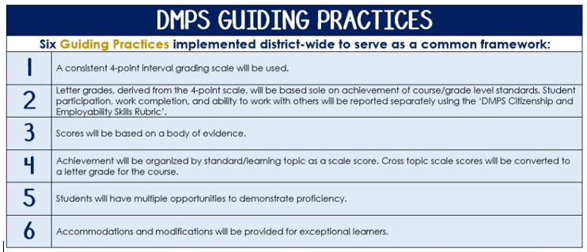
The Body of Evidence in a Process-Based Course
Process-Based SRG is defined as an SRG course design where the same scale recurs throughout the course, but the level of complexity of text and intricacy of task increase over time.

AP US Government & Politics cycles students through the some topics repeatedly as they progress through the course, with changing content and an increasing complexity of the text, analysis, and expectations throughout.

To account for this, process-based courses like this have their evidence considered in a “Sliding Window” approach. When determining the topic score for any given grading topic, the more recent evidence determines the topic score. Teacher discretion remains a vital part of this determination, but it is hard to overlook evidence from the most recent (and therefore rigorous) assessments.

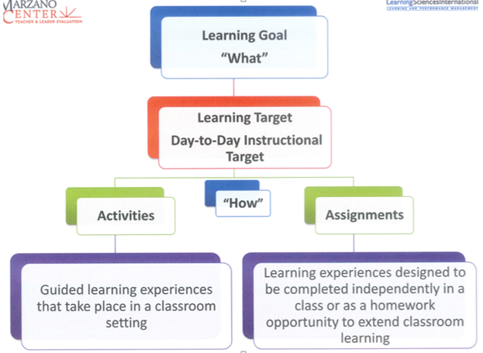
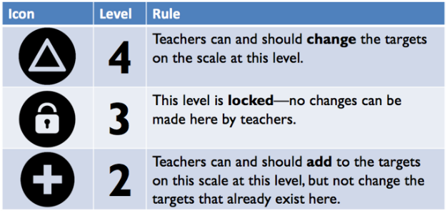

Constitutional Underpinnings
Text and Resources
KIA Project Cycle: Founders’ Intent

Textbook Chapters: Lineberry Government in America
- Chapter 1: Introducing Government in America
- Chapter 2: The Constitution
Landmark Cases: McCulloch v. Maryland, 1819

Foundational Texts: Declaration of Independence, Articles of Confederation, Constitution, Federalist No. 10, Brutus 1, Federalist No. 51

 | 4 | 3
Constitutional Underpinnings | In addition to meeting the learning goal, the student demonstrates in-depth inferences and applications that go beyond the goal. | 3A: Evaluate models of representative democracy.  - Differentiate between the models of representative democracy.  3B: Explain how democratic ideals are reflected in U.S. foundational documents.  - Describe each of the democratic ideals.  - Explain how the “Madisonian model” (checks and balances) limits government.  - Trace the origins of democratic ideals and the founding documents.  3C: Trace the development of debates surrounding the creation of a new government.  - Explain the issues that showed the weaknesses of the Articles of the Confederation.  - Describe the compromises reached when creating the Constitution.  - Evaluate the views of the Federalists regarding the ratification of the Constitution.  - Evaluate the views of the Anti-Federalists regarding the ratification of the Constitution.

Federalism
Text and Resources
KIA Project Cycle: Founders’ Intent

Textbook Chapters: Lineberry Government in America
- Chapter 3: Federalism
Landmark Cases: United States v. Lopez, 1995

Topic | 4 | 3
Federalism | In addition to meeting the learning goal, the student demonstrates in-depth inferences and applications that go beyond the goal. | 3A: Describe how the Constitution allocates power between the national and state governments.  - Differentiate between expressed, concurrent, and reserved powers.  - Classify what powers belong to different levels of government.  3B: Evaluate America’s current federal system.  - Describe different forms of federalism and identify when they were used.  - Assess the proper role of the federal government with regard to a current issue.

Political Culture & Beliefs
Text and Resources
KIA Project Cycle: Elections

Textbook Chapters: Lineberry Government in America
- Chapter 6: Public Opinion and Political Action

Topic | 4 | 3
Political Culture & Beliefs | In addition to meeting the learning goal, the student demonstrates in-depth inferences and applications that go beyond the goal. | 3A: Explain how various factors influence political socialization and attitudes.  - Describe the cultural factors of political socialization.  - Describe generational and lifecycle effects and how they contribute to political socialization.  3B: Contrast how political ideologies vary on the role of government in economic and social issues.  - Describe the beliefs of different political ideologies economic issues.  - Describe the beliefs of different political ideologies social issues.  3C: Evaluate the credibility of a public opinion poll and how it influences elections or political behavior.  - Describe how types of polls influence elections or political behavior differently.  - Describe the elements of a scientific poll that make it credible.  - Explain how a poll influences elections or political behavior.

Linkage Institutions
Text and Resources
KIA Project Cycle: Elections

Textbook Chapters: Lineberry Government in America
- Chapter 7: Mass Media
- Chapter 8: Political Parties
- Chapter 11: Interest Groups

Topic | 4 | 3
Linkage Institutions | In addition to meeting the learning goal, the student demonstrates in-depth inferences and applications that go beyond the goal. | 3A: Explain how different forms of media influence political behaviors.  - Describe the media’s roles as a watchdog and gatekeeper.  - Explaim how diverse forms of media (broadcasting and narrowcasting) influence political behavior.  3B: Compare and contrast the goals and functions of political parties and interest groups.  - Describe the role of interest groups as a linkage institution.  - Describe the role and structure of political parties as a linkage institution.  - Explain how the goals of an interest group influences its functions.  - Explain how the goals of a political party influences its functions.

Electoral Process
Text and Resources
KIA Project Cycle: Elections

Textbook Chapters: Lineberry Government in America
- Chapter 9: Nominations and Campaign
- Chapter 10: Elections and Voting Behavior
Landmark Cases: Citizens United v. Federal Election Commission, 2010

Topic | 4 | 3
Electoral Process | In addition to meeting the learning goal, the student demonstrates in-depth inferences and applications that go beyond the goal. | 3A: Evaluate different electoral processes.  - Describe each of the various means of selecting candidates (caucus, open primary, closed primary, nomination, general election).  - Explain how different electoral processes produce different electoral outcomes (i.e. turnout rates, participants).  3B: Evaluate campaign finance laws.  - Trace the origins of current campaign finance laws.  3C: Evaluate the extent to which the Electoral College helps or hurts democracy.  - Describe the constitutional foundation of the Electoral College.  - Explain how the Electoral College functions.

z

Legislative Branch
Text and Resources
KIA Project Cycle: Congress

Textbook Chapters: Lineberry Government in America
- Chapter 12: Congress
- Chapters 17-20: Economic, Social Welfare, Healthcare, Environment, and National Security
Landmark Cases: Baker v. Carr, 1961; Shaw v. Reno, 1993

Topic | 4 | 3
Legislative Branch | In addition to meeting the learning goal, the student demonstrates in-depth inferences and applications that go beyond the goal. | 3A: Contrast how the structure, powers, and functions of both house of Congress affect the policy-making process.  - Contrast the structure of the House and Senate (constituencies, term lengths, and leadership).  - Compare and contrast the powers of the House and Senate (revenue bills; advice and consent).  - Contrast the functions of the House and Senate (committee process, rules for debate).  3B: Explain how Congress uses its oversight power to check the President and bureaucracy.  - Define oversight power.  - Describe oversight powers that Congress uses to check the President and bureaucracy (committee hearings; power of the purse; advice and consent).

Executive Branch & Bureaucracy
Text and Resources
Mini-Cycle – Presidency

Textbook Chapters: Lineberry Government in America
- Chapter 13: Presidency
- Chapter 15: Federal Bureaucracy
Foundational Texts: Federalist No. 70

3A: CON-4.A, CON-4.C, and CON-4.D
3B: CON-4.B

Topic | 4 | 3
Executive Branch & Bureaucracy | In addition to meeting the learning goal, the student demonstrates in-depth inferences and applications that go beyond the goal. | 3A: Evaluate the power of the presidency.  - Describe the formal and informal powers of presidency.  - Explain how presidents have interpreted and justified their use of formal and informal (bully pulpit, executive orders, executive agreements, executive privilege) powers.  3B: Explain the relationship between the executive branch and legislative branch within the context of policymaking.  - Describe how Congress and the President use their powers to check each other.  - Describe the role of the bureaucracy in the policymaking process.  - Explain how the president’s agenda can create confrontation with Congress.  - Explain how the executive branch responds to congressional oversight.

Judicial Branch
Text and Resources
KIA Project Cycle: SCOTUS

Textbook Chapters: Lineberry Government in America
- Chapter 16: Federal Courts
Landmark Cases: Marbury v. Madison, 1803

Foundational Texts: Federalist No. 78

3A: CON-5.A, CON-5.C
3B: CON-5.B

Topic | 4 | 3
Judicial Branch | In addition to meeting the learning goal, the student demonstrates in-depth inferences and applications that go beyond the goal. | 3A: Assess the role of the judicial branch in the constitutional system of checks and balances.  - Describe the powers of judicial branch as set forth in the Constitution and Marbury v. Madison.  - Describe checks placed on the Supreme Court by the legislative branch, executive branch, and the judicial appointment process.  - Evaluate judicial activism and judicial restraint as it relates to the court’s legitimacy.

Civil Liberties & Civil Rights
Text and Resources
KIA Project Cycle: SCOTUS

Textbook Chapters: Lineberry Government in America
- Chapter 4: Civil Liberties
- Chapter 5: Civil Rights
Landmark Cases:
- Schenck v. U.S., 1919 Engle v. Vitale, 1962 Tinker v. Des Moines, 1969 New York Times v. U.S., 1971 Wisconsin v. Yoder, 1972
- Gideon v. Wainwright, 1963 Roe v. Wade, 1973 McDonald v. Chicago, 2010
- Brown v. Board of Education, 1954
Foundational Texts: Letter from a Birmingham Jail

Topic | 4 | 3
Civil Liberties & Civil Rights | In addition to meeting the learning goal, the student demonstrates in-depth inferences and applications that go beyond the goal. | 3A: Evaluate the judicial decision-making used in a current Supreme Court case.  - Categorize the liberties protected by the Bill of Rights.  - Trace the changes in the Supreme Court’s interpretation of a given liberty over time (religion, speech, press, rights of the accused).  - Make and defend a claim about how the judicial ideology influenced the Court’s decision.  3B: Explain how the interpretation of the 14th amendment has expanded the role of the federal government in relation to the states.  - Describe the parts of the 14th amendment.  - Trace the development of how the Bill of Rights has been applied to the states.  - Explain the implications of the doctrine of selective incorporation.  - Describe the social movements that have been inspired by the 14th amendment’s equal protection clause.

Writing for AP
Text and Resources

Topic | 4 | 3
Writing for AP  Semester 1 | In addition to meeting the learning goal, the student demonstrates in-depth inferences and applications that go beyond the goal.  4 - Addresses all parts of the prompt, and scores all available points.  or  4- Develops the writing with relevant facts, evidence and accurate examples that are appropriate to the topic; uses extended definitions and/or examples. | 3A – Analyze quantitative data.  - Identify a trend or pattern.  - Draw a conclusion for the visual representation.  - Explain how it relates to a political principle, institution, or process.  3B – Develop an argument.  - State a claim.  - Defend the claim with evidence from one foundational document.  - Defend the claim with evidence from another foundational document.  - Connect the evidence to the claim, using reasoning.  - Include a rebuttal, or counterclaim.

Topic | 4 | 3
Writing for AP  Semester 2 | In addition to meeting the learning goal, the student demonstrates in-depth inferences and applications that go beyond the goal.  4 - Addresses all parts of the prompt, and scores all available points.  or  4- Develops the writing with relevant facts, evidence and accurate examples that are appropriate to the topic; uses extended definitions and/or examples. | 3A – Form conclusions about a political concept.  - Identify the political concept.  - Describe the political concept.  - Explain how the political concept relates to another political principle, institution, or process.  3B – Compare two Supreme Court cases.  - Identify the constitutional issue.  - Describe the facts, reasoning, decision, and opinion(s) of the precedent Supreme Court case.  - Explain how the cases are similarly or differently resolved.  - Apply a judicial concept or principle.

Civic Practices
Text and Resources
3A: CCSS.ELA-LITERACY.WHST.11-12.7
3B: CCSS.ELA-LITERACY.SL.11-12.1
3C: CCSS.ELA-LITERACY.SL.11-12.4

Topic | 4 | 3
Civic Practices | In addition to meeting the learning goal, the student demonstrates in-depth inferences and applications that go beyond the goal. | 3A – Research specific concepts to answer a question or solve a problem.  - Investigate multiple, credible sources.  - Use sources to answer a question or solve a problem.  3B - Engage effectively in a range of collaborative discussions (1:1, small group, structured debates, etc.).  - Prepare materials for a discussion.  - Participate actively in group and team learning experiences.  3C - Present information in a coherent way.  - Present claims with logical, sequential, or reasonable organization.  - Support claims with evidence and reasoning.  - Present using speech appropriate to purpose, audience, and task.

SRG Scale Score | Topic:  AP-Style Assessments | AP Exam  Score Conversion
4 | In addition to meeting the learning goal, the student demonstrates in-depth inferences and applications that go beyond the goal. | 90-100%
3.5 | Student’s performance reflects exceptional facility with some, but not all Level 4 learning targets. | 80-89%
3 | Student’s performance reflects success on all Level 3 learning targets. | 70-79%
2.5 | Student’s performance reflects success on some, but not all, Level 3 learning targets | 60-69%
2 | Student’s performance reflects success on all Level 2 learning targets. | 50-59%
1.5 | Student’s performance reflects success on some but not all Level 2 learning targets | 40-49%
1 | Student’s performance reflects insufficient progress towards foundational skills and knowledge. | 20-39%

