AP Psychology: Des Moines Public Schools
2019-20 CURRICULUM GUIDE SOC 513/514

AP Psychology
The AP Psychology course is equivalent to an introductory college-level course in psychology. This year-long course covers in depth all topics in introductory psychology. The course is designed to introduce students to the systematic and scientific study of human behavior and mental processes. While considering the psychologists and studies that have shaped the field, students explore and apply psychological theories, key concepts, and phenomena associated with such topics as the biological bases of behavior, sensation and perception, learning and cognition, motivation, developmental psychology, testing and individual differences, treatment of abnormal behavior, and social psychology. Throughout the course, students use research methods as they analyze bias, evaluate claims and evidence, and effectively communicate ideas.

Topic Outline for AP Psychology - The AP Psychology course is organized around major topics:
• Scientific Foundations of Psychology
• Biological Bases of Behavior
• Sensation and Perception
• Learning
• Cognitive Psychology
• Developmental Psychology
• Motivation, Emotion, and Personality
• Clinical Psychology
• Social Psychology

AP Psychology Exam
The AP Psychology Exam measures students’ knowledge of the major topics and fields of study in psychology and tests their ability to define, compare, and apply concepts and research findings. Questions are based on key terminology, scientific methodology, and theories associated with each subfield.
Format of Assessment
Section I: Multiple Choice | 100 Questions | 70 Minutes |66.6% of Exam Score
• Define and explain content from a range of course topics • Apply skills of comparison and interpretation to course concepts and theories.
Section II: Constructed Response | 2 Questions | 50 Minutes | 33.3% of Exam Score
• Analyze a unique scenario using concepts from different frameworks or sub-domains in the field • Design, analyze, or critique a study

Link to Course Information @ AP Central: http://apcentral.collegeboard.com/apc/public/courses/teachers_corner/2265.html?excmpid=MTG243-PR-13-cd
Grading Topics  Semester 1 | College Board Curriculum Framework Alignment | Grading Topics  Semester 2 | College Board Curriculum Framework Alignment
Scientific Foundations of Psychology | 9-12.BS.1 Understand the historical development of the behavioral sciences and the changing nature of society.  9-12.BS.3 Understand the appropriate research procedures and skills of the behavioral scientist. | Cognitive Psychology | 9-12.BS.6 Understand the process of how humans develop, learn, adapt to their environment, and internalize their culture.  9-12.BS.3 Understand the appropriate research procedures and skills of the behavioral scientist.
Biological Bases of Behavior | 9-12.BS.2 Understand the influences on individual and group behavior and group decision making.  9-12.BS.6 Understand the process of how humans develop, learn, adapt to their environment, and internalize their culture. | Developmental Psychology | 9-12.BS.6 Understand the process of how humans develop, learn, adapt to their environment, and internalize their culture.
Sensation and Perception | 9-12.BS.6 Understand the process of how humans develop, learn, adapt to their environment, and internalize their culture. | Motivation, Emotion, and Personality | 9-12.BS.2 Understand the influences on individual and group behavior and group decision making.  9-12.BS.7 Understand how personality and agents of socialization impact the individual.
Learning | 9-12.BS.6 Understand the process of how humans develop, learn, adapt to their environment, and internalize their culture. | Clinical Psychology | 9-12.BS.2 Understand the influences on individual and group behavior and group decision making.  9-12.BS.3 Understand the appropriate research procedures and skills of the behavioral scientist.
Social Psychology | 9-12.BS.5 Understand how social status, social groups, social change, and social institutions influence individual and group behaviors.
Writing Informative Text | Write informative/explanatory texts to examine and convey complex ideas, concepts, and information clearly and accurately through the effective selection, organization, and analysis of content. | Writing Informative Text | Write informative/explanatory texts to examine and convey complex ideas, concepts, and information clearly and accurately through the effective selection, organization, and analysis of content.
Research Practices | Use research skills to analyze psychological studies, analyze and interpret quantitative data, and present in a coherent manner. | Research Practices | Use research skills to analyze psychological studies, analyze and interpret quantitative data, and present in a coherent manner.

Standards-Referenced Grading Basics
The teacher designs instructional activities and assessments that grow and measure a student’s skills in the elements identified on our topic scales. Each scale features many such skills and knowledges, also called learning targets. These are noted on the scale below with letters (A, B, C) and occur at Levels 2 and 3 of the scale. In the grade book, a specific learning activity could be marked as being 3A, meaning that the task measured the A item at Level 3.
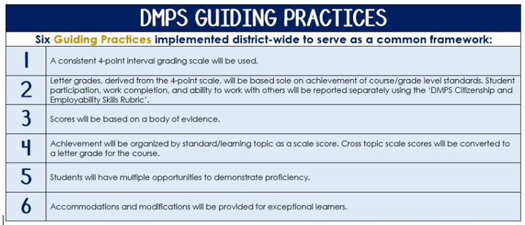
The Body of Evidence in a Process-Based Course
Process-Based SRG is defined as an SRG course design where the same scale recurs throughout the course, but the level of complexity of text and intricacy of task increase over time.

AP Psychology cycles students through the some topics repeatedly as they progress through the course, with changing content and an increasing complexity of the text, analysis, and expectations throughout.

To account for this, process-based courses like this have their evidence considered in a “Sliding Window” approach. When determining the topic score for any given grading topic, the more recent evidence determines the topic score. Teacher discretion remains a vital part of this determination, but it is hard to overlook evidence from the most recent (and therefore rigorous) assessments.

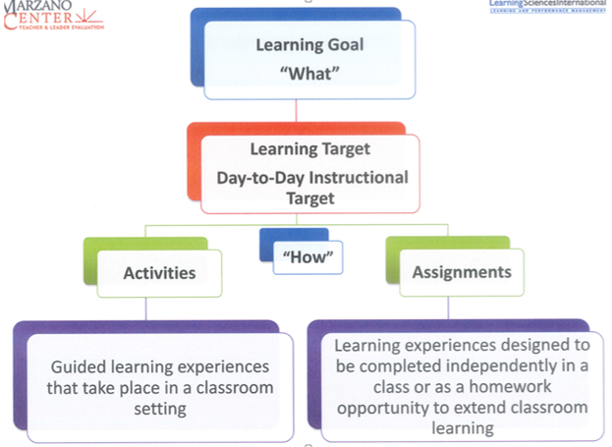
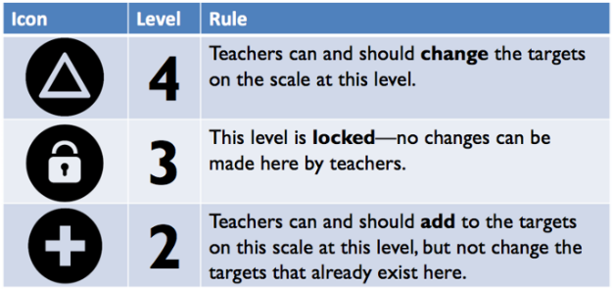

Scientific Foundations of Psychology
Text and Resources
Textbook Chapters: Myers’ Psychology for AP David G. Myers, 2010.
- Chapter 1: Psychology’s History & Approaches
- Chapter 2: Research Methods: Thinking Critically with Psychological Science
Key Contributors: Mary Whiton Calkins, Charles Darwin, Dorothea Dix, Sigmund Freud, G. Stanley Hall, William James, Ivan Pavlov, Jean Piaget, Carl Rogers, B.F. Skinner, Margaret Floy Washburn, John B. Watson, Wilhelm Wundt

Topic | 4 | 3
Scientific Foundations of Psychology  (10-14%) | In addition to meeting the learning goal, the student demonstrates in-depth inferences and applications that go beyond the goal. | 3A: Apply and compare different theoretical approaches in explaining behavior.  - Describe each theoretical approach.  - Recognize the strengths and limitations of each theory.  - Identify the different domains of psychology as they relate to the approaches.  3B: Differentiate types of research with regard to purpose, strengths, and weaknesses.  - Describe each type of research method.  - Discuss the importance of operational definitions in behavioral research.  3C: Evaluate how research design drives the reasonable conclusions that can be drawn.  - Identify independent, dependent, confounding, and control variables in experimental designs.  - Distinguish between random assignment and random selection of participants.  - Discuss prediction of validity based on the quality of research design.  - Describe the difference between correlation and causation.  - Identify how ethical guidelines inform and promote sound research practices.  3D: Apply basic descriptive statistical concepts.  - Interpret and construct graphs.  - Calculate simple descriptive statistics (measures of central tendency, variation, correlation coefficient, frequency distribution)  - Distinguish the purposes of descriptive and inferential statistics.

Biological Bases of Behavior
Text and Resources
Textbook Chapters: Myers’ Psychology for AP David G. Myers, 2010.
- Chapter 3A: Neural Processing and the Endocrine System
- Chapter 3B: The Brain
- Chapter 3C: Genetics, Evolutionary Psychology, and Behavior
- Chapter 5: States of Consciousness
Key Contributors: Charles Darwin, Paul Broca, Carl Wernicke, Roger Sperry, Michael Gazzaniga, William James, Sigmund Freud

Topic | 4 | 3
Biological Bases of Behavior  (8-10%) | In addition to meeting the learning goal, the student demonstrates in-depth inferences and applications that go beyond the goal. | 3A: Describe how the different subdivisions of the nervous system function and interact.  - Identify basic processes and systems in the biological bases of behavior, including parts of the neuron.  - Identify components of the central and peripheral nervous systems.  - Identify major brain regions, lobes, and cortical areas.  - Discuss the effects of the endocrine system on behavior.  - Explain how research tools and technologies help understand nervous system functions.  3B: Investigate the influence of drugs on neurotransmitters and behavior.  - Identify basic process of transmission of a signal between neurons.  - Describe the difference between agonists and antagonists.  - Explain how neurotransmitters affect biological behavior.  3C: Assess how various states of consciousness impact behavior.  - Explain aspects of sleep and dreaming.  - Discuss drug dependence, addiction, tolerance, and withdrawal.  - Identify the major psychoactive drug categories and their psychological and physiological effects.

Sensation and Perception
Text and Resources
Textbook Chapters: Myers’ Psychology for AP David G. Myers, 2010.
- Chapter 4: Sensation and Perception
Key Contributors: Gustav Fechner, David Hubel, Ernst Weber, Torsten Wiesel

Topic | 4 | 3
Sensation and Perception  (6-8%) | In addition to meeting the learning goal, the student demonstrates in-depth inferences and applications that go beyond the goal. | 3A: Evaluate how experience and culture can influence perceptual processes.  - Describe Gestalt principles, depth perception, top-down processing, and bottom-up processing.  - Describe perceptual set, context effects, and schemas.  - Discuss the role of attention in behavior.  3B: Explain basic principles of sensory transduction, including absolute threshold, difference threshold, signal detection, and sensory adaptation.  - Describe sensory processes for each of the senses.  - Identify the specific nature of energy transduction for each of the senses.  - Identify relevant anatomical structures.  - Identify specialized pathways in the brain for each of the senses.  - Explain common sensory conditions.

Learning
Text and Resources
Textbook Chapters: Myers’ Psychology for AP David G. Myers, 2010.
- Chapter 6: Learning
Key Contributors: Albert Bandura, Ivan Pavlov, Robert Rescorla, B.F. Skinner, Edward Thorndike, Edward Tolman, John B. Watson, John Garcia

Topic | 4 | 3
Learning  (7-9%) | In addition to meeting the learning goal, the student demonstrates in-depth inferences and applications that go beyond the goal. | 3A: Describe basic classical conditioning phenomena.  - Identify unconditioned stimulus, unconditioned response, neutral stimulus, conditioned stimulus, and conditioned response.  - Identify acquisition, generalization, discrimination, extinction, spontaneous recovery, and higher order learning.  - Identify how biological constraints create learning predispositions.  3B: Predict how practice, schedules of reinforcement, other aspects of reinforcement, and motivation will influence quality of learning.  - Describe components of operant conditioning.  - Describe schedules of reinforcement.

Social Psychology
Text and Resources
Textbook Chapters: Myers’ Psychology for AP David G. Myers, 2010.
- Chapter 14: Social Psychology
Key Contributors: Leon Festinger, Solomon Asch, Stanley Milgram, Philip Zimbardo

Topic | 4 | 3
Social Psychology  (8-10%) | In addition to meeting the learning goal, the student demonstrates in-depth inferences and applications that go beyond the goal. | 3A: Predict the impact of the presence of others on individual behavior.  - Describe group influences on behavior.  - Describe conformity, compliance, and obedience.  3B: Interpret motives, attitudes, and the behavior of self and others utilizing the contexts of personal and situational factors.  - Describe attribution theory.  - Identify attitude formation and change.  - Discuss central and peripheral routes of persuasion.  - Identify the effects of cognitive dissonance.  3C: Describe processes that contribute to the differential treatment of group members.  - Explain the variables that support prosocial or antisocial behavior (altruism, attraction, aggression).  - Identify the use of bias, prejudice, and discrimination.

Cognitive Psychology
Text and Resources
Textbook Chapters: Myers’ Psychology for AP David G. Myers, 2010.
- Chapter 7A: Memory
- Chapter 7B: Thinking, Problem Solving, Creativity, and Language
- Chapter 11: Testing and Individual Differences
Key Contributors: Noam Chomsky, Hermann Ebbinghaus, Wolfgang Kohler, Elizabeth Loftus, George A. Miller, Alfred Binet, Francis Galton, Howard Gardner, Charles Spearman, Robert Sternberg, Lewis Terman, David Wechsler

Topic | 4 | 3
Cognitive Psychology  (13-17%) | In addition to meeting the learning goal, the student demonstrates in-depth inferences and applications that go beyond the goal. | 3A: Compare and contrast various cognitive processes and how they relate to different psychological and physiological systems of memory.  - Describe different cognitive processes.  - Describe the different systems of memory.  - Outline the principles that underlie construction and encoding of, effective storage of, and retrieval strategies for memories.  - Describe strategies for memory improvement and typical memory errors as they relate to cognitive processes.  3B: Adapt problem-solving strategies to situations as well as evaluate the factors that influence their effectiveness.  - Describe the different types of heuristics.  - Describe divergent and convergent thinking.  - Describe cognitive factors.  - List the characteristics of creative thought and creative thinkers.  3C: Evaluate the theories of intelligence.  - Describe the theories of Charles Spearman, Howard Gardner, and Robert Sternberg.  - Define intelligence and list characteristics of how psychologists measure intelligence.  - Discuss how culture influences the definition of intelligence.  - Explain how psychologists design tests, including standardization strategies and other techniques to establish reliability and validity.  - Describe relevant labels related to intelligence testing.  3D: Investigate how biological, cognitive, and cultural factors converge to facilitate acquisition, development, and use of language.  - Identify stages of language development.  - Describe theories of language development.  - Discuss the importance of critical periods.

Developmental Psychology
Text and Resources
Textbook Chapters: Myers’ Psychology for AP David G. Myers, 2010.
- Chapter 9: Developmental Psychology
Key Contributors: Albert Bandura, Diana Baumrind, Konrad Lorenz, Harry Harlow, Mary Ainsworth, Sigmund Freud, Lev Vygotsky, Jean Piaget, Erik Erikson, Carol Gilligan, Lawrence Kohlberg

Topic | 4 | 3
Developmental Psychology  (7-9%) | In addition to meeting the learning goal, the student demonstrates in-depth inferences and applications that go beyond the goal. | 3A: Predict the physical and cognitive changes that emerge throughout the lifespan.  - Describe maturation from prenatal development through adulthood.  - Describe Piaget’s stages of cognitive development.  3B: Critique theories of social and moral development within and across cultures.  - Describe the relationship between temperament and attachment.  - Discuss the effects of parenting styles on children’s socialization.  - Explain Erikson’s theory of psychosocial development.  - Compare Kohlberg and Gilligan’s competing theories of moral development.  - Describe the influence of sex and gender on development.

Motivation, Emotion, and Personality
Text and Resources
Textbook Chapters: Myers’ Psychology for AP David G. Myers, 2010.
- Chapter 8A: Motivation
- Chapter 8B: Emotion, Stress, and Health
- Chapter 10: Personality
Key Contributors: William James, Alfred Kinsey, Abraham Maslow, Stanley Schachter, Hans Selye, Alfred Adler, Albert Bandura, Paul Costa, Robert McCrae, Sigmund Freud, Carl Jung, Abraham Maslow, Carl Rogers

Topic | 4 | 3
Motivation, Emotion, and Personality  (11-15%) | In addition to meeting the learning goal, the student demonstrates in-depth inferences and applications that go beyond the goal. | 3A: Compare and contrast theories of motivation.  - Identify and apply basic motivational concepts to understand the behavior of humans and other animals.  - Describe the different theories of motivation.  - Discuss the biological underpinnings of motivation, including needs, drives, and homeostasis.  - Explain how motivation theories relate to hunger, sex, and achievement.  3B: Differentiate between major theories of emotion.  - Describe the different theories of emotion.  - Discuss cultural influences on emotion (display rules, facial feedback).  - Explain the effects of stress on emotion.  3C: Evaluate theories of personality based on reliability and validity of psychometric assessments.  - Define reliability and validity.  - Describe various psychometric design for personality measurement (projective, self-report, objective, etc.)  - Explain the various theories of personality.

Clinical Psychology
Text and Resources
Textbook Chapters: Myers’ Psychology for AP David G. Myers, 2010.
- Chapter 12: Abnormal Psychology (note: DSM is out of date in this textbook)
- Chapter 13: Treatment of Psychological Disorders
Key Contributors: David Rosenhan, Aaron Beck, Albert Ellis, Sigmund Freud, Mary Cover Jones, Carl Rogers, B.F. Skinner, Joseph Wolpe

Topic | 4 | 3
Clinical Psychology  (12-16%) | In addition to meeting the learning goal, the student demonstrates in-depth inferences and applications that go beyond the goal. | 3A: Justify clinical diagnoses of mental disorders based on symptoms of major diagnostic categories.  - Identify symptoms of psychological disorders from various diagnostic categories within the most recent version of the Diagnostic and Statistical Manual of Mental Disorders.  - Identify the positive and negative consequences of diagnostic labels.  3B: Evaluate strengths, weaknesses, and empirical support for treatments of disorders.  - Summarize effectiveness of specific treatments used to address specific problems.  - Compare and contrast different treatment methods.  - Discuss how cultural and ethnic context influence choice and success of treatment.  3C: Decide which psychological perspectives best explain the origins and causes of psychological disorders.  - Identify the different approaches to explaining behavior.  - Describe contemporary and historical conceptions of what constitutes psychological disorders.

Writing Informative Text
Text and Resources

Topic | 4 | 3
Writing Informative Text | In addition to meeting the learning goal, the student demonstrates in-depth inferences and applications that go beyond the goal.  4A - Addresses all parts of the prompt and scores all available points.  4B- Develops the writing with relevant facts, evidence and accurate examples that are appropriate to the topic; uses extended definitions and/or examples. | 3A – Addresses all the parts of the prompt and scores more than half of the available points.  - Organize ideas in the order presented  3B – Develops the topic with relevant facts, evidence and accurate examples that are appropriate to the topic.  - Define the concepts  - Apply the concepts to the situation in the prompt

Research Practices
Text and Resources

Topic | 4 | 3
Research Practices | In addition to meeting the learning goal, the student demonstrates in-depth inferences and applications that go beyond the goal. | 3A – Analyze psychological research studies.  - Identify and describe research method used.  - Describe ethical and/or research design flaws and explain how they can be corrected.  - Describe implications and limitations of the research.  - Explain why conclusions are or are not appropriate based on the method and/or design.  3B – Analyze and interpret quantitative data.  - Interpret the meaning of scores in terms of the normal curve.  - Construct a graph using quantitative data.  - Use statistics to analyze data.  - Connect the results of a research study to a psychological principle.  3C - Present information in a coherent way.  - Present claims with logical, sequential, or reasonable organization.  - Support claims with evidence and reasoning.  - Present using speech appropriate to purpose, audience, and task.

SRG Scale Score | Topic:  AP-Style Assessments | AP Exam  Score Conversion
4 | In addition to meeting the learning goal, the student demonstrates in-depth inferences and applications that go beyond the goal. | 90-100%
3.5 | Student’s performance reflects exceptional facility with some, but not all Level 4 learning targets. | 80-89%
3 | Student’s performance reflects success on all Level 3 learning targets. | 70-79%
2.5 | Student’s performance reflects success on some, but not all, Level 3 learning targets | 60-69%
2 | Student’s performance reflects success on all Level 2 learning targets. | 50-59%
1.5 | Student’s performance reflects success on some but not all Level 2 learning targets | 40-49%
1 | Student’s performance reflects insufficient progress towards foundational skills and knowledge. | 20-39%

