The Des Moines Public Schools Curriculum guide contains the prioritized standards, required pacing, materials and resources, and assessment correlates for the school year. This document is intended to be used in conjunction with our balanced assessment plan to scaffold our students in mastery of the Iowa Core State Standards and the essential learnings outlined by the College Board.
World History People and Places: Des Moines Public Schools
2018-2019 CURRICULUM GUIDE SOC213/214

World History People and Places
Course Goals: World History People and Places - SOC213/SOC214
Social Studies Weebly: socialstudies.dmschools.org

Historical Thinking Skills
- Key Concepts in Human Geography
- Source Analysis
- Chronological Reasoning
- Making Historical Connections
- Historical Writing
Human Geography Concepts
- Geography: Its Nature and Perspectives
- Population and Migration
- Cultural Patterns and Processes
- Political Organization of Space
- Agriculture, Food Production, and Rural Land Use
- Industrialization and Economic Development
- Cities and Urban Land Use
World History People and Places will prepare students for success on the AP Human Geography Exam
The AP Human Geography Exam requires students to explain and apply key and supporting geographical concepts. The exam employs multiple-choice questions and free-response questions based on components of the seven major curriculum topics. Students must be able to define, explain, and apply geographical concepts and interpret geographical data.
Format of Assessment Section I: Multiple Choice | 75 Questions | 60 Minutes | 50% of Exam Score
• Define, explain, and apply geographic concepts • Interpret geographic data
Section II: Constructed Response | 3 Questions | 75 Minutes | 50% of Exam Score
• Synthesize different topical areas • Analyze and evaluate geographical concepts • Supply appropriately selected and well-explained real-world examples to illustrate geographic concepts • Interpret verbal descriptions, maps, graphs, photographs, and/or diagrams • Formulate responses in narrative form.

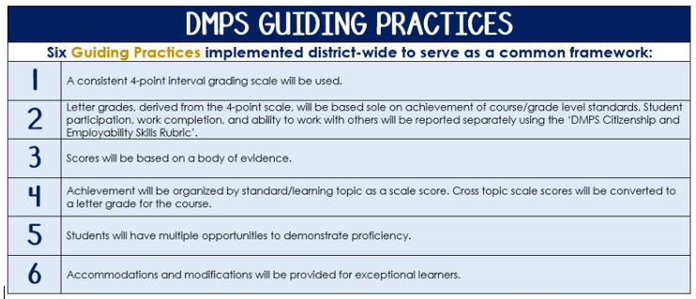
Standards-Referenced Grading Basics
The teacher designs instructional activities and assessments that grow and measure a student’s skills in the elements identified on our topic scales. Each scale features many such skills and knowledges, also called learning targets. These are noted on the scale below with letters (A, B, C) and occur at Levels 2 and 3 of the scale. In the grade book, a specific learning activity could be marked as being 3A, meaning that the task measured the A item at Level 3.

The Body of Evidence in a Process-Based Course
Process-Based SRG is defined as an SRG course design where the same scale recurs throughout the course, but the level of complexity of text and intricacy of task increase over time.

World History People & Places is a course in which students cycle through focused topics repeatedly as they progress through the course, with changing content and an increasing complexity of the text, analysis, and writing expectations throughout.

To account for this, process-based courses like this have their evidence considered in a “Sliding Window” approach. When determining the topic score for any given grading topic, the most recent evidence determines the topic score. Teacher discretion remains a vital part of this determination, but it is hard to overlook evidence from the most recent (and therefore rigorous) assessments.

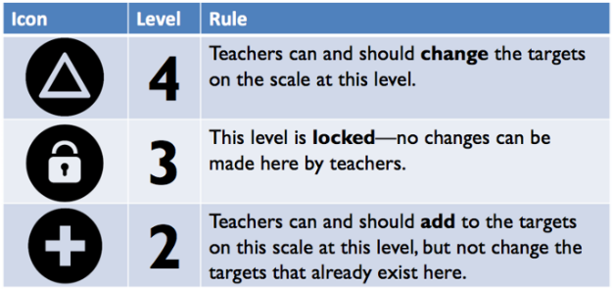
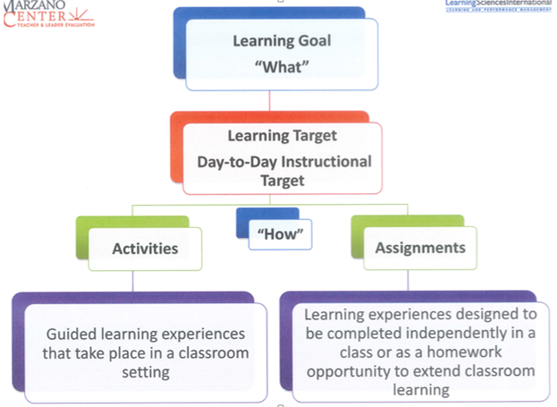

Historical Thinking Skills
Enduring Understandings |  | Suggested Resources
The course is designed to develop greater understanding of the evolution of global processes and interactions among different societies. Students will analyze the nature of social, economic, political, environmental, and cultural elements within societies. Students will determine changes in international frameworks and their causes and consequences. Students will assess the influence of geography on the development of societies. Students will recognize the similarities and differences among societies.  Geography: Its Nature and Perspectives  -geography as a social science  -patterns and processes  -analytical tools  -spatial reasoning  Population and Migration  -measures of population demographics  -patterns and processes in population  -population policies  -causes and consequences of migration  Cultural Patterns and Processes  -concepts of culture  -cultural variations by place and region  -folk and popular culture  -language, religion, and ethnicity | Political Organization of Space  -historical influence on the political map  -territoriality and power at various scales  -patterns in contemporary political geography  Agriculture, Food Production, and Rural Land Use  -agriculture and alteration of the environment  -agriculture regions and physical and economic forces  -settlement patterns and rural land use  -changes in food production and consumption  Industrialization and Economic Development  -diffusion of the Industrial Revolution  -measures of development  -variations in development over space and time  -sustainable development  Cities and Urban Land Use  -form, function, and size of urban settlements  -distribution and size of cities  -models of internal city structure  -built landscapes and social space  -challenges for urban areas | Course Text:  Rubenstein, J. (2010). The Cultural Landscape: An Introduction to Human Geography.  Supplemental Text:  Fouberg, E., A. Murphy, and H.J. de Blij (2009). Human Geography: People, Place, and Culture.
Topic | Standards Alignment | Topic | Standards Alignment
Key Concepts in Human Geography |  | Making Historical Connections
Source Analysis |  | Creating and Supporting a Historical Argument
Chronological Reasoning

Scales

Topic | 4 | 3 | 2
Key Concepts in Human Geography | Synthesize understandings of key concepts with prior learning or authentic, relevant events, processes, or developments. | Apply and analyze understandings of key concepts. | Identify and explain key concepts.
Topic | 4 | 3 | 2
Source Analysis | Evaluate the strengths and weaknesses of arguments found in primary and/or secondary sources. | Analyze primary and/or secondary sources while explaining how the argument is supported in relation to author’s point of view, author’s purpose, historical context, and/or intended audience. | Determine the central idea of primary and/or secondary sources.
Topic | 4 | 3 | 2
Chronological Reasoning | 4A - Evaluate the significance of long and/or short-term causes and/or effects of an historical event, development, or process.  4B - Evaluate the relative significance of the historical continuities and changes over periods of time.  4C – Evaluate the relative significance of an event or process as a turning point relative to other events or processes in a given time period. | 3A – Explain long and/or short-term causes and/or effects of an historical event, development, or process.  3B - Explain the reasons for historical continuities and changes over periods of time.  3C – Explain why different events or processes can be described as turning points. | 2A – Identify long and/or short-term causes and/or effects of an historical event, development, or process.  2B – Identify the dynamics of historical continuity and change over periods of time.  2C – Identify significant turning points between different, definable historical periods.
Topic | 4 | 3 | 2
Making Historical Connections | Evaluate the relative significance of events, developments, and/or processes within the historical or cultural contexts in which they occurred. | 3A – Analyze the reasons for similarities and/or differences among historical events, developments, and/or processes.  3B – Analyze the reasons why an event, development, or process is part of a broader historical or cultural context. | 2A – Identify similarities and/or differences among historical events, developments, and/or processes.  2B – Identify the connections between an event, development, or process and the broader historical or cultural context.
Topic | 4 | 3 | 2
Historical Writing | In addition to meeting the learning goal, the argument:  Incorporates a development from a different historical period, situation, era, or geographical area or a connection to a course theme or approach to history that is not the focus of the writing (such as political, economic, social, cultural, or intellectual history). | A level 3 meets all of the learning goal targets:  - Introduce a knowledgeable claim.  - Organize claim(s) and evidence (chronologically, thematically, etc.).  - Develop claim(s) with relevant and accurate data, evidence, examples, and extended definitions of content-specific terminology. | A level 2 meets one of the learning goal targets:  - Introduce a knowledgeable claim.  - Organize claim(s) and evidence (chronologically, thematically, etc.).  - Develop claim(s) with relevant and accurate data, evidence, examples, and extended definitions of content-specific terminology.

