AP World History: Des Moines Public Schools
2018-2019 curriculum guide

AP World History
The AP World History course is equivalent to an introductory college-level course in world history. This course develops students’ abilities to think conceptually about world history from approximately 8000 B.C.E. to the present and apply historical thinking skills as they learn about the past. Five themes of equal importance – interaction between humans and the environment; development and interaction of cultures; state-building, expansion, and conflict; creation, expansion, and interaction of economic systems; and development and transformation of social structures – provide areas of historical inquiry for investigation throughout the course. These require students to reason historically about continuity and change over time and make comparisons among various historical developments in different times and places.

AP World History – Course Content:
• Period 1: c. 8000 B.C.E.-c. 600 B.C.E. • Period 2: c. 600 B.C.E.-c.600 C.E. • Period 3: c. 600 C.E.-c. 1450 • Period 4: c. 1450-c. 1750
• Period 5: c. 1750-c. 1900 • Period 6: c. 1900-present

AP World History – Historical Thinking Skills:
• Chronological Reasoning
• Comparison and Contextualization
• Crafting Historical Arguments from Historical Evidence
• Historical Interpretation and Synthesis

AP World History Exam
The AP World History Exam measures students’ knowledge of world history and their ability to think historically.
Format of Assessment
Section I Part A: Multiple Choice | 50-55 Questions | 55 Minutes | 40% of Exam Score
• Questions appear in sets of 2-5 • Students analyze historical texts, interpretations, and evidence • Primary and secondary sources, images, graphs, and maps are included
Section I Part B: Short Answer | 4 Questions | 45 Minutes | 20% of Exam Score
• Questions provide opportunities for students to demonstrate what they know best • Some questions include texts, images, graphs, or maps
Section II Part A: Document-Based | 1 Question | 60 Minutes | 25% of Exam Score
• Analyze and synthesize historical data • Assess written, qualitative, or visual materials as historical evidence
Section II Part B: Long Essay | 1 Question | 35 Minutes | 15% of Exam Score
• Students select one of two questions • Explain and analyze significant issues in world history • Develop an argument supported by an analysis of historical evidence

Link to Course Information @ AP Central: https://advancesinap.collegeboard.org/english-history-and-social-science/us-history

Topic | Standards | Topic | Standards
Chronological Reasoning |  | Writing for AP
Comparison and Contextualization |  | Historical Source Interpretation
Historical Source Interpretation |  | Key Concepts

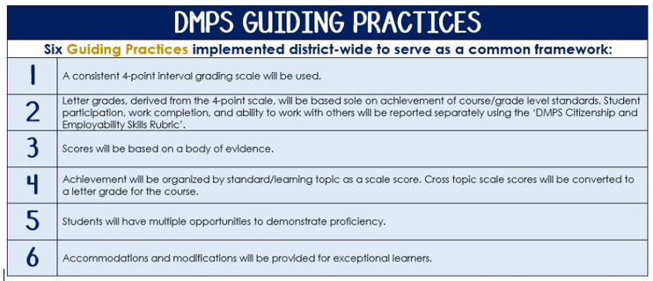
Standards-Referenced Grading Basics
The teacher designs instructional activities and assessments that grow and measure a student’s skills in the elements identified on our topic scales. Each scale features many such skills and knowledges, also called learning targets. These are noted on the scale below with letters (A, B, C) and occur at Levels 2 and 3 of the scale. In the grade book, a specific learning activity could be marked as being 3A, meaning that the task measured the A item at Level 3.

The Body of Evidence in a Process-Based Course
Process-Based SRG is defined as an SRG course design where the same scale recurs throughout the course, but the level of complexity of text and intricacy of task increase over time.

AP World History is a course in which students cycle through focused topics repeatedly as they progress through the course, with changing content and an increasing complexity of the text, analysis, and writing expectations throughout.

To account for this, process-based courses like this have their evidence considered in a “Sliding Window” approach. When determining the topic score for any given grading topic, the most recent evidence determines the topic score. Teacher discretion remains a vital part of this determination, but it is hard to overlook evidence from the most recent (and therefore rigorous) assessments.

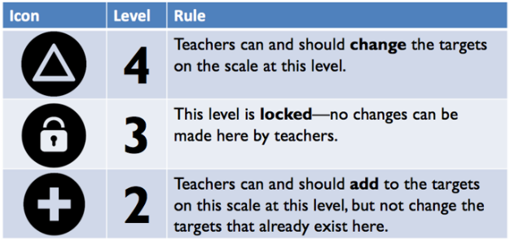
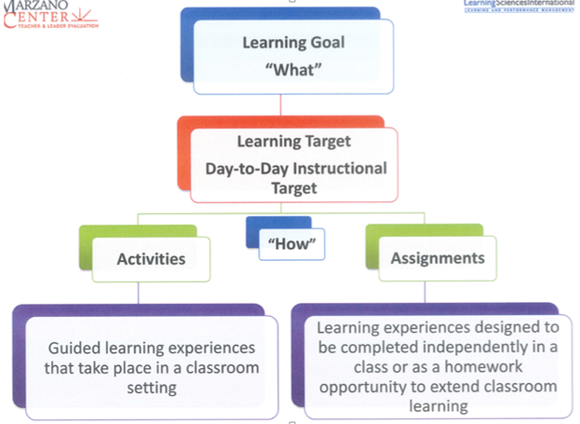

AP World History Course Topics – Semester 1
Text and Resources
Course Text: Ways of the World: A Brief Global History with Sources, 3rd Edition. Robert W. Strayer
AP Teacher Community: https://apcommunity.collegeboard.org/web/apworldhistory

Scales

Topic | 4 | 3  Learning Goal | 2
Chronological Reasoning | - Causation-Synthesize causes/effects by connecting to different period, situation or area or by utilizing a different historical lens  - CCOT-Synthesize CCOT by connecting to different period, situation or area or by utilizing a different historical lens | - Causation-Evaluate causes/effects & significance of factors  - Continuity/Change over Time (CCOT)-Evaluate the significance of historical continuities and changes over periods of time | - Causation-Identify cause/effect & identify significance of factors  - CCOT-Identify historical continuities and changes over time
Comparison and Contextualization | - Comparison-Compare and contrast multiple sources and types while analyzing the reasons for those  - Comparison-Compare and contrast across multiple events, development or processes and the reasons for those  - Contextualization- Situate historical events, developments, or processes within the broader regional, national, or global context in which they occurred and draw conclusions about their relative significance | - Comparison-Compare and contrast multiple sources and types  - Comparison-compare and contrast historical events, developments, or processes  - Contextualization-Situate historical events, developments, or processes within the broader regional, national, or global context in which they occurred | - Comparison-Identify similarities or differences between sources and/or  - Comparison-Identify similarities or differences between historical events, developments, or processes  - Contextualization-Recognize that historical events, developments, or processes occur within a broader regional, national, or global context
Historical Source Interpretation | - Critique an historian’s argument, considering author’s point of view, purpose, audience and/or historical context  - Critique competing arguments or understanding of historical events, developments or processes | - Analyze an historian’s argument while explaining how the argument has been supported in relation to the author’s point of view, purpose, audience, and/or historical context  - Analyze diverse historical interpretations | - Summarize an historian’s argument but fails to connect to author’s point of view, purpose, audience, and/or historical context  - Identify diverse historical interpretations
Key Concepts | Synthesize understandings of content-specific key ideas, people, events and developments from within and through historical periods. | Apply and analyze content-specific key ideas, people, events and developments from each historical period. | Identify and explain content-specific key ideas, people, events and developments from each historical period
Writing for AP | - Thesis-historically defensible claim that answers all parts of the question and creates a cohesive argument that recognizes and accounts for historical complexity by demonstrating relationships among evidence such as contradiction, corroboration and/or qualification  - DBQ: Utilizes 6 documents to support argument and explains significance of author’s point of view, purpose, historical context or audience for at least 3 documents  - Option 1 DBQ: Utilizes specific examples of evidence to fully and effectively substantiate the stated thesis or a relevant argument (DBQ requires outside knowledge)  Option 2 LEQ: supports an argument analyzing multiple perspectives in response to the prompt using specific and relevant examples of evidence  - Demonstrates a complex understanding of the historical development that is the focus of the prompt, using evidence to corroborate, qualify or modify an argument that addresses the prompt | - Thesis-historically defensible claim that answers all parts of the question and creates a cohesive argument that recognizes and accounts for historical complexity by demonstrating relationships among evidence such as contradiction, corroboration and/or qualification  - DBQ: Utilizes content of at least 3-6 documents to support argument and/or address topic of prompt and explains significance of author’s point of view, purpose, historical context or audience for at least 3 documents  - Option 1 DBQ: Utilizes a specific piece of evidence relevant to an argument about the prompt (DBQ requires outside knowledge)  Option 2 LEQ: supports an argument in response to the prompt using specific and relevant examples of evidence  - Demonstrates an understanding of the historical development that is the focus of the prompt, using evidence to corroborate, qualify or modify an argument that addresses the prompt | - Thesis-historically defensible claim that answers all parts of the question and creates a cohesive argument that recognizes and accounts for historical complexity by demonstrating relationships among evidence such as contradiction, corroboration and/or qualification  - DBQ: Utilizes content of at least 3 documents to support argument and/or address topic of prompt and attempts to explain significance of author’s point of view, purpose, historical context or audience for at least 3 documents  - LEQ only: provides specific examples of evidence relevant to the topic of the prompt  - Attempts to demonstrate an understanding of the historical development that is the focus of the prompt, using evidence to corroborate, qualify or modify an argument that addresses the prompt

AP World History Course Topics – Semester 2
Text and Resources
Course Text: Ways of the World: A Brief Global History with Sources, 3rd Edition. Robert W. Strayer
AP Teacher Community: https://apcommunity.collegeboard.org/web/apworldhistory

Scales
Topic | 4 | 3  Learning Goal | 2
Chronological Reasoning | - Causation-Synthesize causes/effects by connecting to different period, situation or area or by utilizing a different historical lens  - CCOT-Synthesize CCOT by connecting to different period, situation or area or by utilizing a different historical lens | - Causation-Evaluate causes/effects & significance of factors  - Continuity/Change over Time (CCOT)-Evaluate the significance of historical continuities and changes over periods of time | - Causation-Identify cause/effect & identify significance of factors  - CCOT-Identify historical continuities and changes over time
Comparison and Contextualization | - Comparison-Compare and contrast multiple sources and types while analyzing the reasons for those  - Comparison-Compare and contrast across multiple events, developments or processes and the reasons for those  - Contextualization- Situate historical events, developments, or processes within the broader regional, national, or global context in which they occurred and draw conclusions about their relative significance | - Comparison-Compare and contrast multiple sources and types  - Comparison-compare and contrast historical events, developments, or processes  - Contextualization-Situate historical events, developments, or processes within the broader regional, national, or global context in which they occurred | - Comparison-Identify similarities or differences between sources and/or  - Comparison-Identify similarities or differences between historical events, developments, or processes  - Contextualization-Recognize that historical events, developments, or processes occur within a broader regional, national, or global context
Historical Source Interpretation | - Critique an historian’s argument, considering author’s point of view, purpose, audience and/or historical context  - Critique competing arguments or understanding of historical events, developments or processes | - Analyze an historian’s argument while explaining how the argument has been supported in relation to the author’s point of view, purpose, audience, and/or historical context  - Analyze diverse historical interpretations | - Summarize an historian’s argument but fails to connect to author’s point of view, purpose, audience, and/or historical context  - Identify diverse historical interpretations
Key Concepts | Synthesize understandings of content-specific key ideas, people, events and developments from within and through historical periods. | Apply and analyze content-specific key ideas, people, events and developments from each historical period. | Identify and explain content-specific key ideas, people, events and developments from each historical period
Writing for AP | - Thesis-historically defensible claim that answers all parts of the question and creates a cohesive argument that recognizes and accounts for historical complexity by demonstrating relationships among evidence such as contradiction, corroboration and/or qualification  - DBQ: Utilizes 6 documents to support argument and explains significance of author’s point of view, purpose, historical context or audience for at least 3 documents  - Option 1 DBQ: Utilizes specific examples of evidence to fully and effectively substantiate the stated thesis or a relevant argument (DBQ requires outside knowledge)  Option 2 LEQ: supports an argument analyzing multiple perspectives in response to the prompt using specific and relevant examples of evidence  - Demonstrates a complex understanding of the historical development that is the focus of the prompt, using evidence to corroborate, qualify or modify an argument that addresses the prompt | - Thesis-historically defensible claim that answers all parts of the question and creates a cohesive argument that recognizes and accounts for historical complexity by demonstrating relationships among evidence such as contradiction, corroboration and/or qualification  - DBQ: Utilizes content of at least 3-6 documents to support argument and/or address topic of prompt and explains significance of author’s point of view, purpose, historical context or audience for at least 3 documents  - Option 1 DBQ: Utilizes a specific piece of evidence relevant to an argument about the prompt (DBQ requires outside knowledge)  Option 2 LEQ: supports an argument in response to the prompt using specific and relevant examples of evidence  - Demonstrates an understanding of the historical development that is the focus of the prompt, using evidence to corroborate, qualify or modify an argument that addresses the prompt | - Thesis-historically defensible claim that answers all parts of the question and creates a cohesive argument that recognizes and accounts for historical complexity by demonstrating relationships among evidence such as contradiction, corroboration and/or qualification  - DBQ: Utilizes content of at least 3 documents to support argument and/or address topic of prompt and attempts to explain significance of author’s point of view, purpose, historical context or audience for at least 3 documents  - LEQ only: provides specific examples of evidence relevant to the topic of the prompt  - Attempts to demonstrate an understanding of the historical development that is the focus of the prompt, using evidence to corroborate, qualify or modify an argument that addresses the prompt

