The Des Moines Public Schools Curriculum guide contains the prioritized standards, required pacing, materials and resources, and assessment correlates for the school year. This document is intended to be used in conjunction with our balanced assessment plan to scaffold our students in mastery of the Iowa Core State Standards.
AP Psychology: Des Moines Public Schools
2018-2019 CURRICULUM GUIDE SOC513/514

AP Psychology
The AP Psychology course is equivalent to an introductory college-level course in psychology. This year-long course covers in depth all topics in introductory psychology. The course is designed to introduce students to the systematic and scientific study of human behavior and mental processes. While considering the psychologists and studies that have shaped the field, students explore and apply psychological theories, key concepts, and phenomena associated with such topics as the biological bases of behavior, sensation and perception, learning and cognition, motivation, developmental psychology, testing and individual differences, treatment of abnormal behavior, and social psychology. Throughout the course, students use research methods as they analyze bias, evaluate claims and evidence, and effectively communicate ideas.

Topic Outline for AP Psychology - The AP Psychology course is organized around major topics:
• History, Approaches, and Research Methods
• Biological Bases of Behavior
• Sensation and Perception
• States of Consciousness
• Learning and Cognition
• Motivation and Emotion
• Developmental Psychology
• Personality
• Testing and Individual Differences
• Abnormal Behavior and Treatments
• Social Psychology

AP Psychology Exam
The AP Psychology Exam measures students’ knowledge of the major topics and fields of study in psychology and tests their ability to define, compare, and apply concepts and research findings. Questions are based on key terminology, scientific methodology, and theories associated with each subfield.
Format of Assessment
Section I: Multiple Choice | 100 Questions | 70 Minutes |66.6% of Exam Score
• Define and explain content from a range of course topics • Apply skills of comparison and interpretation to course concepts and theories.
Section II: Constructed Response | 2 Questions | 50 Minutes | 33.3% of Exam Score
• Analyze a unique scenario using concepts from different frameworks or sub-domains in the field • Design, analyze, or critique a study

Link to Course Information @ AP Central: http://apcentral.collegeboard.com/apc/public/courses/teachers_corner/2265.html?excmpid=MTG243-PR-13-cd
Semester 1 Topics | Standards | Semester 2 Topics | Standards
History, Approaches, and  Research Methods | 9-12.BS.1 Understand the historical development of the behavioral sciences and the changing nature of society.  9-12.BS.3 Understand the appropriate research procedures and skills of the behavioral scientist. | Motivation and Emotion | 9-12.BS.2 Understand the influences on individual and group behavior and group decision making.
 |  | Developmental Psychology | 9-12.BS.6 Understand the process of how humans develop, learn, adapt to their environment, and internalize their culture.
Biological Basis of Behavior | 9-12.BS.2 Understand the influences on individual and group behavior and group decision making.  9-12.BS.6 Understand the process of how humans develop, learn, adapt to their environment, and internalize their culture. | Personality | 9-12.BS.7 Understand how personality and agents of socialization impact the individual.
Sensation and Perception | 9-12.BS.6 Understand the process of how humans develop, learn, adapt to their environment, and internalize their culture. | Testing and Individual Differences | 9-12.BS.3 Understand the appropriate research procedures and skills of the behavioral scientist.
States of Consciousness | 9-12.BS.2 Understand the influences on individual and group behavior and group decision making. | Abnormal Psychology &  Treatment of Disorders | 9-12.BS.2 Understand the influences on individual and group behavior and group decision making.  9-12.BS.3 Understand the appropriate research procedures and skills of the behavioral scientist.
Learning | 9-12.BS.6 Understand the process of how humans develop, learn, adapt to their environment, and internalize their culture.
Social Psychology | 9-12.BS.5 Understand how social status, social groups, social change, and social institutions influence individual and group behaviors. | Memory and Cognition | 9-12.BS.6 Understand the process of how humans develop, learn, adapt to their environment, and internalize their culture.
Writing Informative Text | Write informative/explanatory texts to examine and convey complex ideas, concepts, and information clearly and accurately through the effective selection, organization, and analysis of content. | Writing Informative Text | Write informative/explanatory texts to examine and convey complex ideas, concepts, and information clearly and accurately through the effective selection, organization, and analysis of content.

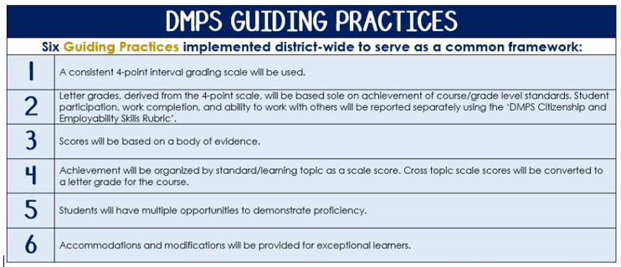
Standards-Referenced Grading Basics
The teacher designs instructional activities and assessments that grow and measure a student’s skills in the elements identified on our topic scales. Each scale features many such skills and knowledges, also called learning targets. These are noted on the scale below with letters (A, B, C) and occur at Levels 2 and 3 of the scale. In the grade book, a specific learning activity could be marked as being 3A, meaning that the task measured the A item at Level 3.

The Body of Evidence in a Process-Based Course
Process-Based SRG is defined as an SRG course design where the same scale recurs throughout the course, but the level of complexity of text and intricacy of task increase over time.

AP Psychology students cycle through the topics in a unit-based structure, with changing content and an increasing complexity of the text, analysis, and writing expectations throughout.

To account for this, process-based courses like this have their evidence considered in a “Sliding Window” approach. When determining the topic score for any given grading topic, the most recent evidence determines the topic score. Teacher discretion remains a vital part of this determination, but it is hard to overlook evidence from the most recent (and therefore rigorous) assessments.

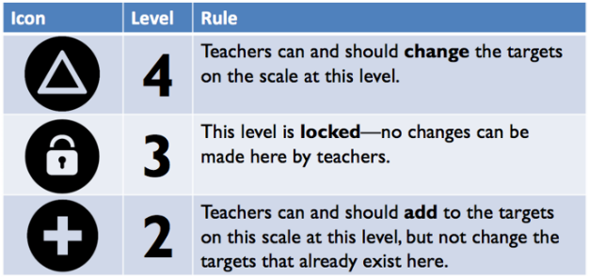
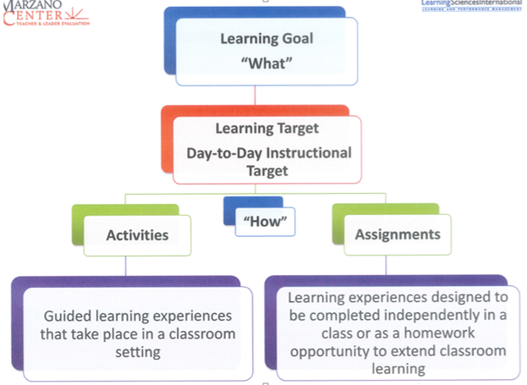

AP Psychology Course Topics – Semester 1
Text and Resources
Myers’ Psychology for AP David G. Myers, 2010.

AP Teacher Community: https://apcommunity.collegeboard.org/web/appsychology

Scales
Topic | 4 | 3 | 2
History, Approaches, and Research Methods | In addition to meeting the learning goal, the student demonstrates in-depth inferences and applications that go beyond the goal.  Analyze strengths and weaknesses of major theoretical perspectives and use an eclectic approach, devise your own explanation for behavior.  Using various research designs, specify how a certain topic might be studied. Evaluate the quality of the various designs.  Investigate a real-life experiment from psychology’s history and evaluate its quality. | 3A - Describe and compare different theoretical approaches in explaining behavior:  -structuralism, functionalism, behaviorism  -Gestalt, psychoanalytic/psychodynamic, and humanism  -evolutionary, biological, cognitive  3B - Evaluate the strengths and limitations of theories to explain behavior.  3C - Describe how research design drives the reasonable conclusions that can be drawn.  3D - Distinguish between random assignment of participants to conditions in experiments and random selection of participants.  3E - Apply basic descriptive statistical concepts, including interpreting and constructing graphs and calculating simple descriptive statistics (e.g. measures of central tendency, standard deviation). | 2A - Identify the major historical figures in psychology (e.g., Mary Whiton Calkins, Charles Darwin, Dorothea Dix, Sigmund Freud, G. Stanley Hall, William James, Ivan Pavlov, Jean Piaget, Carl Rodgers, B.F. Skinner, Margaret Floy Washburn, John B. Watson, Wilhelm Wundt).  2B – Identify theories to explain behavior.  Describe the evolution of perspectives and approaches over a timeline of the field of psychology.  2C - Identify independent, dependent, confounding, and control variable in experimental designs.  Identify how ethical issues effect research practices.  2D - Distinguish between types of research (e.g. experiments, correlational studies, survey, research, naturalistic observation, and case studies) with regard to purpose, strengths, and weaknesses.  2E – Identify basic descriptive statistical concepts.  Define central tendency and standard deviation.
Biological Basis of Behavior | The Brain on Match.com:  Investigate the brain and create a profile for it including a physical description, physical evolution, occupation, and a “how do we know” section by researching brain scans. | 3A - Describe the nervous system and its subdivisions and functions.  -Central and Peripheral Nervous System  -Major Brain Regions, Lobes, and Cortical Areas  -Brain Lateralization and Hemispheric Specialization  3B – Compare and differentiate drugs from neurotransmitters. | 2A - Identify basic processes and systems of behavior, including parts of the brain, the neuron, and the process of transmission of a signal between neurons.  2B - Recount historic and contemporary strategies and technologies that support research (e.g. case studies, split-brain research, imaging techniques).
Sensation and Perception | Adapt or create a children’s book with five characters: eye, ear, nose, tongue, fingertip/skin.  Tell the story of a day in the life of your character that accurately predicts and describes functioning:  -top down and bottom up processing  -perceptual cues  -the role of culture  -absolute threshold and Weber’s Law | 3A - Describe general principles of organizing and integrating sensation to promote stable awareness of the external world.  3B - Discuss how experience and culture can influence perceptual processes.  3C - Explain common sensory disorders.  3D - Explain the role of top down and bottom up processing. | 2A/2B - Describe sensory processes (e.g. hearing, vision, touch, taste, smell, vestibular, kinesthesis, pain), including the specific nature of energy transduction.  2C/2D - Identify basic principles of sensory transduction, including absolute threshold, difference threshold, signal detection, and sensory adaptation.
States of Consciousness | Discuss drug dependence, addition, tolerance, and withdrawal. | 3A - Discuss aspects of sleep and dreaming  -Stages and characteristics of the sleep cycle  -Theories of sleep and dreaming  -Symptoms and treatments of sleep disorders  3B – Evaluate how the various states of consciousness and their impact on behavior and vice versa. | 2A - Identify the major psychoactive substance categories (e.g., depressants, stimulants) and classify specific drugs, including their psychological and physiological effects.  2B - Explain hypnotic phenomena, sleep stages.
Learning | Design a utopia that correctly applies:  -classical conditioning (US, UR, CS, CR)  -operant conditioning (PR, PP, NR, NP)  -observational learning/modeling  -insight/latent  -acquisition, association, extinction, spontaneous recovery, generalization, and discrimination | 3A - Describe basic classical conditioning phenomenon, such as acquisition, extinction, spontaneous recovery, generalization, discrimination, and higher-order learning.  3B – Test the impact of classical, operant, and observational learning; specifically, how real world stimuli and consequences might impact behavior. | 2A - Identify key contributors in the psychology of learning (e.g., Albert Bandura, John Garcia, Ivan Pavlov, B.F. Skinner, Edward Thorndike, Edward Tolman, and John B. Watson.  2B - Describe the essential characteristics of insight learning, insight learning, and social learning.
Social Psychology | Make predictions. An airplane containing 20 teenagers crash lands on a deserted island. Both pilots die on impact. Using your knowledge of group dynamics, propose five things that can potentially happen to the group until they are rescued 1 year later. | 3A – Apply attribution theory to explain motives.  3B – Analyze the structure and function of different kinds of group behavior.  3C – Assess important figures in social psychology and organize their significant research as it applies to behavior.  3D – Apply the central route to persuasion and its effect on attitudes.  3E – Organize processes that contribute to differential treatment of group members. | 2A - Understand attribution theory.  2B - Recognize and recall different kinds of group behavior.  2C - Understand contributions of major psychologists to social psychology theories.  2D - Identify the central and peripheral route to persuasion.  2E - Describe the processes contributing to differential treatment of group members.
Writing Informative Text | 4A - Addresses all parts of the prompt, and scores all available points.  4B - Develops the topic with relevant facts, evidence and accurate examples that are appropriate to the topic; uses extended definitions and/or examples. | 3A - Addresses all parts of the prompt, and scores more than half of the available points.  3B - Organize ideas and concepts in the order presented.  3C - Develops the topic with relevant facts, evidence and accurate examples that are appropriate to the topic. | A level 2 writing sample fails to meet the learning goal in two or more areas.  *A level 1.5 writing sample fails to meet the level 3 standard in three areas.  *A level 1 writing sample fails to meet the level 3 standard in all areas, but a valid attempt was made by the student.

AP Psychology Course Topics – Semester 2
Text and Resources
Myers’ Psychology for AP David G. Myers, 2010.

AP Teacher Community: https://apcommunity.collegeboard.org/web/appsychology

Scales
Topic | 4 | 3 | 2
Memory and Cognition | “What would happen if . . .” Use your knowledge of memory and cognition in real-life situations. Which memory method would fit situations such as:  -recalling a long list of grocery items  -describing a crime you witnessed 10 minutes earlier  -describe a crime you witnessed over 10 years ago  -investigating a missing person’s case  -teaching a young child a new language | 3A –Provide examples of the different types of heuristics and explain how they are both essential to human interaction and highly susceptible to bias.  3B - Describe the usage of models and prototypes in acquiring a new basis for understanding.  3C – Analyze a variety of memory models and aids (mnemonics, chunking, visualization, context and state dependent, mood-congruent, distributed practice, and others), articulating how they might improve study habits and skills for students. | 2A - Identify different cognitive processes (e.g., effortful processing, automatic processing, deep processing, shallow processing, focused attention, and divided attention).  2B - Outline the principles that underlie effective encoding, storage, and construction of memories.  2C - List the characteristics of creative thought and creative thinkers.
Motivation and Emotion | Investigate motivational and emotional processes in an empirical setting. Create a principle, generalization, or rule.  Evaluate key concepts and theories of motivation and emotion, citing strengths and weaknesses. Combine key aspects of the theories, edit, and revise to create your own theory of both. | 3A – Apply basic concepts of motivation to understand human and animal behavior.  3B – Discuss biological underpinnings of motivation, including needs, drives, and homeostasis.  3C – Compare and contrast theories of motivation, including strengths and weaknesses of each. | 2A/2C – Identify and describe motivational theories.  2B - Recall and define key vocabulary such as: motivation, homeostasis.
Developmental Psychology | Evaluate and critique the merits of the major developmental theories.  Develop and create an original lifespan theory, using key elements of all major theorists. | 3A – Explain biological and physical development throughout the lifespan.  3B – Describe the influence of temperament and other social factors on attachment and socialization.  3C – Compare and contrast the major theorists of human development.  3D – Describe how sex and gender influence socialization and healthy development. | 2A - Identify the basic tenets of the major developmental theories.  2B - Recall and define key vocabulary such as: temperament, attachment, socialization.  2C – Identify major theorists of human development.  2D – Recognize characteristics of sex and gender.
Personality | Using the major approaches, generate a novel theory on personality.  Critique the various assessment tools for validity and reliability. | 3A – Compare and contrast the major theories and approaches used to explain personality.  3B – Describe often used assessment strategies and evaluate the validity and reliability of the strategies.  3C – Analyze key contributors and their theories to the concept of personality. | 2A - Summarize major personality theories.  2B - Identify various personality assessment tools and strategies.  2C - Recognize key contributors to personality theory.
Testing and Individual Differences | Create your own intelligence test and justify its use based on the theories of intelligence. | 3A – Analyze how psychologists measure intelligence.  3B – Trace the development of historical theories of intelligence  3C – Evaluate key contributors to the study of intelligence.  3D – Differentiate the testing practices as they apply to cultural fairness. | 2A - Define intelligence.  2B - Identify key contributors to intelligence research and testing.  2C - Summarize theories of intelligence. List methods psychologists use to measure intelligence.  2D – Identify the appropriate testing practices as related to culture-fair use.
Abnormal Psychology  &  Treatment of Disorders | Critique the diagnostic categories and their efficacy in the identification of symptoms.  Justify the use of a diagnostic label, knowing their positive and negative consequences.  Create a novel treatment plan, utilizing key components of the major approaches to treatment.  Reflect on the usefulness/effectiveness of the major approaches. | 3A – Apply the major diagnostic categories to case studies.  3B – Discuss the impact of diagnostic labels.  3C – Trace the historical conceptions of mental disorders.  3D - Analyze major treatment orientations used in therapy and how they influence therapeutic planning.  3E - Compare/contrast the major figures and theories of psychological treatment. | 2A - Identify and describe the major diagnostic categories and types of mental disorders.  2B - Identify positive and negative consequences of diagnostic labels.  2C - Explain the contemporary and historical conceptions of mental disorders.  2D - Understand the major treatment orientations citing the major tenets.  2E - Recognize and classify the major figures and theories of psychological treatment.
Writing Informative Text | 4A - Addresses all parts of the prompt, and scores all available points.  4B - Develops the topic with relevant facts, evidence and accurate examples that are appropriate to the topic; uses extended definitions and/or examples. | 3A - Addresses all parts of the prompt, and scores more than half of the available points.  3B - Organize ideas and concepts in the order presented.  3C - Develops the topic with relevant facts, evidence and accurate examples that are appropriate to the topic. | A level 2 writing sample fails to meet the learning goal in two or more areas.  *A level 1.5 writing sample fails to meet the level 3 standard in three areas.  *A level 1 writing sample fails to meet the level 3 standard in all areas, but a valid attempt was made by the student.

SRG Scale Score | Topic:  AP-Style Assessments | AP Exam  Score Conversion
4 | In addition to meeting the learning goal, the student demonstrates in-depth inferences and applications that go beyond the goal. | 90-100%
3.5 | Student’s performance reflects exceptional facility with some, but not all Level 4 learning targets. | 80-89%
3  Learning Goal | Student’s performance reflects success on all Level 3 learning targets. | 70-79%
2.5 | Student’s performance reflects success on some, but not all, Level 3 learning targets | 60-69%
2 | Student’s performance reflects success on all Level 2 learning targets. | 50-59%
1.5 | Student’s performance reflects success on some but not all Level 2 learning targets | 40-49%
1 | Student’s performance reflects insufficient progress towards foundational skills and knowledge. | 20-39%

SRG Scale Score | Topic:  Free Response Questions for AP | FRQ Score Conversion
4 | In addition to meeting the learning goal, the student demonstrates in-depth inferences and applications that go beyond the goal.  4A - Addresses all parts of the prompt, and scores all available points.  4B - Develops the topic with relevant facts, evidence and accurate examples that are appropriate to the topic; uses extended definitions and/or examples. | 6
3.5 | Student’s performance exceeds the standard, but misses at least one of the Level 4 learning targets. | 5
3  Learning Goal | Students demonstrate they have the ability to:  3A - Addresses all parts of the prompt, and scores more than half of the available points.  3B - Organize ideas and concepts in the order presented.  3C - Develops the topic with relevant facts, evidence and accurate examples that are appropriate to the topic. | 4
2.5 | Student’s performance reflects success on some, but not all, Level 3 learning targets. | 3
2 | A level 2 writing sample fails to meet the learning goal in two or more areas. | 2
1.5 | Student’s performance reflects success on some but not all Level 2 learning targets. | 1
1 | Student’s performance reflects insufficient progress towards foundational skills and knowledge. | 1

