AP Music Theory: Des Moines Public Schools
2018-2019 CURRICULUM GUIDE MUS501/502

AP Music Theory
The AP Music Theory course corresponds to one or two semesters of a typical introductory college music theory course that covers topics such as musicianship, theory, musical materials, and procedures. Musicianship skills, including dictation and other listening skills, sight singing, and harmony, are considered an important part of the course. Through the course, students develop the ability to recognize, understand, and describe basic materials and processes of tonal music that are heard or presented in a score. Development of aural skills is a primary objective. Performance is also part of the curriculum through the practice of sight singing. Students understand basic concepts and terminology by listening to and performing a wide variety of music. Notational skills, speed, and fluency with basic materials are also emphasized.

AP Music Theory – Course Content:
The AP Music Theory course supports mastery of the rudiments and vocabulary of music, including hearing and notating:
• Pitches
• Intervals
• Scales and keys
• Chords
• Meter
• Rhythm

Building on this foundation, the course progresses to include more complex and creative tasks, such as melodic and harmonic dictation; composition of a bass line for a given melody, implying appropriate harmony; realization of a figured bass; realization of a Roman numeral progression; analysis of melody, harmony, rhythm, texture, and form in repertoire drawn mostly from the Western European Common Practice style, but also including jazz, 20th century works, and world music; and sight singing of simple melodies.
Students learn to identify, both aurally and through score reading, tonal procedures based in common-practice tonality, such as: • Functional triadic harmony in traditional four-voice texture (with vocabulary including nonharmonic tones, seventh chords, and secondary dominants) • Cadences • Melodic and harmonic compositional processes (e.g., sequence, motivic development) • Standard rhythms and meters • Phrase structure (e.g., contrasting period, phrase group) • Small forms (e.g., rounded binary, simple ternary, theme and variation, strophic) • Modulation to closely related keys

AP Music Theory Exam: Format of Assessment – 2 Hours 40 Minutes
Section I: Multiple Choice | 75 Questions | 1 Hour 20 Minutes | 45% of Exam Score
• Questions based on aural stimuli and Questions based on the analysis of printed music scores
Section II: Free Response | 9 Exercises | 1 Hour 20 Minutes | 55% of Exam Score
• Melodic and Harmonic Dictation
• Part Writing from Roman Numerals and Figured Bass
• Composition of a Bass Line/Harmonization of a Melody
• Sight Singing

Link to DMPS Grading Resources: http://grading.dmschools.org
Link to Course Information @ AP Central: http://apcentral.collegeboard.com/apc/public/courses/teachers_corner/2261.html?excmpid=CBP5-ED-3-apcd
Skills | College Board Curriculum Framework Alignment
Notational Skills  FRQ 1, 2, 3,  4, 5, 6, & 7 | I. Musical Terminology  A. Terms for intervals, triads, seventh chords, scales, and modes  B. Terms pertaining to rhythm and meter, melodic construction and variation, harmonic function, cadences and phrase structure, texture, small forms, and musical performance.  II. Notational Skills  A. Rhythms and meters  B. Clefs and pitches  C. Key signatures, scales, and modes  D. Intervals and chords  E. Melodic transposition
Compositional Skills  FRQ 5, 6, & 7 | III. Basic Compositional Skills  A. Four-voice realization of figured-bass symbols and Roman numerals  B. Composition of a bass line (with chord symbols) for a given melody
Analytical Skills  FRQ 3, 4,  5, 6, & 7 | IV. Score Analysis (with or without aural stimulus)  A. Small-scale and large-scale harmonic procedures  B. Melodic organization and developmental procedures  C. Rhythmic/metric organization  D. Texture  E. Formal devices and/or procedures
Aural Skills  FRQ 1, 2, 3,  4, 8 & 9 | V. Aural Skills  A. Sight-singing  B. Melodic dictation  C. Harmonic dictation  D. Identification of isolated pitch and rhythmic patterns  E. Detection of errors in pitch and rhythm in one- and two-voice examples  F. Identification of processes and materials in the context of music literature representing a broad spectrum of genres, media, and styles.

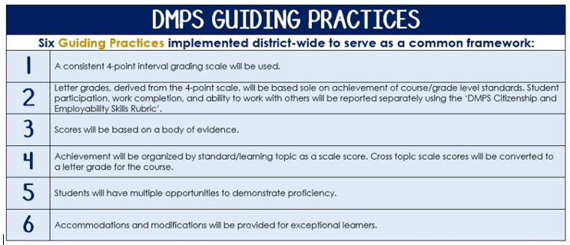
Standards-Referenced Grading Basics
The teacher designs instructional activities and assessments that grow and measure a student’s skills in the elements identified on our topic scales. Each scale features many such skills and knowledges, also called learning targets. These are noted on the scale below with letters (A, B, C) and occur at Levels 2 and 3 of the scale. In the grade book, a specific learning activity could be marked as being 3A, meaning that the task measured the A item at Level 3.

The Body of Evidence in a Process-Based Course
Process-Based SRG is defined as an SRG course design where the same scale recurs throughout the course, but the level of complexity of text and intricacy of task increase over time.

AP Music Theory does have a traditional unit-based design. In some topics, however, students cycle through the same topic repeatedly as they progress through the course, with changing content and an increasing complexity of the music, analysis, and expectations throughout.

To account for this, process-based courses like this have their evidence considered in a “Sliding Window” approach. When determining the topic score for any given grading topic, the most recent evidence determines the topic score. Teacher discretion remains a vital part of this determination, but it is hard to overlook evidence from the most recent (and therefore rigorous) assessments.

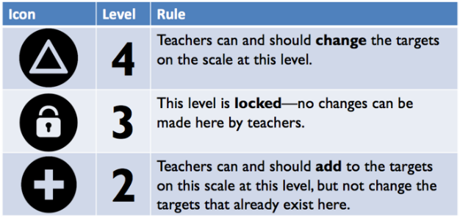
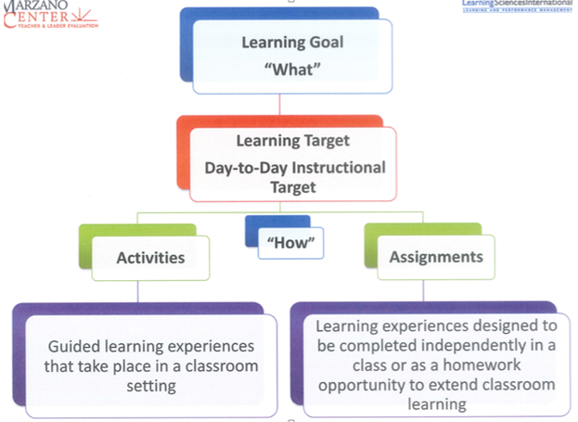

Fundamentals – Semester 1

Topic | 4 | 3 | 2
Fundamentals | 4A: Investigate notational weaknesses and develop an individualized strategy to perform at a level beyond the learning goal.  4B: Investigate analytical weaknesses and develop an individualized strategy to perform at a level beyond the learning goal.  4C: Investigate aural weaknesses and develop an individualized strategy to perform at a level beyond the learning goal. | 3A: Notate pitches in octave registers, rhythms, scales, key signatures, intervals and inversions.  3B: Analyze meter type, pitches in octave registers, rhythms, scales, key signatures, intervals and inversions.  3C: Aurally distinguish rhythms, meter type, scales, intervals and inversions. | 2ABC.1: Visually distinguish pitches.  2ABC.2: Visually distinguish duration symbols.  2ABC.3: Notate correct beaming in simple and compound meters.

Triads and Seventh Chords – Semester 1

Topic | 4 | 3 | 2
Triads and  Seventh Chords | 4A: Investigate notational weaknesses and develop an individualized strategy to perform at a level beyond the learning goal.  4B: Investigate analytical weaknesses and develop an individualized strategy to perform at a level beyond the learning goal.  4C: Investigate aural weaknesses and develop an individualized strategy to perform at a level beyond the learning goal. | 3A: Notate major, minor, augmented, and diminished triads and inversions; major, minor, dominant, half-diminished, and fully-diminished seventh chords and inversions.  3B: Analyze major, minor, augmented, and diminished triads and inversions; major, minor, dominant, half-diminished, and fully-diminished seventh chords and inversions.  3C: Aurally distinguish major, minor, augmented, and diminished triads and inversions; major, minor, dominant, half-diminished, and fully-diminished seventh chords and inversions. | 2AB.1: Visually distinguish pitches.  2AB.2: Visually distinguish intervals.  2AB.3: Visually distinguish key signatures.  2C.1: Aurally distinguish intervals.  2C.2: Aurally distinguish scales.

Diatonic Roman Numerals – Semester 1

Topic | 4 | 3 | 2
Diatonic Roman  Numerals | 4A: Investigate notational weaknesses and develop an individualized strategy to perform at a level beyond the learning goal.  4B: Investigate analytical weaknesses and develop an individualized strategy to perform at a level beyond the learning goal.  4C: Investigate aural weaknesses and develop an individualized strategy to perform at a level beyond the learning goal. | 3A: Notate chords from diatonic Roman numerals with bass position symbols.  3B: Analyze chords using diatonic Roman numerals with bass position symbols.  3C: Aurally distinguish chord progressions. |  | 2ABC.1: Visually distinguish major, minor, augmented, and diminished triads and inversions.  2ABC.2: Visually distinguish major, minor, dominant, half-diminished, and fully-diminished seventh chords and inversions.

Forms and Cadences – Semester 1

Topic | 4 | 3 | 2
Forms and  Cadences | 4ABC: Investigate analytical weaknesses and develop an individualized strategy to perform at a level beyond the learning goal.  4D: Investigate compositional weaknesses and develop an individualized strategy to perform at a level beyond the learning goal.  4EF: Investigate aural weaknesses and develop an individualized strategy to perform at a level beyond the learning goal. | 3A: Analyze perfect and imperfect authentic, plagal, half, and deceptive cadences.  3B: Analyze phrase organization.  3C: Analyze form organization.  3D: Compose all cadences.  3E: Aurally distinguish all cadences.  3F: Aurally distinguish form organization. | 2A: Compare and contrast cadences.  2B: Compare and contrast motives, phrases, periods, and sentences.  2C: Compare and contrast strophic, binary, ternary, rondo, variational, and developmental forms.  2D: Compare and contrast cadences.  2E: Compare and contrast cadences.  2F.1: Compare and contrast motives, phrases, periods, and sentences.  2F.2: Compare and contrast strophic, binary, ternary, rondo, variational, and developmental forms.

Principles of Voice Leading – Semester 2

Topic | 4 | 3 | 2
Principles of  Voice Leading | 4AB: Investigate compositional weaknesses and develop an individualized strategy to perform at a level beyond the learning goal.  4C: Investigate analytical weaknesses and develop an individualized strategy to perform at a level beyond the learning goal.  4D: Investigate aural weaknesses and develop an individualized strategy to perform at a level beyond the learning goal. | 3A: Compose a melody following common practice era procedures.  3B: Compose first species counterpoint following common practice era procedures.  3C: Analyze common practice era procedure errors in four-voice texture.  3D: Aurally distinguish outer voices in four-voice texture (harmonic dictation). | 2ABC.1: Visually distinguish pitches in octave registers.  2ABC.2: Visually distinguish intervals.  2ABC.3: Visually distinguish key signatures.  2ABC.4: Visually distinguish traids and seventh chords.  2D.1: Aurally distinguish intervals.  2D.2: Aurally distinguish chord progressions.

Nonchord Tones – Semester 2

Topic | 4 | 3 | 2
Nonchord Tones | 4A: Investigate notational weaknesses and develop an individualized strategy to perform at a level beyond the learning goal.  4B: Investigate analytical weaknesses and develop an individualized strategy to perform at a level beyond the learning goal.  4C: Investigate compositional weaknesses and develop an individualized strategy to perform at a level beyond the learning goal. | 3A: Notate passing, neighbor, retardation, suspension, appoggiatura, escape tone, pedal, and anticipation nonchord tones.  3B: Analyze passing, neighbor, retardation, suspension, appoggiatura, escape tone, pedal, and anticipation nonchord tones.  3C: Compose using passing, neighbor, retardation, suspension, appoggiatura, escape tone, pedal, and anticipation nonchord tones. | 2ABC: Categorize and define passing, neighbor, retardation, suspension, appoggiatura, escape tone, pedal, and anticipation nonchord tones.

Secondary Functions – Semester 2

Topic | 4 | 3 | 2
Secondary Functions | 4A: Investigate analytical weaknesses and develop an individualized strategy to perform at a level beyond the learning goal.  4B: Investigate compositional weaknesses and develop an individualized strategy to perform at a level beyond the learning goal.  4C: Investigate aural weaknesses and develop an individualized strategy to perform at a level beyond the learning goal. | 3A: Analyze secondary dominant and secondary leading tone chords.  3B: Compose using secondary dominant and secondary leading tone chords.  3C: Aurally distinguish secondary dominant and secondary leading tone chords. | 2ABC.1: Notate tonicizations.  2ABC.2: Compare and contrast functions of secondary dominant and secondary leading tone chords.

