Course Numbers
LA503/504
LA529/530 (Dual-Credit)

AP English Literature & Composition
2018-2019

AP English Literature & Composition
The AP English Literature and Composition course aligns to an introductory college-level literary analysis course. The course engages students in the close reading and critical analysis of imaginative literature to deepen their understanding of the ways writers use language to provide both meaning and pleasure. As they read, students consider a work’s structure, style, and themes, as well as its use of figurative language, imagery, symbolism, and tone. Writing assignments include expository, analytical, and argumentative essays that require students to analyze and interpret literary works.

AP English Literature and Composition – Course Objectives:
Reading complex imaginative literature (fiction, drama, and poetry) appropriate for college-level study.
• Writing an interpretation of a piece of literature that is based on a careful observation of textual details, considering the work’s structure, style, and themes; the social and historical values it reflects and embodies; and such elements as the use of figurative language, imagery, symbolism, and tone
• Composing in several forms (e.g., narrative, expository, analytical, and argumentative essays) based on students’ analyses of literary texts
• Writing that proceeds through several stages or drafts, with revision aided by teacher and peers
• Writing informally (e.g., response journals, textual annotations, collaborative writing), which helps students better understand the texts they are reading
• Revising their work to develop a wide-ranging vocabulary used appropriately and effectively; a variety of sentence structures, including appropriate use of subordination and coordination; logical organization, enhanced by techniques such as repetition, transitions, and emphasis; a balance of generalization and specific, illustrative detail; and an effective use of rhetoric, including tone, voice, diction, and sentence structure.

AP English Literature Exam: Format of Assessment – 3 Hours
Section I: Multiple Choice | 55 Questions | 1 Hour | 45% of Exam Score
• Includes excerpts from several published works of drama, poetry, or prose fiction
• Each excerpt is accompanied by several multiple-choice questions or prompts
Section II: Free Response | 3 Essays | 2 Hours | 55% of Exam Score
• Students have 2 hours to write essay responses to three free response prompts from the following categories:
-A literary analysis of a given poem
-A literary analysis of a given passage of prose fiction (this may include drama)
-An analysis that examines a specific concept, issue, or element in a work of literary merit selected by the student

Link to DMPS Grading Resources: http://grading.dmschools.org
Link to Course Information @ AP Central: http://apcentral.collegeboard.com/apc/public/courses/teachers_corner/2124.html

Semester 1 and 2 Topics | College Board Curriculum Framework Alignment
Timed Literary Analysis  - Poetry  - Prose  - Theme (Open-Ended) | CCSS.ELA-LITERACY.W.11-12.9 Draw evidence from literary or informational texts to support analysis, reflection, and research. CCSS.ELA-LITERACY.W.11-12.9.A Apply grades 11-12 Reading standards to literature.  The Advanced Placement English Literature & Composition exam requires students to respond to three types of prompts within approximately 40 minutes: 1) an analysis of a passage or poem in which students are required to discuss how particular literary elements or features contribute to meaning; and 2) an “open” question in which students are asked to select a literary work and discuss its relevant features in relation to the question provided.
Untimed Literary Analysis  - Poetry  - Prose  - Theme (Open-Ended) | CCSS.ELA-LITERACY.W.11-12.9 Draw evidence from literary or informational texts to support analysis, reflection, and research. CCSS.ELA-LITERACY.W.11-12.9.A Apply grades 11-12 Reading standards to literature.
Writing Construction | CCSS.ELA-LITERACY.W.11-12.4 Produce clear and coherent writing in which the development, organization, and style are appropriate to task, purpose, and audience.  CCSS.ELA-LITERACY.W.11-12.5 Develop and strengthen writing as needed by planning, revising, editing, rewriting, or trying a new approach, focusing on addressing what is most significant for a specific purpose and audience.
Vocabulary/Terminology | CCSS.ELA-LITERACY.RL.11-12.4 Determine the meaning of words and phrases as they are used in the text, including figurative and connotative meanings; analyze the impact of specific word choices on meaning and tone, including words with multiple meanings or language that is particularly fresh, engaging, or beautiful.
Reading Interpretation  (multiple-choice, dialectical journals, etc.) | CCSS.ELA-LITERACY.RL.11-12.1 Cite strong and thorough textual evidence to support analysis of what the text says explicitly as well as inferences drawn from the text, including determining where the text leaves matters uncertain.  CCSS.ELA-LITERACY.RL.11-12.2 Determine two or more themes or central ideas of a text and analyze their development over the course of the text, including how they interact and build on one another to produce a complex account; provide an objective summary of the text.  CCSS.ELA-LITERACY.RL.11-12.3 Analyze the impact of the author's choices regarding how to develop and relate elements of a story or drama.  CCSS.ELA-LITERACY.RL.11-12.5 Analyze how an author's choices concerning how to structure specific parts of a text (e.g., the choice of where to begin or end a story, the choice to provide a comedic or tragic resolution) contribute to its overall structure and meaning as well as its aesthetic impact.  CCSS.ELA-LITERACY.RL.11-12.6 Analyze a case in which grasping a point of view requires distinguishing what is directly stated in a text from what is really meant.  CCSS.ELA-LITERACY.RL.11-12.7 Analyze multiple interpretations of a story, drama, or poem (e.g., recorded or live production of a play or recorded novel or poetry), evaluating how each version interprets the source text.  CCSS.ELA-LITERACY.RL.11-12.9 Demonstrate knowledge of eighteenth-, nineteenth- and early-twentieth-century foundational works of American literature, including how two or more texts from the same period treat similar themes or topics.  CCSS.ELA-LITERACY.RL.11-12.10 By the end of grade 12, read and comprehend literature, including stories, dramas, and poems, -independently and proficiently.
Speaking and Listening  (includes preparation for discussion) | CCSS.ELA-LITERACY.SL.11-12.1 Initiate and participate effectively in a range of collaborative discussions (one-on-one, in groups, and teacher-led) with diverse partners on topics, texts, and issues, building on others' ideas and expressing their own clearly and persuasively.  CCSS.ELA-LITERACY.SL.11-12.1.A Come to discussions prepared, having read and researched material under study; explicitly draw on that preparation by referring to evidence from texts and other research on the topic or issue to stimulate a thoughtful, well-reasoned exchange of ideas.  CCSS.ELA-LITERACY.SL.11-12.1.B Work with peers to promote civil, democratic discussions and decision-making, set clear goals and deadlines, and establish individual roles as needed.  CCSS.ELA-LITERACY.SL.11-12.1.C Propel conversations by posing and responding to questions that probe reasoning and evidence; ensure a hearing for a full range of positions on a topic or issue; clarify, verify, or challenge ideas and conclusions; and promote divergent and creative perspectives.  CCSS.ELA-LITERACY.SL.11-12.1.D Respond thoughtfully to diverse perspectives; synthesize comments, claims, and evidence made on all sides of an issue; resolve contradictions when possible; and determine what additional information or research is required to deepen the investigation or complete the task.  CCSS.ELA-LITERACY.SL.11-12.2 Integrate multiple sources of information presented in diverse formats and media (e.g., visually, quantitatively, orally) in order to make informed decisions and solve problems, evaluating the credibility and accuracy of each source and noting any discrepancies among the data.  CCSS.ELA-LITERACY.SL.11-12.3 Evaluate a speaker's point of view, reasoning, and use of evidence and rhetoric, assessing the stance, premises, links among ideas, word choice, points of emphasis, and tone used.

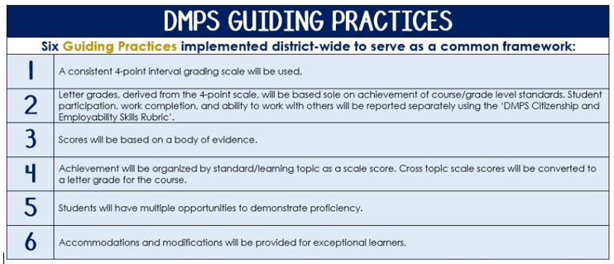
Standards-Referenced Grading Basics
The teacher designs instructional activities and assessments that grow and measure a student’s skills in the elements identified on our topic scales. Each scale features many such skills and knowledges, also called learning targets. These are noted on the scale below with letters (A, B, C) and occur at Levels 2 and 3 of the scale. In the grade book, a specific learning activity could be marked as being 3A, meaning that the task measured the A item at Level 3.
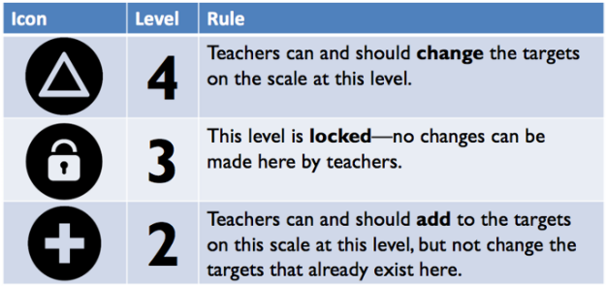
The Body of Evidence in a Process-Based Course
Process-Based SRG is defined as an SRG course design where the same scale recurs throughout the course, but the level of complexity of text and intricacy of task increase over time.

AP English Literature & Composition immerses students in six themes as outlined by the College Board curriculum framework. Students cycle through the similar topics repeatedly as they progress through the course, with changing content and an increasing complexity of the text, analysis, listening, speaking, and writing expectations throughout.

To account for this, process-based courses like this have their evidence considered in a “Sliding Window” approach. When determining the topic score for any given grading topic, the most recent evidence determines the topic score. Teacher discretion remains a vital part of this determination, but it is hard to overlook evidence from the most recent (and therefore rigorous) assessments.

DMPS Grading Resources: grading.dmschools.org

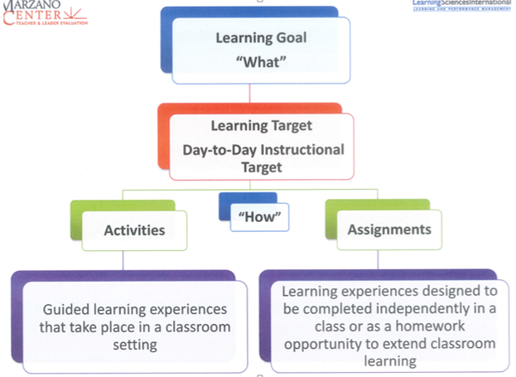
Grading Topic: Vocabulary and Terminology
4 |  | In addition to score 3.0 performance, the student demonstrates complex and autonomous analysis of word meaning and usage.
3 |  | The student demonstrates the ability to:  3A. Interpret, analyze, and critique author’s use of literary devices, language, and/or style. (AP R3.2)  3B. Make stylistic choices with vocabulary and terminology to achieve intended effects. (AP W3.2; R1.1)
Learning Goal
2 |  | The student demonstrates the ability to:  2A. Identify literary devices.  2B. Use appropriate and varied vocabulary.

Topic Resources

Grading Topic: Reading Interpretation |  |  | 1 |  | 2
4 |  | The student’s performance reflects exceptional facility. | 65-100% | 70-100%
3.5 |  |  | 60-64% | 65-69%
3 |  | The student demonstrates the ability to:  3A. Analyze how an author achieves specific effects and purposes using literary and poetic devices, figurative language, and word choice to reinforce key ideas, events, and themes in order to create multiple layers of meaning. (R3.2-2.5)  3B. Analyze explicit and implicit references to elements of the social, cultural, and historical context and use that understanding to extend and elaborate the meaning of texts. (R2.2-1.5) | 50-59% | 60-64%
Learning Goal
2.5 |  |  | 45-49% | 50-59%
2 |  | The student demonstrates the ability to:  2A. Describe how an author achieves specific effects and purposes using literary devices, figurative language, and word choice to reinforce key ideas, events, and themes in order to create multiple layers of meaning. (R1.2-4.5)  2B. Describe explicit and implicit references to elements of the social, cultural, and historical context and use that understanding to extend and elaborate the meaning of texts. | 35-44% | 45-49%
1.5 |  |  | 30-34% | 40-44%
1 |  |  | 10-29% | 20-39%

Topic Resources

Grading Topic: Writing Process
4 |  | In addition to score 3.0 performance, the student demonstrates sophisticated style and a wide range of control over elements of effective composition.
3 |  | The student demonstrates the ability to:  3A. Produce clear and coherent writing in which the development, organization, and style are appropriate the task, purpose, and audience.  3B. Develop and strengthen writing through intentional planning, revising, and editing.  3C. Use MLA format to integrate citations in a variety of ways, if applicable (demonstrate use of textual evidence including embedded quotes, paraphrase, stems, etc.). (AP W5.3-1.5)  3D. Consistently adheres to standard grammatical and mechanical conventions.
Learning Goal
2 |  | The student demonstrates the ability to:  2A. Produce writing in which the development, organization, and style are appropriate to address the task, purpose, and audience.  2B. Plan, revise, and edit writing.  2C. Use appropriate MLA format to cite sources, if applicable.  2D. Use standard grammatical and mechanical conventions.

Topic Resources

Grading Topic: Untimed Literary Analysis |  |  | 1 | 2
4 |  | Student’s performance reflects exceptional facility with untimed literary analysis. | 8 or 9 | 8 or 9
3.5 |  |  | 6 or 7 | 7
3 |  | The student demonstrates the ability to:  3A. Create a thoughtful, substantive, and sustained interpretation, weaving together effective reasoning with apt, specific evidence from the text (e.g., direct quotations, paraphrases, and examples). (AP W3.1-1.5L and W3.1-2.6L)  3B. Respond to all aspects of the task or prompt and express ideas in a clear and organized fashion, developing a coherent and smooth progression of ideas. (AP W3.1-1.5L)  3C. Incorporate varied syntax, precise language, and fluid style. | 5 | 6
Learning Goal
2.5 |  |  | 4 | 5
2 |  | The student demonstrates the ability to:  2A. Develop a claim supported by evidence and reasoning. (based on W3.1-1.5L)  2B. Respond to the task or prompt and express ideas in formulaic fashion. (based on W3.1-1.5L)  2C. Utilize conventional sentence structure, language, and style. | 3 | 4
1.5 |  |  | 2 | 3
1 |  |  | 1 | 1 or 2

Topic Resources
Note: 3B. Attend to length requirement when required.

Grading Topic: Timed Literary Analysis |  |  | 1 | 2
4 |  | Student’s performance reflects exceptional facility with timed literary analysis. | 8 or 9 | 8 or 9
3.5 |  |  | 6 or 7 | 7
3 |  | The student demonstrates the ability to:  3A. Create a thoughtful, substantive, and sustained interpretation, weaving together effective reasoning with apt, specific evidence from the text (e.g., direct quotations, paraphrases, and examples). (AP W3.1-1.5L and W3.1-2.6L)  3B. Respond to all aspects of the task or prompt and express ideas in a clear and organized fashion, developing a coherent and smooth progression of ideas. (AP W3.1-1.5L)  3C. Incorporate varied syntax, precise language, and fluid style. | 5 | 6
Learning Goal
2.5 |  |  | 4 | 5
2 |  | The student demonstrates the ability to:  2A. Develop a claim supported by evidence and reasoning. (based on W3.1-1.5L)  2B. Respond to the task or prompt and express ideas in formulaic fashion. (based on W3.1-1.5L)  2C. Utilize conventional sentence structure, language, and style. | 3 | 4
1.5 |  |  | 2 | 3
1 |  |  | 1 | 1 or 2

Topic Resources

Grading Topic: Speaking and Listening
4 |  | Student’s performance reflects exceptional facility with speaking and listening.  4A. Prepare materials for class discussion that reveal sophisticated insight and connections.  4B. Facilitate the communication process, with speaker and listener framing, sharing, interpreting, and responding to messages (L1.1-1.2), OR invite others into the discussion in a way that deepens and enhances analysis.
3 |  | The student demonstrates the ability to:  3A. Prepare materials for class discussion that reveal insight and connections.  3B. Utilize the transactional nature of the communication process, with speaker and listener framing, sharing, interpreting, and responding to messages (L1.1-1.2).
Learning Goal
2 |  | The student demonstrates the ability to:  2A. Prepare for class discussions.  2B. Understand the transactional nature of the communication process (L1.1-1.2).

Topic Resources

