AP Computer Science Principles: Des Moines Public Schools
2018-19 CURRICULUM GUIDE TEC551/552

AP Computer Science Principles
The AP Computer Science Principles course is designed to be equivalent to a first-semester introductory college computing course. In this course, students will develop computational thinking vital for success across all disciplines, such as using computational tools to analyze and study data and working with large data sets to analyze, visualize, and draw conclusions from trends. The course is unique in its focus on fostering student creativity. Students are encouraged to apply creative processes when developing computational artifacts and to think creatively while using computer software and other technology to explore questions that interest them. They will also develop effective communication and collaboration skills, working individually and collaboratively to solve problems, and discussing and writing about the importance of these problems and the impacts to their community, society, and the world.

AP Computer Science Principles – Course Content:
The following are the major areas of study, or big ideas which are foundational to studying computer science:
• Creativity: Computing is a creative activity. Creativity and computing are prominent forces in innovation; the innovations enabled by computing have had and will continue to have far-reaching impact.
• Abstraction: Abstraction reduces information and detail to facilitate focus on relevant concepts. It is a process, a strategy, and the result of reducing detail to focus on concepts relevant to understanding and solving problems.
• Data and Information: Data and information facilitate the creation of knowledge. Computing enables and empowers new methods of information processing, driving monumental change across many disciplines — from art to business to science.
• Algorithms: Algorithms are used to develop and express solutions to computational problems. Algorithms realized in software have affected the world in profound and lasting ways.
• Programming: Programming enables problem solving, human expression, and creation of knowledge. Programming and the creation of software has changed our lives. Programming results in the creation of software, and it facilitates the creation of computational artifacts, including music, images, and visualizations.
• The Internet: The Internet pervades modern computing. The Internet and the systems built on it have had a profound impact on society. Computer networks support communication and collaboration.
• Global Impact: Computing has global impact. Our methods for communicating, collaborating, problem solving, and doing business have changed and are changing due to innovations enabled by computing.

AP Computer Science Principles Exam: Format of Assessment – 2 Hours – 60% of Exam Score
Multiple Choice | 74 Questions | 2 Hours

AP Computer Science Principles Through-Course Performance Tasks: 2 – 40% of Exam Score
• Explore – Impact of Computing Innovations – 8 Hours (classroom time)
• Create – Application to Ideas – 12 Hours (classroom time)

Link to DMPS Grading Resources: http://grading.dmschools.org
Link to Course Information @ AP Central: https://advancesinap.collegeboard.org/stem/computer-science-principles
Grading Topics | College Board Curriculum Framework Alignment
Abstraction | Big Idea 2: Abstraction  EU2.1 A variety of abstractions built on binary sequences can be used to represent all digital data.  EU2.2 Multiple levels of abstraction are used to write programs or create other computational artifacts.  EU2.3 Models and simulations use abstraction to generate new understanding and knowledge.
Data and Information | Big Idea 3: Data and Information  EU3.1 People use computer programs to process information to gain insight and knowledge.  EU3.2 Computing facilitates exploration and the discovery of connections in information.  EU3.3 There are trade-offs when representing information as digital data.
Algorithms | Big Idea 4: Algorithms  EU4.1 Algorithms are precise sequences of instructions for processes that can be executed by a computer and are implemented by programming languages.  EU4.2 Algorithms can solve many, but not all, computational problems.
Programming | Big Idea 5: Programming  EU5.1 Programs can be developed for creative expression to satisfy personal curiosity, new knowledge, or to solve problems to help people, organizations, or society.  EU5.2 People write programs to execute algorithms.  EU5.3 Programming is facilitated by appropriate abstractions.  EU5.4 Programs are developed, maintained, and used by people for different purposes.  EU5.5 Programming uses mathematical and logical concepts.
The Internet | Big Idea 6: The Internet  EU6.1 The Internet is a network of autonomous systems.  EU6.2 Characteristics of the Internet influence the systems built on it.  EU6.3 Cybersecurity is an important concern for the Internet and the systems built on it.
Creativity | Big Idea 1: Creativity  EU1.1 Creative development can be an essential process for creating computational artifacts.  EU1.2 Computing enables people to use creative development processes to create computational artifacts for creative expression or to solve a problem.  EU1.3 Computing can extend traditional forms of human expression and experience.
Global Impact | Big Idea 7: Global Impact  EU7.1 Computing enhances communication, interaction, and cognition.  EU7.2 Computing enables innovation in nearly every field.  EU7.3 Computing has global effects – both beneficial and harmful – on people and society.  EU7.4 Computing innovations influence and are influenced by the economic, social, and cultural contexts in which they are designed and used.  EU7.5 An investigative process is aided by effective organization and selection of resources.
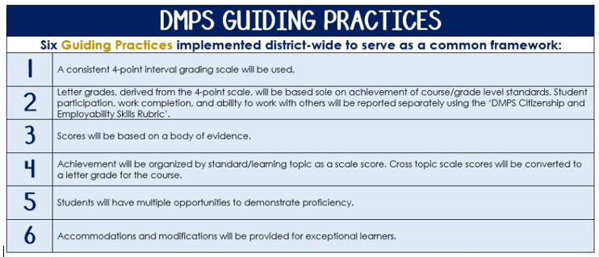
Standards-Referenced Grading Basics
The teacher designs instructional activities and assessments that grow and measure a student’s skills in the elements identified on our topic scales. Each scale features many such skills and knowledges, also called learning targets. These are noted on the scale below with letters (A, B, C) and occur at Levels 2 and 3 of the scale. In the grade book, a specific learning activity could be marked as being 3A, meaning that the task measured the A item at Level 3.

The Body of Evidence in a Process-Based Course
Process-Based SRG is defined as an SRG course design where the same scale recurs throughout the course, but the level of complexity of text and intricacy of task increase over time.

AP Computer Science Principles does have a traditional unit-based design. In some topics, however, students cycle through the same topic repeatedly as they progress through the course, with changing content and an increasing complexity of the coding, analysis, and expectations throughout.

To account for this, process-based courses like this have their evidence considered in a “Sliding Window” approach. When determining the topic score for any given grading topic, the most recent evidence determines the topic score. Teacher discretion remains a vital part of this determination, but it is hard to overlook evidence from the most recent (and therefore rigorous) assessments.

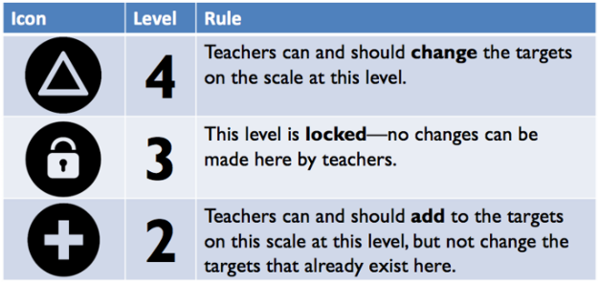
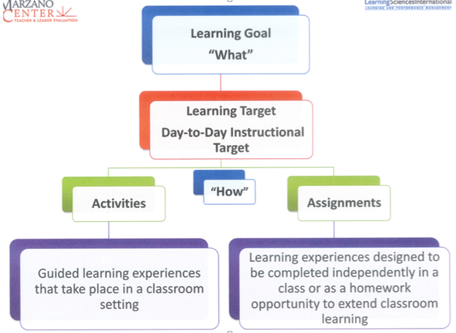

Abstraction
Text and Resources

Topic | 4 | 3 | 2
Abstraction | In addition to meeting the learning goal, the student demonstrates in-depth inferences and applications that go beyond the goal. | 3A: Utilize data sequences to represent digital data.  -Favicon  -Emphasis on binary- school code, what happens when you add a bit to a binary message  -Knowledge Utilization  3B: Develop and use an abstraction with multiple levels to manage complexity in a program. (Create task rows, 7,8) | 2A: Identify the different types of data sequences in an algorithm.  - Send information in binary together (create picture, use in battleship)  - Identify data sequences to show colors, locations, music data, logic gates, etc. (  - Convert binary and hexadecimal to decimal and vice-versa  2B.1 Identify an abstraction in a program  2B.2 Create a function that’s used in a program  2A/B: Identify and define vocabulary terms such as: Base Systems, Number Systems, Logic Gates, Constants, Expressions, Statements, Procedures, and Libraries, Boolean Operators.

Data and Information
Text and Resources

Topic | 4 | 3 | 2
Data and Information | In addition to meeting the learning goal, the student demonstrates in-depth inferences and applications that go beyond the goal. | 3A: Assess how a computing innovation uses digitally processed information to produce, consume, or transform that data (Row 6 on AP Explore Rubric) (Sem2)  3B: Analyze how data representation, storage security, and transmission of data involve computational manipulation of information. (Row 7 on AP Explore Rubric) (Sem2)  3C: Explain how computing processes information to gain insight and knowledge, facilitates exploration, and the trade-offs when representing information as digital data. | 2A:  - Identify data of a computing innovation uses  - Explain how data can be produced, consumed, or transformed  2B:  - Identify one data storage, privacy or security concern  2C: Recognize trends and connections from extracted data information.  - Interpret a table, chart, etc. to identify trends, and gain data  - Identify the trade-offs when representing information as digital data (Compression)  2A/B/C: Identify and define vocabulary terms such as: Large data sets, Big Data, Databases, Metadata, Sorting and Searching, Storage, Privacy, Encryption

Algorithms
Text and Resources

Topic | 4 | 3 | 2
Algorithms | In addition to meeting the learning goal, the student demonstrates in-depth inferences and applications that go beyond the goal.  Row 6 on Create task | 3A: Develop an algorithm for implementation in a program.  (Semester 1 Digital Scene)  (Semester 2 Create task Row 4)  3B: Investigate algorithms analytically and empirically for efficiency, correctness, and clarity. (Test questions) | 2A:  - Develop an algorithm that has some working components. (Sem. 1)  - More than 1 step  - Math or logic component  - Complete color sleuth lesson (Sem. 2)  2B  - Complete a missing component of a non-working or incomplete algorithm  - List and describe the ways an algorithm can be more efficient, correct, and clear  2A/B: Identify and define vocabulary such as: Programming languages (Sequential programming versus Object-oriented programming), Runtime, Heuristic approach

Programming
Text and Resources
Unit 3 and 5 in code.org curriculum

Topic | 4 | 3 | 2
Programming | In addition to meeting the learning goal, the student demonstrates in-depth inferences and applications that go beyond the goal.  - Program is developed to serve a community | 3A: Develop a program for creative expression, to satisfy personal curiosity, or to create new knowledge.  Semester 2 Create task row 1, 2  Semester 1 Digital Scene rows 1,2  3B: Program correctly implements algorithms and abstractions. (Create task program runs efficiently and correctly)  3C: Employ appropriate mathematical logical concepts in programming. (Semester 2 Row 5 Create) | 2A:  - Draft a program for creative expression, to satisfy personal curiosity, or to create new knowledge. (Planning of the program)  - Recall Commands in Javascript (Assessment)  2B  - Describe how programs implement algorithms. (Quick write)  - Describe how abstractions increase efficiency and manage complexity. (Quick write)  2C  - List mathematical logical concepts used in programming. (Unit 5 Lesson 8)  2A/B/C/D: Identify and define vocabulary such as: Iterative process, Program documentation, debug, CPU, Input and Output, Procedures, Variables, Data Abstraction, Strings, Concatenations, Application program interfaces (API), Abstract data types

The Internet
Text and Resources
Semester 1 grade only
Semester 2 discussion in Rapid Research on Cybercrime, but not graded

Topic | 4 | 3 | 2
The Internet | In addition to meeting the learning goal, the student demonstrates in-depth inferences and applications that go beyond the goal. | 3A: Explain the abstractions, hierarchy, and the characteristics of the internet and how it functions.  (test questions, quick writes on protocols)  3B: Given existing cybersecurity concerns research and critique potential options to address these issues with the Internet and systems built on it. (Semester 1 Unit 1 Lesson 14) | 2A:  - List the components of the internet and the role the play.  - DNS, IP addressing, HTTP, SMTP, IETF, DDoS, phishing, virus, firewall, cryptography, encryption, public key security, certificate authority (CA), redundancy  (Vocabulary Assessment)  2B: Identify existing cybersecurity concerns.  - Discuss topic, but does not relate to internet protocols and hierarchy

Creativity
Text and Resources

Topic | 4 | 3 | 2
Creativity | In addition to meeting the learning goal, the student demonstrates in-depth inferences and applications that go beyond the goal. | 3A: Create a computational artifact for creative expression.  3B: Analyze the correctness, usability, functionality of computing innovation.  3C: Use computing tools and techniques for creative expression.  3D: Collaborate in the creation of computational artifacts. | 2A: Draft a computational artifact for creative expression. (Explore Rubric row 1)  2B: Distinguish between an innovation and a computing innovation  Assessment  2C: Create a program different or beyond the guided lessons in class  2D: List ways one can be collaborative in the creation of a computational artifacts. (Iterative and incremental process quick write)  Identify and define vocabulary terms such as: Artifact, Integrated Development Environment (IDE)

Global Impact
Text and Resources
Semester 2 topic only

Topic | 4 | 3 | 2
Global Impact | In addition to meeting the learning goal, the student demonstrates in-depth inferences and applications that go beyond the goal. | 3A: Assess how society uses digitally processed information to gain insight and knowledge  3B: Assess how society is influenced by digitally processed information. (test Questions) | 2A: Recognize computing innovations affect communication, interaction, and cognition in many fields including economic, social, and cultural contexts.  - Identify an effect of a computing innovation  - Harmful  - Beneficial  - Explain how that effect relates to society, economy or culture  2B: Identify and define vocabulary terms such as: Email, SMS, The Cloud, GPS, Smart Technologies, Moore’s Law, Digital Millennium Copyright Act, Digital Divide

