AP Computer Science A: Des Moines Public Schools
2018-19 CURRICULUM GUIDE

AP Computer Science A
AP Computer Science A – Course Content:
The following are the major areas of study, or big ideas which are foundational to studying computer science in Java:

Object-Oriented Program Design: The overall goal for designing a piece of software is to correctly solve the given problem. The design process needs to be based on a thorough understanding of the problem to be solved - Program and Class Design: Problem analysis, Data abstraction and encapsulation, Class specifications, interface specifications, relationships (“is-a,” “has-a”), and extension using inheritance, Code reuse, Data representation and algorithms, Functional decomposition.

Program Implementation: Part of the problem-solving process is the statement of solutions in a precise form that invites review and analysis. The implementation of solutions in the Java programming language reinforces concepts, allows potential solutions to be tested, and encourages discussion of solutions and alternatives. Implementation techniques, Programming constructs, Java library classes and interfaces included in the AP Java Subset.

Program Analysis: The analysis of programs includes examining and testing programs to determine whether they correctly meet their specifications. It also includes the analysis of programs or algorithms in order to understand their time and space requirements when applied to different data sets. Testing, Debugging, Runtime exceptions, Program correctness, Algorithm Analysis, Numerical representations of integers.

Standard Data Structures: Data structures are used to represent information within a program. Abstraction is an important theme in the development and application of data structures. Primitive data types, Strings, Classes, Lists, Arrays (1-dimensional and 2-dimensional)

Standard Operation and Algorithms: Standard algorithms serve as examples of good solutions to standard problems. Many are intertwined with standard data structures. These algorithms provide examples for analysis of program efficiency. Operations on data structures, Searching, Sorting.

Computing in Context: An awareness of the ethical and social implications of computing systems in necessary for the study of computer science. These topics need not be covered in detail, but should be considered through the course: System reliability, Privacy, Legal Issues and intellectual property, Social and ethical ramifications of computer use. System reliability, privacy, Legal issues and intellectual property, Social and ethical ramifications.

AP Computer Science A Exam: Format of Assessment
Section I: Multiple Choice | 40 Questions | 1 Hour, 30 Minutes | 50% of Exam Score
Discrete Question topics will include: programming fundamentals, data structures, logic, algorithms/problem solving, object-oriented programming, recursion, and software engineering.

Section II: Free Response | 4 Questions | 1 Hour, 30 Minutes | 50% of Exam Score • Short Answer
Short Answer (each requiring Java programming language) • Solve problems involving more extended reasoning

Link to DMPS Grading Resources: http://grading.dmschools.org
Link to Course Information @ AP Central: https://apstudent.collegeboard.org/apcourse/ap-computer-science-a
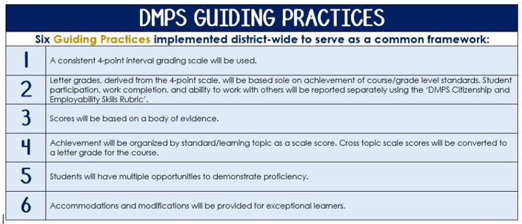
Standards-Referenced Grading Basics
The teacher designs instructional activities and assessments that grow and measure a student’s skills in the elements identified on our topic scales. Each scale features many such skills and knowledges, also called learning targets. These are noted on the scale below with letters (A, B, C) and occur at Levels 2 and 3 of the scale. In the grade book, a specific learning activity could be marked as being 3A, meaning that the task measured the A item at Level 3.

The Body of Evidence in a Process-Based Course
Process-Based SRG is defined as an SRG course design where the same scale recurs throughout the course, but the level of complexity of text and intricacy of task increase over time.

AP Computer Science A does have a traditional unit-based design. In some topics, however, students cycle through the same topic repeatedly as they progress through the course, with changing content and an increasing complexity of the coding, analysis, and expectations throughout.

To account for this, process-based courses like this have their evidence considered in a “Sliding Window” approach. When determining the topic score for any given grading topic, the most recent evidence determines the topic score. Teacher discretion remains a vital part of this determination, but it is hard to overlook evidence from the most recent (and therefore rigorous) assessments.

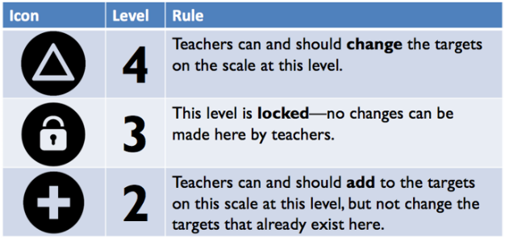
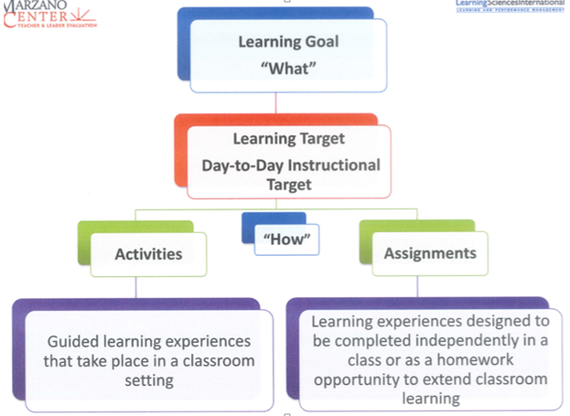

Object-Oriented Program Design
Text and Resources
AP Computer Science in Java https://codehs.gitbooks.io/apjava/content/
Java Methods: Object-Oriented Programming and Data Structures (Third Edition); Litvin; Skylight Publishing; 2015

Topic | 4 | 3 | 2
Object-Oriented Program Design | In addition to meeting the learning goal, the student demonstrates in-depth inferences and applications that go beyond the goal. | 3A: Design a program that is understandable and can be adapted to changing circumstances.  *The student should be able to design a class.  *The student should be able to implement the class and extend the class using inheritance.  *The student should be able to write interfaces, write classes that implement interfaces and write programs that use interfaces.  *The student should be familiar with the AP Java Subset and be able to utilize this subset in their program design and implementation | 2A: Identify a functioning program and its various parts.

Program Implementation
Text and Resources
AP Computer Science in Java https://codehs.gitbooks.io/apjava/content/
Java Methods: Object-Oriented Programming and Data Structures (Third Edition); Litvin; Skylight Publishing; 2015

Topic | 4 | 3 | 2
Program Implementation | In addition to meeting the learning goal, the student demonstrates in-depth inferences and applications that go beyond the goal. | 3A: Explain and give examples of the various implementation techniques:  *Top-down  *Bottom-up  *Object oriented  *Encapsulation and information hiding *Procedural abstraction  3B: Use various programming constructs in the implementation of a program.  *The student should be able to use the various methods of controlling a program through -Method calls.  -Sequential execution  -Conditional execution  -Iteration  *The student should be able to demonstrate and understanding of the concept of recursion.  *The student should be able to use expression evaluation in the implementation of a program using:  -Numeric expressions  -String expressions  -Boolean expressions  -Short-circuit evaluation  -De Morgan’s Law  3C: The student should be able to use existing libraries appropriately in the implementation of a program. | 2A: Identify various implementation techniques.  2B:  *The student should be able to list and identify programming constructs in a program.  *The student should be able to list and explain the various parts of a program declaration  2C: The student should have an awareness of the various libraries available.

Program Analysis
Text and Resources
AP Computer Science in Java https://codehs.gitbooks.io/apjava/content/
Java Methods: Object-Oriented Programming and Data Structures (Third Edition); Litvin; Skylight Publishing; 2015

Topic | 4 | 3 | 2
Program Analysis | In addition to meeting the learning goal, the student demonstrates in-depth inferences and applications that go beyond the goal. | 3A: The student should be able to examine and test programs to determine whether they correctly meet the specifications of the program design.  3B: The student should be able to understand how run time analysis (and exceptions) and memory requirements can affect program design and implementation.  3C: The student should be able to read and modify code for a given program.  *They student should be able to extend existing code to add or change the given class’ functionality.  *The student should understand and design preconditions, postconditions and assertions and correctly interpret them.  *The student should be able to manipulate mathematical expressions on non-negative integers in different bases and the consequences of finite integer representation. | 2A: The student should be able to identify the specification and pre and post conditions of a given program.  2B: The student should l be able to list the ways how run time can effect a program’s efficiency.  2C: The student should be able to identify modifications made to a given program.

Standard Data Structures
Text and Resources
AP Computer Science in Java https://codehs.gitbooks.io/apjava/content/
Java Methods: Object-Oriented Programming and Data Structures (Third Edition); Litvin; Skylight Publishing; 2015

Topic | 4 | 3 | 2
Standard Data Structures | In addition to meeting the learning goal, the student demonstrates in-depth inferences and applications that go beyond the goal. | 3A: Students should understand the standard data structures and their use.  *The student should be able to use the primitive data types  -int  -double  -Boolean  *The student should know and be able to use the Java String class.  *The student should know and be able to use classes  *The student should know and understand 1 and 2-dimensional arrays.  *The student should be able to work with lists of data. | 2A: Students should be able to identify and list standard data structures.

Standard Operations and Algorithms
Text and Resources
AP Computer Science in Java https://codehs.gitbooks.io/apjava/content/
Java Methods: Object-Oriented Programming and Data Structures (Third Edition); Litvin; Skylight Publishing; 2015

Topic | 4 | 3 | 2
Standard Operations and Algorithms | In addition to meeting the learning goal, the student demonstrates in-depth inferences and applications that go beyond the goal. | 3A: The student should be able to identify and use in an algorithm the two standard searches  -Sequential  -Binary  3B: The student should be able to identify and use in an algorithm the three standard sorts.  -Selection  -Insertion  -Merge | 2A: The student should be able to identify the two standard searches  2B: The student should be able to identify the three standard sorts.

Computing in Context
Text and Resources
AP Computer Science in Java https://codehs.gitbooks.io/apjava/content/
Java Methods: Object-Oriented Programming and Data Structures (Third Edition); Litvin; Skylight Publishing; 2015

Topic | 4 | 3 | 2
Computing in Context | In addition to meeting the learning goal, the student demonstrates in-depth inferences and applications that go beyond the goal. | 3A: Identify and explain the impact computers and computing have had on our society  -Acceptable Use  -Right to Privacy  -Property Rights  -Fair Use  3B: Identify and explain the economic and legal impact computers and computing have had on our society. | 2A: Identify the impact computers and computing have had on our society  2B: Identify the economic and legal impact computers and computing have had on our society.

