The Des Moines Public Schools Curriculum guide contains the prioritized standards, required pacing, materials and resources, and assessment correlates for the school year. This document is intended to be used in conjunction with our balanced assessment plan to scaffold our students in mastery of the Iowa Core State Standards and the essential learnings outlined by the College Board.
AP Comparative Government: Des Moines Public Schools
2018-2019 CURRICULUM GUIDE SOC557A

AP Comparative Government
AP Comparative Government – SOC557A
AP Comparative Government and Politics introduces students to the rich diversity of political life outside the United States. The course uses a comparative approach to examine the political structures; policies; and the political, economic, and social challenges among six selected countries: Great Britain, Mexico, Russia, Iran, China, and Nigeria. Additionally, students examine how different governments solve similar problems by comparing the effectiveness of approaches to many global issues.

Social Studies Weebly: socialstudies.dmschools.org
College Board’s AP Comparative Government: http://apcentral.collegeboard.com/apc/public/courses/teachers_corner/2258.html

AP Comparative Government Course Content
Students compare and contrast political institutions and processes across six countries (Great Britain, Mexico, Russia, Iran, China, and Nigeria) and analyze and interpret data to derive generalizations.
Topics include:
• Introduction to Comparative Politics • Sovereignty, Authority, and Power
• Political Institutions • Citizens, Society, and the State
• Political and Economic Change • Public Policy

Course Goals:
Students successfully completing this course will:
• Compare and contrast political concepts, themes, and generalizations;
• Describe and explain typical patterns of political processes and behaviors and their consequences;
• Compare and contrast political institutions and processes across countries to derive generalizations; and
• Analyze and interpret basic data relevant to comparative government and politics.

AP Comparative Government Exam
The AP Comparative Government and Politics Exam asks students to explain and apply key and supporting concepts. The exam measures students’ knowledge of the six core countries and their ability to compare and contrast political regimes; electoral systems; federal structures; civil rights; and state responses to economic, social, and religious challenges over time.

Format of Assessment Section I: Multiple Choice | 55 Questions | 45 Minutes | 50% of Exam Score
• Address major conceptual understandings among the six core countries • Apply skills of comparison and interpretation
Section II: Constructed Response | 8 Questions | 100 Minutes | 50% of Exam Score
• Short-Answer Concept (5 Questions) • Conceptual Analysis (1 Question) • Country Context (2 Questions)

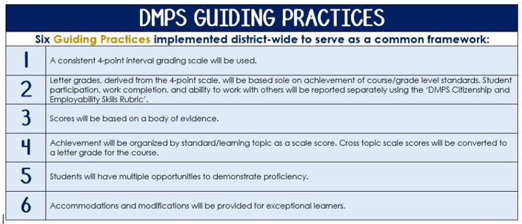
Standards-Referenced Grading Basics
The teacher designs instructional activities and assessments that grow and measure a student’s skills in the elements identified on our topic scales. Each scale features many such skills and knowledges, also called learning targets. These are noted on the scale below with letters (A, B, C) and occur at Levels 2 and 3 of the scale. In the grade book, a specific learning activity could be marked as being 3A, meaning that the task measured the A item at Level 3.

The Body of Evidence in a Process-Based Course
Process-Based SRG is defined as an SRG course design where the same scale recurs throughout the course, but the level of complexity of text and intricacy of task increase over time.

AP Comparative Government is a course in which students cycle through focused topics repeatedly as they progress through the course, with changing content and an increasing complexity of the text, analysis, and writing expectations throughout.

To account for this, process-based courses like this have their evidence considered in a “Sliding Window” approach. When determining the topic score for any given grading topic, the most recent evidence determines the topic score. Teacher discretion remains a vital part of this determination, but it is hard to overlook evidence from the most recent (and therefore rigorous) assessments.

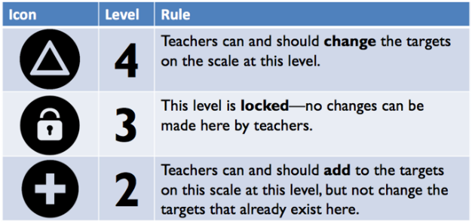
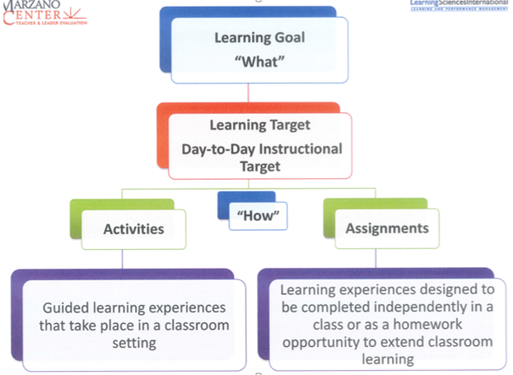

Scales

Topic | 4 | 3 | 2
Key Concepts in Comparative Government | 4A: Develop a strategy to strengthen political structures in a developing democracy.  4B: Develop a strategy related to individual and group decision-making to lessen conflict between competing groups. | 3A: Apply key concepts to support generalizations pertaining to the  political structures in Great Britain, Mexico, Nigeria, Russia, Iran, and China.  3B: Apply key concepts to support generalizations pertaining to individual and group decision-making in Great Britain, Mexico, Nigeria, Russia, Iran, and China. | 2A: Identify and describe key concepts related to political structures.  2B: Identify and describe key concepts related to individual and group decision-making.
Topic | 4 | 3 | 2
Comparing States | Select the best political institutions and processes in the “AP 6” to ensure a successful state. | Compare and contrast political institutions and processes in Great Britain, Mexico, Nigeria, Russia, Iran, and China. | Identify and describe the characteristics of political institutions and processes in Great Britain, Mexico, Nigeria, Russia, Iran, and China.
Topic | 4 | 3 | 2
Patterns of Political Processes and Behavior | Make predictions regarding patterns of political processes/behavior. | Make generalizations about patterns of political processes/behavior and their consequences. | Explain patterns of political process and behaviors.
Topic | 4 | 3 | 2
Interpreting Data | Apply relevant data to test a hypothesis about political structures and decision-making. | Interpret relevant data to draw conclusions about political structures and decision-making. | Describe statistical information related to social, political, and/or economic factors.
Topic | 4 | 3 | 2
Writing Arguments from Evidence | In addition to meeting the learning goal, the argument:  Evaluates the strengths and weaknesses of diverse or contradictory evidence. | A level 3 meets all of the learning goal targets:  a. Introduce a debatable claim  b. Provide multiple pieces of evidence to support the claim.  c. Explain diverse or contradictory evidence or perspectives. | A level 2 meets one of the learning goal targets:  a. Introduce a debatable claim  b. Provide multiple pieces of evidence to support the claim  c. Recognize diverse or contradictory evidence or perspectives.

